 | City of York | North Yorkshire | Both Areas
Monday  Themes: Tell us your concerns & Domestic Abuse | Are you worried about a child? Contact #YorkMASH on 01904 551900 and #TellUsYourConcerns . If you think a child is in immediate danger, call the police on 999. Further information can be found here: https://www.saferchildrenyork.org.uk/concerned-about-a-child-or-young-person.htm | Are you worried about a child? Contact MAST on 01609 780780 and #TellUsYourConcerns . If you think a child is in immediate danger, call the police on 999. Further information can be found here:  https://www.safeguardingchildren.co.uk/about-us/worried-about-a-child/ | North Yorkshire (Only)  Are you a professional working with Domestic Abuse, talk to the IDAS Live Chat for Professionals Monday to Friday 10-12. If you’re worried about a child Contact MAST on 01609 780780 and #TellUsYourConcerns  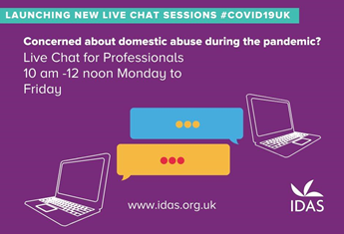  City of York (Only)  Are you a professional working with Domestic Abuse, talk to the IDAS Live Chat for Professionals Monday to Friday 10-12. If you’re worried about a child contact #YorkMASH on 01904 551900 and #TellUsYourConcerns  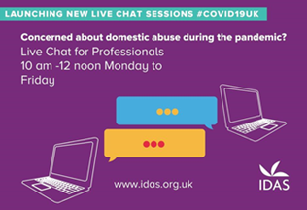
Tuesday Themes:  Tell us your concerns &  Keeping Safe Online | Are you worried about a child? Contact #YorkMASH on 01904 551900 and #TellUsYourConcerns . If you think a child is in immediate danger, call the police on 999. Further information can be found here: https://www.saferchildrenyork.org.uk/concerned-about-a-child-or-young-person.htm | Are you worried about a child? Contact MAST on 01609 780780 and #TellUsYourConcerns . If you think a child is in immediate danger, call the police on 999. Further information can be found here:  https://www.safeguardingchildren.co.uk/about-us/worried-about-a-child/ | North Yorkshire (only):  Young people:  Want to know how to keep yourself safe online, visit our stay and safe online page: https://www.safeguardingchildren.co.uk/ children-young-people/staying-safe-online/ #TellUsYourConcerns or contact MAST on 01609 780780  Parents:  For tips, advice, guides and resources to keep your child safe online visit: https://www.safeguardingchildren.co.uk /parents-carers/online-safety/. If you’re worried #TellUsYourConcerns or contact MAST on 01609 780780  City of York (Only)  Young people:  Want to know how to keep yourself safe online, visit our stay and safe online page: https://www.saferchildrenyork.org.uk/  #TellUsYourConcerns or contact #YorkMASH on 01904 551900  Parents:  For tips, advice, guides and resources to keep your child safe online visit: https://www.saferchildrenyork.org.uk/  If you’re worried #TellUsYourConcerns or contact #YorkMASH on 01904 551900
Wednesday  Themes:  Tell us your concerns & Radicalisation | Are you worried about a child? Contact #YorkMASH on 01904 551900 and #TellUsYourConcerns . If you think a child is in immediate danger, call the police on 999. Further information can be found here: https://www.saferchildrenyork.org.uk/concerned-about-a-child-or-young-person.htm | Are you worried about a child? Contact MAST on 01609 780780 and #TellUsYourConcerns . If you think a child is in immediate danger, call the police on 999. Further information can be found here:  https://www.safeguardingchildren.co.uk/about-us/worried-about-a-child/ | North Yorkshire (Only):  Professionals:  Professionals, do you want to know more about Prevent and the North Yorkshire Channel Panel, visit: https://www.safeguardingchildren.co.uk/wp-content/uploads/2020/05/NY-Channel-Leaflet-for-professionals-2020.pdf  City of York (Only)  Professionals:  Professionals, do you want to know more about Prevent and the City of York Channel Panel, visit: https://www.saferchildrenyork.org.uk/prevent.htm  Both Areas  Public:  Let’s Talk about it, is an initiative designed to provide help and guidance to educate against hate, for more information visit: https://educateagainsthate.com/resources/lets-talk/ #letstalkaboutit #TellUsYourConcerns  (Use Image below):
Thursday  Themes: Themes:  Tell us your concerns & County Lines/ Cuckooing | Are you worried about a child? Contact #YorkMASH on 01904 551900 and #TellUsYourConcerns . If you think a child is in immediate danger, call the police on 999. Further information can be found here: https://www.saferchildrenyork.org.uk/concerned-about-a-child-or-young-person.htm | Are you worried about a child? Contact MAST on 01609 780780 and #TellUsYourConcerns . If you think a child is in immediate danger, call the police on 999. Further information can be found here:  https://www.safeguardingchildren.co.uk/about-us/worried-about-a-child/ | North Yorkshire (Only):  For information on County Lines and Cuckooing please see our One Minute Guide: https://www.safeguardingchildren.co.uk/wp-content/uploads/2020/06/County-Lines-and-Cuckooing-OMG-2020-06-15.pdf  If you are worried about a child #TellUsYourConcerns on 01609 780780  (Use image below)  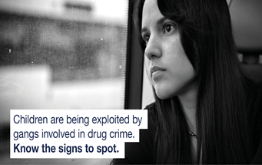  City of York (Only)  For information on County Lines and Cuckooing please visit our website: https://www.saferchildrenyork.org.uk/child-sexual-abuse-and-exploitation.htm  If you’re worried about a child #TellUsYourConcerns on 01904 551900  (Use image below)  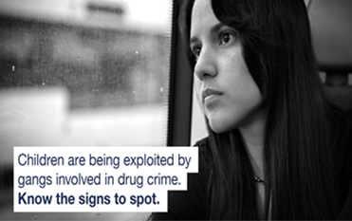
Friday  Themes: Themes:  Tell us your concerns & Mental Health & Wellbeing | Are you worried about a child? Contact #YorkMASH on 01904 551900 and #TellUsYourConcerns . If you think a child is in immediate danger, call the police on 999. Further information can be found here: https://www.saferchildrenyork.org.uk/concerned-about-a-child-or-young-person.htm | Are you worried about a child? Contact MAST on 01609 780780 and #TellUsYourConcerns . If you think a child is in immediate danger, call the police on 999. Further information can be found here:  https://www.safeguardingchildren.co.uk/about-us/worried-about-a-child/ | North Yorkshire (Only):  Young People’s mental health matters, if you are feeling stressed, anxious or upset. You can find help and support from our website: https://www.safeguardingchildren.co.uk/children-young-people/mental-health-2/ or #TellUsYourConcerns on 01609 780780  City of York (Only):  Young People’s mental health matters, if you are feeling stressed, anxious or upset. You can find help and support from our website: https://www.saferchildrenyork.org.uk/ or #TellUsYourConcerns on 01904 551900

