Over Arching Tweet
Have you been a victim of #HateCrime or #MateCrime? Contact North Yorkshire Police 101 or Supporting Victims on 01609 643100 or make a report online at https://www.supportingvictims.org/
#helpnothate2020 If you are in immediate danger contact the Police on 999.

Monday 12th October
- What is a Hate Crime?
- What support is available?
- How do you report it?
NYCSP | Tweet 1  Have you been a victim of #HateCrime or #MateCrime? Contact North Yorkshire Police 101 or Supporting Victims on 01609 643100 or make a report online at https://www.supportingvictims.org/  #helpnothate2020 If you are in immediate danger contact the Police on 999.  It is #HateCrimeAwarenessWeek20. NY and COY are working together to stop hate #helpnotate2020. If you are a victim of #HateCrime, you can contact https://www.supportingvictims.org, call NYP 101 or if you are in immediate danger contact the police on 999
NYSCP | It is #HateCrimeAwarenessWeek20. Don’t stand for Hate Crime #helpnotate2020. If you are a victim of #HateCrime, you can contact https://www.supportingvictims.org, call NYCC on 01609 780780 or if you are in immediate danger contact the police on 999
NYSAB | Tweet 1:  Have you been a victim of Hate Crime or Mate Crime? Contact North Yorkshire Police 101 or Supporting Victims 01609 643100 or make a report online at https://www.supportingvictims.org/  #helpnothate2020 If you are in immediate danger contact the Police on 999.  Tweet 2:  This easy read guide provides important information on what #HateCrime and #MateCrime is and how you report it:  https://safeguardingadults.co.uk/wp-content/uploads/2020/10/Easy-read-hate-crime-document-150120-1.pdf  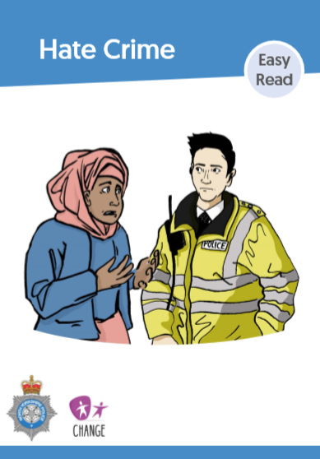  Tweet 3:  If you or someone you know has been the victim of #HateCrime or #MateCrime and have safeguarding concerns, contact North Yorkshire County Council Customer Service Centre on 01609 780 780 #helpnothate2020  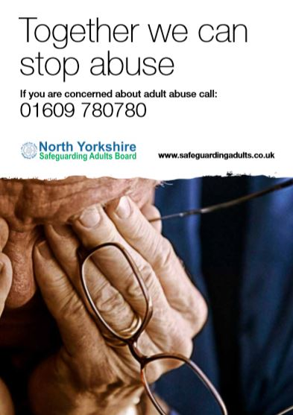  Resources from the North Yorkshire Learning Disability Partnership Board / Self Advocates will be shared via the NYSAB Twitter. Please share via your social media platforms
CYCSB | Hate crime is when someone commits a crime against you because of any perceived difference. Hate crime is against the law.  See the #CYSCP website for more information and how to report it:  https://www.yor-ok.org.uk/Safer%20Children%20York%202014/bullying.htm  #helpnothate2020
Tuesday 13th October
Training: Hate Crime Awareness Training to Partners Webinar
- What is Mate Crime and how do you report it?
- Young people urged to play the KYMSGAME (Keeping Your Mates Safe) developed by the Youth Commission
- Highlight the services provided by Supporting Victims

NY CSP | Have you been a victim of #HateCrime or #MateCrime? Contact North Yorkshire Police 101 or Supporting Victims on 01609 643100 or make a report online at https://www.supportingvictims.org/  #helpnothate2020 If you are in immediate danger contact the Police on 999.  Tweet 2  This handy one-minute guide provides important information on what Mate Crime is and how you report it:  https://www.nypartnerships.org.uk/sites/default/files/Partnership%20files/Safer%20communities/Hate%20crime/Mate-Crime-OMG-2020-06-16.pdf  #helpnothate2020  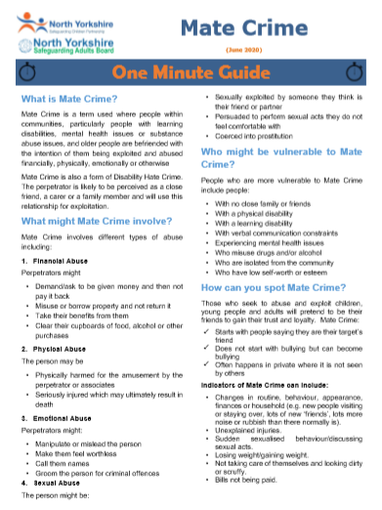
NYSCP | Don’t stand for #MateCrime #helpnothate2020. See our one minute guide at https://www.safeguardingchildren.co.uk/wp-content/uploads/2020/06/Mate-Crime-OMG-2020-06-16.pdf  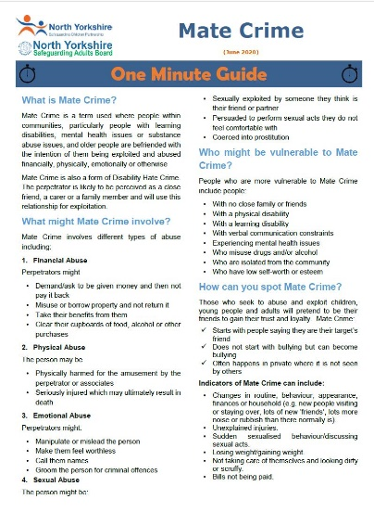
NY SAB | Tweet 1:  This handy one-minute guide provides important information on what Mate Crime is and how you report it: https://safeguardingadults.co.uk/wp-content/uploads/2020/06/Mate-Crime-OMG-2020-06-16.pdf  Tweet 2:  Have you been a victim of Hate Crime or Mate Crime? Contact North Yorkshire Police 101 or Supporting Victims 01609 643100 or make a report online at https://www.supportingvictims.org/  #helpnothate2020 If you are in immediate danger contact the Police on 999  Tweet 3:  If you or someone you know has been the victim of Hate of Mate Crime and have safeguarding concerns, contact North Yorkshire County Council Customer Service Centre on 01609 780 780  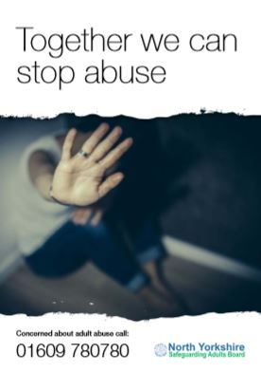  Resources from the North Yorkshire Learning Disability Partnership Board / Self Advocates will be shared via the NYSAB Twitter. Please share via your social media platforms
CYCSB | Mate crime happens when someone ‘makes friends’ with you and goes on to abuse or exploit that relationship. See the #CYSCP Bullying webpage for more information and how to report it:  https://www.yor-ok.org.uk/Safer%20Children%20York%202014/bullying.htm  #helpnothate2020
Wednesday 14th October
Prevent Webinar no 1: Understanding and Challenging anti-minority narratives
- What is Prevent?
- What do I do if I have a prevent concern?
- Project: ‘Wakeup call’
- What is ‘Wake up call?’

NYCSP | Have you been a victim of #HateCrime or #MateCrime? Contact North Yorkshire Police 101 or Supporting Victims on 01609 643100 or make a report online at https://www.supportingvictims.org/  #helpnothate2020 If you are in immediate danger contact the Police on 999.  Tweet 2  Prevent concern? Call 101 or report anonymously on the Anti-Terror Hotline 0800789321. Partner agencies should follow existing safeguarding routes or call a NYP Prevent Officer for advice#helpnothate2020  Tweet 3  Prevent is about safeguarding and supporting those vulnerable to radicalisation #helpnothate2020. For more information, visit the Lets Talk About It website https://www.ltai.info/what-is-prevent/  Or visit https://www.nypartnerships.org.uk/prevent
NYSCP | Want to know more about #HateCrime, see this video from Victim Support https://www.youtube.com/watch?v=1Mo2QCW7-eA #helpnothate2020
NYSAB | Tweet 1  Prevent is about safeguarding and supporting those vulnerable to radicalisation. For more information, visit the Lets Talk About It website https://www.ltai.info/what-is-prevent/  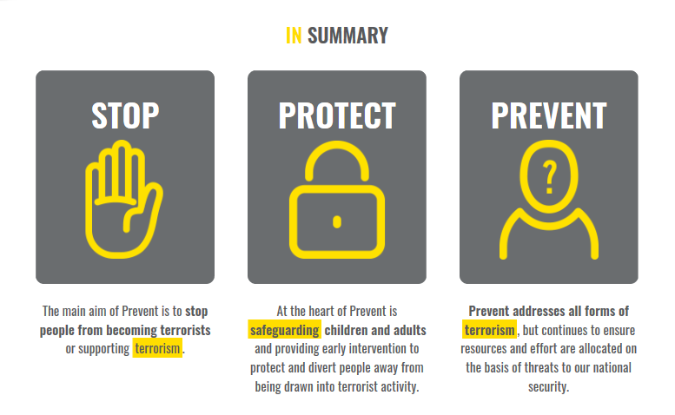  Tweet 2  If you need to make a Prevent concern for you or someone you know, talk to the police on 101. You can also contact the North Yorkshire safeguarding team for further advice on 01609 780 780  For more information visit https://www.ltai.info/what-is-prevent/  #helpnothate2020  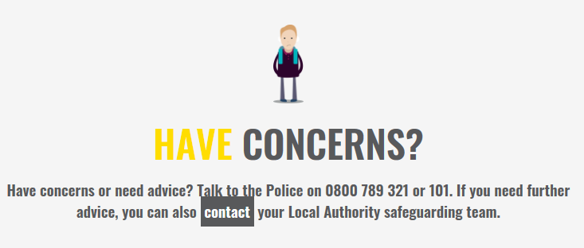
CYCSB | If you think an individual is exhibiting behaviour or making comments that suggest they may be involved in activity which could be linked to terrorism, you should report it, see the #CYSCP website:  https://www.saferchildrenyork.org.uk/prevent.htm  #helpnothate2020
Thursday 15th October
Safe Places Scheme in North Yorkshire
- What is the Safe Places scheme?
- How can vulnerable people affected by hate crime become members in both York and North Yorkshire?

NYCSP | Tweet 1  Have you been a victim of #HateCrime or #MateCrime? Contact North Yorkshire Police 101 or Supporting Victims on 01609 643100 or make a report online at https://www.supportingvictims.org/  #helpnothate2020 If you are in immediate danger contact the Police on 999.  Tweet 2  North Yorkshire Safe Places Scheme is for people who may need more help and support to feel safe in their local community #helpnothate2020 For more information visit https://www.northyorks.gov.uk/safe-places  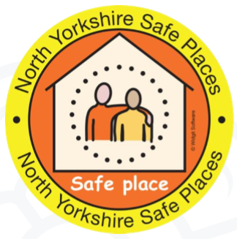  Tweet 3  If you or someone you know are a vulnerable adults who has been affected by Hate Crime and want to become a member of the North Yorkshire Safe Places Scheme you can phone: 03307 260260 or e-mail: safeplaces@spsdoorguard.com  For more information you can also visit https://www.northyorks.gov.uk/safe-places
NYSCP | Don’t stand for hate crimes, #helpnothate20  https://www.youtube.com/watch?v=tdUUD7jcMVs  If you have been a victim of Hate Crime contact the Police on 101 or NYCC on 01609 780780.
NYSAB | Tweet 1  The Safe Places Scheme is community initiative that is nationally recognised. It is for people who may need more help and support to feel safe in their local community. For more information visit https://www.northyorks.gov.uk/safe-places  Tweet 2  If you or someone you know are a vulnerable adults who has been affected by Hate Crime and want to become a member of the North Yorkshire Safe Places Scheme you can phone: 03307 260260 or e-mail: safeplaces@spsdoorguard.com  For more information you can also visit https://www.northyorks.gov.uk/safe-places  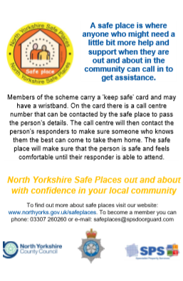  Resources from the North Yorkshire Learning Disability Partnership Board / Self Advocates will be shared via the NYSAB Twitter. Please share via your social media platforms
CYCSB | York’s Safe Places are located in libraries, cafes, shops and museums that are open to the public and accessible. They provide a safe and supportive space if someone who is vulnerable needs to ask for help while out and about.  https://www.yorkcvs.org.uk/safeplaces/  #helpnothate2020
Friday 16th October
Prevent Webinar No 2: ‘Creating a perfect storm: the local dynamics of anti-minority protest
- What is a Prevent Champion?
- How can I become a Prevent Champion?

NYCSP | Tweet 1  Have you been a victim of #HateCrime or #MateCrime? Contact North Yorkshire Police 101 or Supporting Victims on 01609 643100 or make a report online at https://www.supportingvictims.org/  #helpnothate2020 If you are in immediate danger contact the Police on 999.  Tweet 2  Prevent concern? Call 101 or report anonymously on the Anti-Terror Hotline 0800789321. Partner agencies should follow existing safeguarding routes or call a NYP Prevent Officer for advice #helpnothate2020  Tweet 3  If you need to make a Prevent concern for you or someone you know, talk to the police on 101. You can also contact the North Yorkshire safeguarding team for further advice on 01609 780 780  #helpnothate2020
NYSCP | Don’t stand for #MateCrime #helpnothate2020. See our one minute guide at https://www.safeguardingchildren.co.uk/wp-content/uploads/2020/06/Mate-Crime-OMG-2020-06-16.pdf
NYSAB | The NYSAB will be tweeting and retweeting existing information / resources around what is a Prevent Champion and How people can become a Prevent Champion  Tweet 1  If you need to make a Prevent concern for you or someone you know, talk to the police on 101. You can also contact the North Yorkshire safeguarding team for further advice on 01609 780 780  For more information visit https://www.ltai.info/what-is-prevent/  #helpnothate2020
CYCSB | If you think an individual is exhibiting behaviour or making comments that suggest they may be involved in activity which could be linked to terrorism, you should report it, see the #CYSCP website:  https://www.saferchildrenyork.org.uk/prevent.htm  #helpnothate2020

