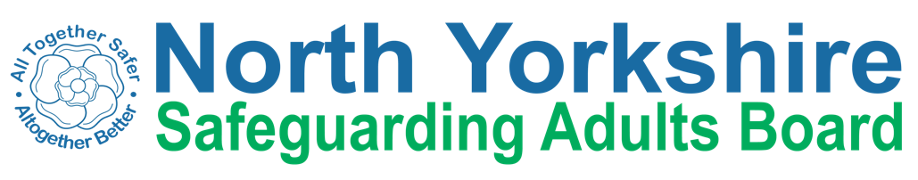

Learning and Review Sub Group
Terms of Reference

Aims
  - To promote a culture of continuous learning across the Safeguarding Board and its wider partnership
  - To share learning so that there are lasting improvements to services which safeguard and promote the welfare of adults at risk of abuse or neglect
  - To oversee Safeguarding Adults Review and Lessons Learned processes and outcomes on behalf of North Yorkshire Safeguarding Adults Board consistent with national guidance and the Board’s Safeguarding Adults Review Policy.
  - To ensure that recommendations from Safeguarding Adult Reviews, or lessons learned are incorporated into front line practice.
  - To carry out reviews or audits of practice/lessons learnt that do not meet the requirement for a SAR, with a view to gathering further learning that can be shared amongst partners of the NYSAB.

Objectives
  - Develop a SAB Learning and Improvement in Practice Framework to underpin processes for learning and change across the partners.
  - Gather shared learning from practice nationwide, including developing action plans as a result of SARs undertaken elsewhere in the country
  - Regularly carry out reviews/audits to establish whether there are lessons to be learned from cases about the way in which local agencies work together to safeguard adults in North Yorkshire, including cases that have been well- managed by multi-partnership agencies and where examples of best practice can be shared
  - Establish what those lessons are, how they will be acted on, and what is expected to change as a result
  - As required on behalf of the Board, set up a Safeguarding Adults Review Panel to carry out Safeguarding Adults Reviews in accordance with Section 44 of the Care Act
  - Enable effective communication with all stakeholders to ensure that national and local learning is widely disseminated. Monitor progress of a review/lessons learnt investigation, and report to the Executive as appropriate
  - Meet at least annually with the Communications and Engagement Sub group to discuss proposals for topics for learning summits and/or safeguarding conferences or seminars
  - Report on outcomes and learning points from Safeguarding Adults Reviews and Lessons Learned Reviews to the Safeguarding Adults Board
  - Keep the Safeguarding Adults Review Policy (including criteria for reviews) under review, advising on its effectiveness and best practice.
  - To monitor compliance with recommendations of completed SARs and Lessons Learned Reviews for a period of 12 months after publication of an overview report (or as agreed by the SAB), and seek assurance through additional audits that changes to practice have been embedded.

Membership
Chair - tbc
HAS Assistant Director (Integration)
HAS Head of Practice
Nurse Consultant Safeguarding Children and Vulnerable Adults Primary Care
Police representative
Designated Nurse Safeguarding Adults
Healthwatch
Additional Members to be considered on a case by case basis Secretariat – Support from HAS Governance Team

Meetings
Quarterly

Accountability and Decision Making Authority
The Sub-Group is formally accountable to the SAB, and will provide quarterly updates to the Executive.

The Chair will meet with the NYSAB Independent Chair at least annually

The Sub-Group Chair is responsible for ensuring links and effective communications are made between it and other Board Sub-Groups and partnerships.

North Yorkshire Safeguarding Adults Board Safeguarding Adults Review Sub-Group (Task and Finish)
Terms of Reference

Aims

To support the Board to ensure robust, transparent and consistent practice regarding:
  - The screening and reviewing of cases against the criteria within the SAB’s Safeguarding Adults Review Policy;
  - The type, mechanism and methodology of review undertaken; and
  - The progress and outcome of the review.

Objectives

  - Consider referrals of new cases against the criteria within the NYSAB Policy for holding a SAR or other type of learning review
  - Commission and consider sufficient information on which to make a recommendation to the NYSAB Chair whether a statutory or non-statutory SAR should be commissioned
  - Make recommendations to the NYSAB Independent Chair on the appropriate type of case review and where responsibility rests for leadership, oversight and co-ordination of the chosen review process

  - Convene a SAR Panel to
    - Establish individual terms of reference and set timescales for the SAR in agreement with the Learning and Review Sub-Group
    - Ensure the review is conducted according to the agreed terms of reference and methodology
    - Ensure appropriate involvement of, and information from, professionals and organisations that were involved with the adult
    - Where relevant, nominate and agree individuals to link to the adult and/or family members to ensure they are clear about the purpose of a SAR, and have an advocate if needed
    - Identify the resources required to carry out a SAR, including the need to commission independent expertise.
    - Notify NYSAB of any administrative/ resourcing arrangements that require attention
    - Consider how the interfaces between other reviews/proceedings should be managed in order to maximise learning for individuals and organisations, and to avoid duplication for families and professionals
    - Initiate the preparation and implementation of media and communication strategies as necessary,
    - Ensure legal advice is sought as required
    - Inform the Learning and Review Sub-Group of outcomes of a SAR through a final report including recommendations for action.

Membership
The Sub-group size should be proportionate to the nature and complexity of the review, in addition to a chair with a level of independence from the case under review. As a guide, this should be a Chair and 3 members of NYSAB

Meetings
Meetings will be convened at the request of the SAB in response to incidents which potentially meet the criteria.

Accountability and Decision Making Authority

The Sub-group is accountable to the Learning and Review Sub-Group. Matters of
concern or urgency should be communicated to the NYSAB Independent Chair

Secretariat – Support from HAS Governance Team

