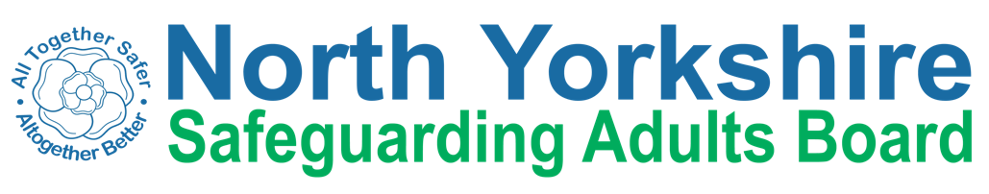

Policies, Practice and Legislation Sub Group
Terms of Reference

Aims
- To work in partnership with multi-agency partners to lead the development and improvement of safeguarding practice that is focused on improving the outcomes for adults at risk in North Yorkshire.
- To have oversight through regular monitoring of the implementation of multi- agency safeguarding policies and procedures across the NYSAB partners
- To have oversight of the establishment & delivery of a Multi-Agency Safeguarding Team (MAST), ensuring capacity, capability and delivery of its agreed objectives

- To provide assurance through monitoring of training uptake and evaluation across the partnership
- To lead the implementation of the Mental Capacity Act, Liberty Protection Safeguards and other relevant legislation across North Yorkshire, ensuring good practice and a coherent approach across all organisations;

Objectives
- To support the purpose of North Yorkshire Safeguarding Adult Board through delivery of aspects of the Delivery Plan which relate to multi agency procedures and practices and training and practice relating to key areas of legislation.

- To develop and embed arrangements around People in Positions of Trust (PIPOT)
- To ensure that a Board training strategy is agreed and implemented to improve knowledge and skills of practitioners and respond to variation in needs from multi agency partners.

- To ensure partners’ compliance with multi-agency safeguarding procedures by undertaking/commissioning regular audits of activity under the NYSAB Quality and Performance Framework;

- To ensure that the safeguarding training strategy is integrated with Mental Capacity Act and Liberty Protection Safeguards training so that mental capacity issues are embedded within the safeguarding training pathway

- To ensure that multi-agency training is up to date and there are consistent standards in safeguarding training delivery. Monitor the completion of training by individual partners’ staff.

- Identify new and emerging training needs

- To ensure implementation of the agreed multi-agency policy and procedures and embedding within practice, including identification of training.

- To review the operational effectiveness of safeguarding adults policies and procedures, and propose amendments for consideration by the SAB.

- To monitor progress against those elements of the NYSAB Delivery Plan for which it has responsibility, and report to the Executive on a quarterly basis.

Membership
Chair – tbc
HAS Assistant Director (Care and Support)
HAS Head of Practice
HAS Service Manager Mental Capacity (MCA) / Deprivation of Liberty Safeguards (DoLS)
Nurse Consultant Safeguarding Children and Vulnerable Adults Primary Care
Designated Nurse Safeguarding Adults
Police representative
Healthwatch representative
Independent Care Group (ICG) representative
Community First Yorkshire representative
Additional Members to be considered as necessary

Members will be safeguarding leads who manage practice in SAB partner agencies and must be able to influence senior decision makers in their respective organisations

Accountability and Decision Making Authority
The sub-group is accountable to the Executive Group through the sub-group chair, who attends the Executive Group as a full member. Individual members of sub- groups are responsible for ensuring two-way communication between the sub-group and the agency/organisation they represent.

This group will oversee the MAST task and finish group and link with the HAS Safeguarding Project group and ensure that regular reports are shared with the Executive, and concerns escalated as required.

Reporting
The Policies, Practice & Legislation Group will report to the Executive on a quarterly basis. The group will also identify messages that can be shared with other partnerships, e.g. Community Safety Partnership.

Secretariat – Support from HAS Governance Team

