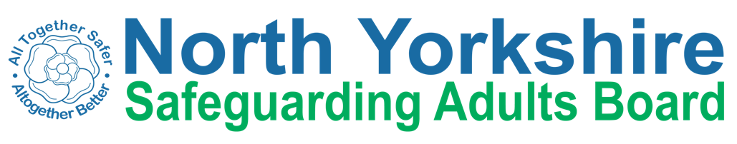

Performance and Quality Improvement Sub Group
Terms of Reference

Aims
  - To establish a performance management framework that enables NYSAB to effectively meet its objectives;
  - To review and monitor key perfomance indicators, ensuring progress and seeking assurance of improvements, or authorising intervention to address concerns
  - To ensure that systems are in place to collate, analyse and report qualitative and quantitative intelligence from across partners in order to inform policy, practice and service delivery; and
  - To support the purpose of North Yorkshire Safeguarding Adult Board through delivery of key aspects of the Delivery Plan.

Objectives
  - To identify key data sources from partner agencies relevant to the monitoring of adult safeguarding services and gaps in data collection;
  - To establish a core dataset to be used to monitor and report performance and outcomes;
  - To establish a framework and mechanisms for routine collection of data from partners;
  - To monitor the presentation of the dataset and its effectiveness;
  - To review both qualitative and quantitative data and to discuss and analyse the findings;
  - To provide quarterly reports of performance data, including annual trend data to the Executive Group;
  - To constructively challenge data anomalies and unexplained trends and commission, where appropriate, additional intelligence;
  - To work with other SABs in the region/country around collection and benchmarking of data;
  - To oversee effective flows of intelligence between the sub-groups and the Board.

Membership
Chair – tbc
CCG Director of Nursing Public Health Consultant
AD Health and Integration (HAS) Designated Nurse for Adult Safeguarding North Yorkshire Police senior representative
Independent Care group senior representative NHS Trust Deputy Director
Head of Practice (HAS)
Data and Intelligence Team Leader (NYCC)

Secretariat – Support from HAS Governance Team

Meetings
- The Performance & Quality Improvement Group will meet four times a year as a minimum, with meetings scheduled to enable timely reports to the Executive Group. Members are expected to attend all meetings. If they are unable to attend they will identify an alternative attendee from their agency.

Accountability and Decision Making Authority

The sub-group is accountable to the Executive Group through the sub-group chair, who attends the Executive Group as a full member. Individual members of sub- groups are responsible for ensuring two-way communication between the sub-group and the agency/organisation they represent.

The sub-group is responsible for ensuring links and effective communications are made between this group and other Board sub-groups including Local Safeguarding Adults Groups, to ensure consistency of standards and messages.

Reporting

The Performance & Quality Improvement Sub-Group will report to the Executive Group on a quarterly basis. The group will also identify messages that can be shared with other partnerships, e.g. Community Safety Partnership.

