

**North Yorkshire Safeguarding Adults Board**

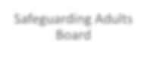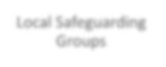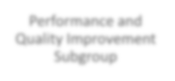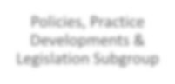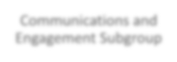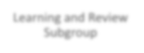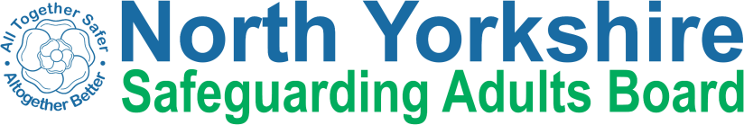

Joint Communications and Engagement

Policies, Practice Developments & Legislation Subgroup

Performance and Quality Improvement Subgroup

Local Safeguarding Partnerships

Safeguarding Adults Board

Conference Planning

Learning and Review Subgroup

Executive Group