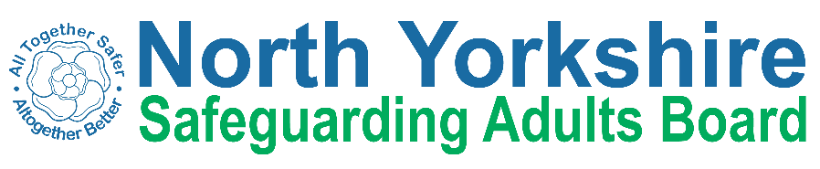

North Yorkshire Safeguarding Adults Board Full meeting minutes

 | Item
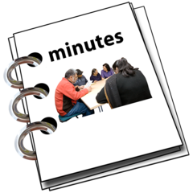 | These are the minutes for the North Yorkshire Safeguarding Adults (NYSAB) Board meeting on Wednesday 16th December, 2020
 | This meeting took place as a video conference
This is because of coronavirus

The Government asked everyone to work from home and not have face to face meetings
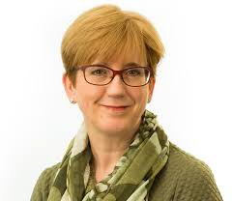 | 1. Welcome and Introductions  Sue Proctor, the Chair of the Board, welcomed everyone to the meeting.

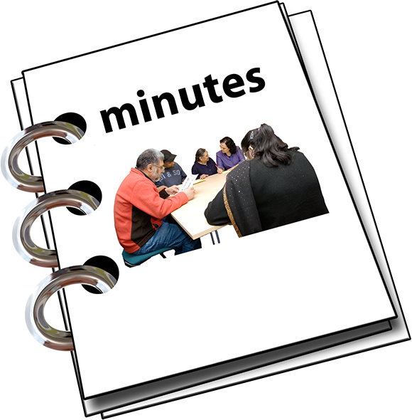 | 2. Previous meeting minutes  Everyone was happy with the minutes from the previous NYSAB meeting in September
3. Action Log
The action log is a list of all of the things that members of the NYSAB have promised to do

The Board reviewed the actions.

An update on action 2020/15 will come back to the Board in March.
This is because there is still some work going on around this action.

Olwen told the Board that a review is taking place in January. The review is happening because of a care home closing in Whitby.

Olwen will give the Board an update on this at the next meeting in March.
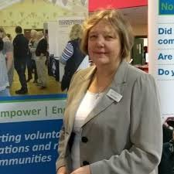 | Sue Proctor asked Caroline for an update on the voluntary and community sectors’ (VCS) work with Healthwatch
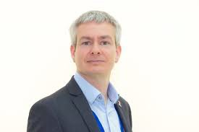 | Caroline said that the the VCS have regular updates with Ashley Green from Healthwatch

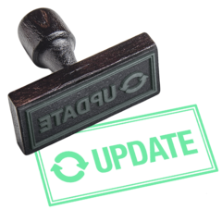 | They also have regular updates at other meetings
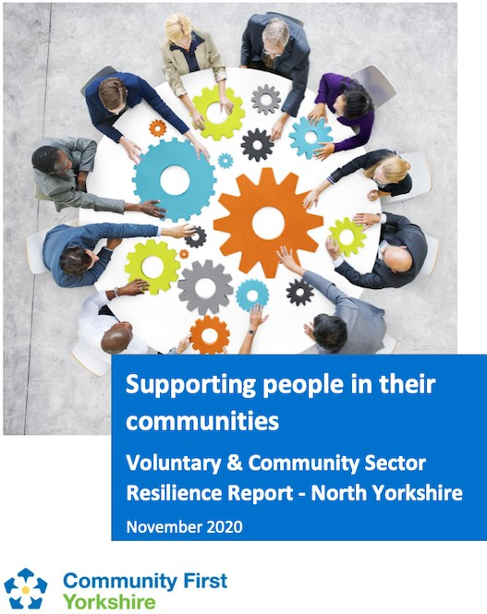 | Caroline provided the link to the VCS  resilience survey:  h"ps://communityﬁrstyorkshire.org.uk/what-we- do/representa9on/results-of-november-2020- pandemic-impact-survey-unveiled/
The resilience survey looks at the pressures on the VCS sector because of COVID-19

This includes charities and businesses not having enough money to stay open

It also includes not having enough volunteers to help deliver services

This is because many of the volunteers need to stay at home because of COVID-19
x | Caroline is working closely with NHS and Public Health Partners to look at volunteers and vaccinations.  Caroline will bring another update from the survey to the Board in March
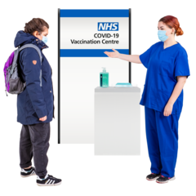

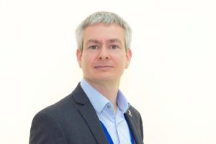 | Sue Proctor welcomed Ashley.  Ashley is the Chief Executive Officer of Healthwatch North Yorkshire  Ashley is happy to support the work of the Board and share pieces of work with the Board
 | 4. Response and Recovery to Covid-19
 | Sue Proctor asked for an update from partners about the impact of Covid-19 on safeguarding.
North Yorkshire CCG
Sue Peckitt said there has been an increase in the number of concerns about the level of abuse, especially towards children.

This could be because there are less visits being carried out because of the pandemic.
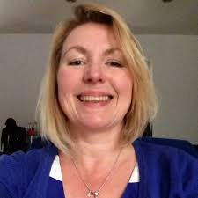 | Sue Peckitt said there are also concerns around some staff behaviour and the way they work.  These concerns are being followed up.
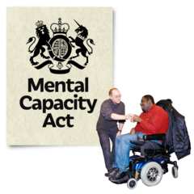 | Olwen said that there are concerns around the Mental Capacity Act (MCA) in Care Homes

 | These concerns are being managed well because the CCG, NYCC and the CQC are working well together.
Four care homes have been closed since September

The residents from these homes have moved to other care homes
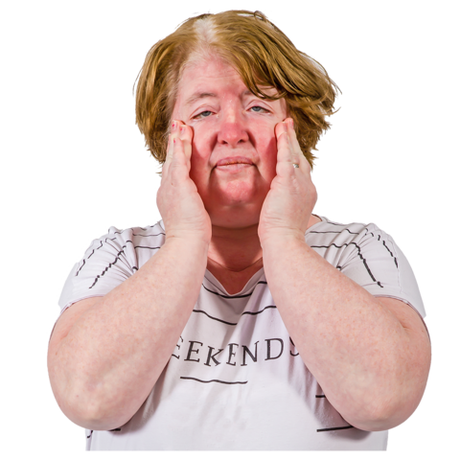 | Staff who work in care homes are feeling the impact of working through COVID-19  They are working extremely hard and this can make them feel very tired.  It can also affect their physical and mental health.
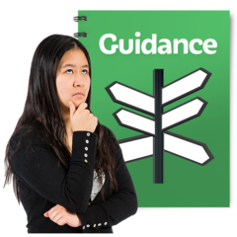 | The CCG and NYCC are working together on guidelines about the MCA and vaccinations for care home residents
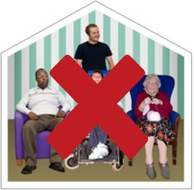 | Some care providers are refusing visits in their care settings such as care homes

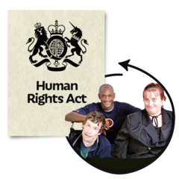 | This affects peoples Human Rights  Human Rights is about making sure that everyone has the right to live the life they want and the right to feel safe.
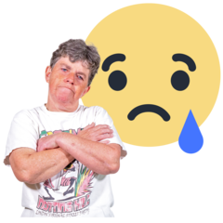 | Residents mental health and capacity have been affected during COVID-19  This is due to people moving less and not having social interactions during lockdown.
There was an action for Abi, Caroline and Ashley to discuss MCA issues caused because of lockdown.

Abi, Caroline and Ashley will also share areas of best practice.
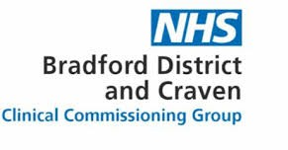 | Bradford District & Craven CCG (BDC CCG) Lyn from BDC CCG said they had seen an increase in the numbers of agency staff they are using.  A theme from using agency staff is that they are not always managed enough.  This is being challenged by the CCG.

 | Lyn said that they have also noticed a rise in mental health issues for residents and staff.
 | Tees, Esk and Wear Valleys (TEWV) Margaret said they are trying to make face to face visits a priority where possible.
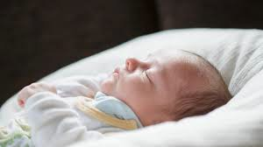 | TEWV have noted that children under the age of 1 are very vulnerable.
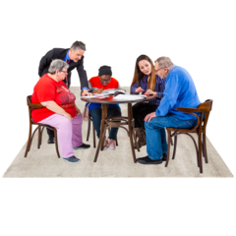 | TEWV have tried to work with whole families as fathers are suffering with their mental health too.
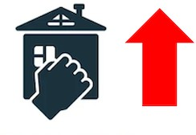 | Margaret said that an increase in domestic abuse has been noticed.
North Yorkshire Police
Annette said that the findings on the domestic abuse deep dive have not been received from the Home Office yet.

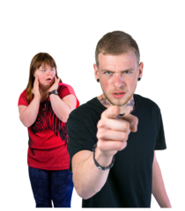 | NYP have not seen an increase in reports of domestic abuse.  They have seen a huge increase in instances of coercive and controlling behaviour.  Coercive control is an act or a pattern of acts of assault, threats, humiliation and intimidation or other abuse that is used to harm, punish, or frighten their victim.
 | The number of non-accidental injuries for children has increased a lot in North Yorkshire and the rest of the country
Annette said that NYP’s concern was households mixing indoors over the Christmas period.

Christmas time is a very busy period for the Police and so they are working on how they will respond if households do mix indoors during the restrictions.
North Yorkshire Safeguarding Children’s Partnership
James agreed with Annette’s comments.
 | James said that there had been fewer social care referrals from schools
 | Social care and Early Help have continued face to face visits to families

More families are choosing to teach their children at home.

This is because a lot of parents and families are worried about their children going to school during the pandemic.

These worries might reduce when the vaccine is rolled out.
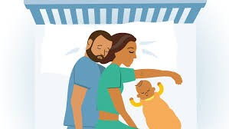 | James told the Board that some children’s deaths have been caused due to co-sleeping.  Co-sleeping is when babies or young children sleep closely to one or both parents.  Staff are sharing information and guides around safe sleeping arrangements.
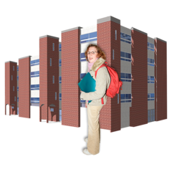 | NYSCP are working closely with Public Health and schools.  This is to minimise the impact of children being out of school because of support bubbles isolating.
Health and Adult Services (HAS)
Chris told the Board that there has been no increase in mental health or domestic abuse reports after the second lockdown
 | A deep dive reviews is being carried out into hospital admissions where people have been admitted into hospital under section 2 and section 3 of the Mental Capacity Act

The deep dive review will identify why these referrals are coming through and where they are coming from.

It will also identify the impact is on older people.
There was an action for Chris to share the findings of the Deep Dive with the board when it has been completed
Safeguarding referrals and Deprivation of Liberty Safeguards (DoLS) requests have been a little higher because of COVID-19 vaccine and testing issues.

If you are deprived of your liberty, there must be a special agreement called Deprivation of Liberty Safeguards Authorisation.

This is a legal document which says you can be stopped from doing some things to keep you safe.

If this has happened to you, it must be in your best interests.

This means that those caring for you need to think about what is best for you and make sure they involve you as much as possible in any decisions about you.

Chris told the Board that HAS continue to work with care settings regarding safeguarding.

They also work with care settings around quality issues.

These issues may not have been identified by the management of the care setting of by the Care Quality Commission (CQC)

This is because the CQC have not been carrying out visits
Chris said that there had been issues in care settings around staffing.

NYCC went in to support care settings as a lot of staff had COVID-19 and it was difficult to get agency staff to work in the care settings.
Caroline said that she heard about the staffing issue and would like to speak to the Local Enterprise Partnership (LEP) to try to re-train people to provide further staffing.
Chris said that the staffing shortages have included reablement staff in Selby and Scarborough.

Usually there would not be issues with recruiting staff in these areas

 | There was an action for Caroline to speak to Chris about recruitment to help support care settings in Selby and Scarborough.
 | Voluntary & Community Service Caroline told the Board that they provide support groups with DBS checks.
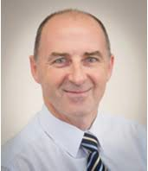 | District and Borough Councils  Tony said that the poverty and debt levels are going up.  The number of benefit applications are also going up.
 | Domestic abuse cases are starting to increase
 | Tony told the Board that they are still doing home visits in housing associations and supported living settings when residents are happy for them to do so.

Probation Service
Fran said there had been fewer cases of domestic abuse.

She said that these are expected to increase in the new year as usual.
Healthwatch
Ashley said there was an increase in people calling about safeguarding in September.

Some people are saying they do not have the support they were hoping for because of COVID-19.

They are turning to organisations like Healthwatch for support instead.
5. Report from Executive
The report from the Executive was noted
6. Local Safeguarding Partnerships (LSPs)

The report was noted and the next steps agreed.
Caroline said that the VCS will look at building closer links with the LSPs
7. Delivery Plan
Sheila said that the sub groups will review the delivery plan at their next meetings

They will suggest priority actions for 2021-22 and these will be brought to the Board in March

Priority actions are important tasks and work for the Board to carry out.
8. Risk Register
The risk register was noted

Although lots of work is still happening to lower risks, some of the risks are still high because of the current pandemic.
9. Expectations of the vaccination programme

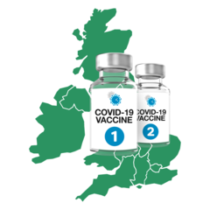 | Sue Peckitt said a small number of vaccines have been secured.
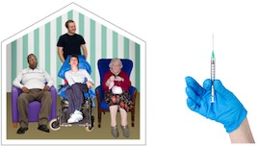 | People who are over 80 years old and staff who work in care homes will receive the vaccine first.
Sue Peckitt explained that when the vaccines have been delivered to a location they cannot be moved to another location.

This can make it difficult to roll the vaccinations out across an area.
 | Some sites can apply for more vaccines.
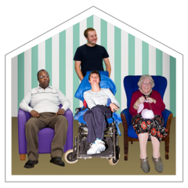 | A trial is being carried out to get vaccines into care homes across North Yorkshire

A second vaccine for COVID-19 should be approved shortly.

This means there will be two types of vaccine available to protect people against COVID-19
Some people are worried about how people are selected for the vaccine.
There are also very strict controls on the people who can administer the vaccine.
Sue Proctor thanked Sue Peckitt and all health colleagues for their hard word.
Lyn said that vaccinations will be starting in Airedale in the next two weeks
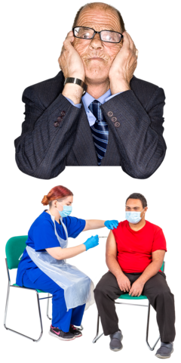

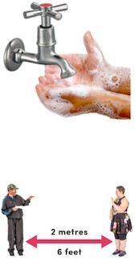 | Louise said that it will take time to get people vaccinated and that we have to try and be patient  People should still follow the rules and continue to wash their hands and social distance.
 | 10. LeDeR Update
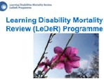 | The LeDeR position statement was noted.  Allison highlighted the following:  LeDeR have secured funding from NHS England  There have been 16 deaths this year Last year there were 5 deaths  Notifications are quite low at the moment The LeDeR steering group has asked  providers to provide assurance that learning is  taking place

 | Sue Proctor asked if partners are showing that they are learning from the LeDeR reviews and if they are changing their practices and the way they work
 | Allison said that they have been showing the changes they have made
Sheila told the Board that Joe Smith has joined the LeDeR steering group

Joe will provide feedback to the Learning and Review sub-group when lessons have been identified from LeDeR reviews
 | Cara asked Allison if the increase in reported deaths could be because people are more aware about LeDeR
 | Allison said it is probably a combination of an increase in awareness and in notifications of the spread from different professionals.
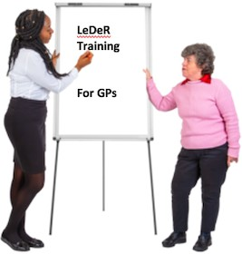 | Olwen told the Board that all North Yorkshire GPs have received training about LeDeR over the last 2 years

There was an action for Allison to share the Lessons Learned report so this can be shared with the Board

There was an action that inequality issues for adults with learning disabilities will be included on the “Lessons Learned from COVID-19” section at the Board’s development day
 | 11. Liberty Protection Safeguards (LPS)
 | The Liberty Protection Safeguards report was noted.
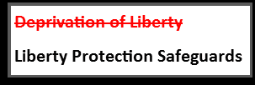 | Liberty Protection Safeguards will replace Deprivation of Liberty Safeguards (DoLS)
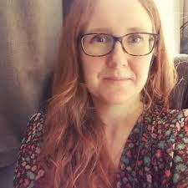 | Claire requested that a person from each agency linked into the work around planning for LPS.  The Policies, Practice Development and Legislation (PPDL) will lead on this work.
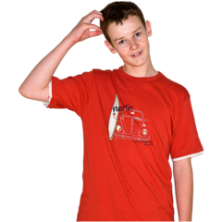 | James said that there was a lack of knowledge about DoLS in Children’s and Young Peoples Service (CYPS) and how it applies to people who are aged 16 - 18 years old.

 | Cara said she will provide colleagues in CYPS with slides about DoLS and capacity to support them with their understanding.
Chris told the Board that lots of work is being carried out around the Mental Capacity Act (MCA) and Best Interest decision making.

This will help partners and organisations to be more prepared for when LPS is implemented

Implemented means to put a new policy or law into practice that people will start to use and follow.
 | Cara told the Board that she is linking in with mental health colleagues at City of York Council on this piece of work.
 | 12. Care Market Sustainability Update
 | Abi Barron, Head of Commissioning at NYCC, presented a report on Care Market Sustainability
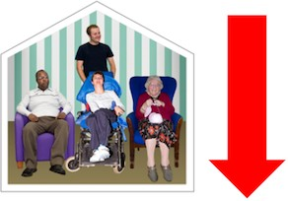 | Abi highlighted that the number of people in residential and nursing homes has gone down.  There has been an increase in the number of people who have died compared to last year

There has been an increase in the number of people who have died compared to last year
Abi’s team carried out a survey on the residential and nursing market
32 care providers think they might have challenged with their finances in the next 12-18 months
The survey helped to identify areas of risk.

This means help and support can be targeted at these areas of risk.
Financial support is in place to support the care market.

The financial support will help with Personal Protective Equipment (PPE), staffing costs and reducing risk.

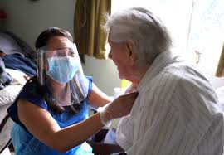 | The IFC fund supports with care home visiting and testing.
 | The PPE portal gives care providers access to the support they need.
Support is available for those providers who have gone through a long period of hardship.

Hardship is a period of time when a care provider is not making enough money for their business to survive.
The support for these providers includes a review of their financial accounts.

It also includes making a plan for them so that their business can survive.
 | Since February 2020 7 providers in North Yorkshire have asked for hardship support.

The Strategic Market Development Board (SMDB) has been set up to look at sustainability and making sure care costs are fair for the care that is on offer.

Sustainability means that care settings can be continue at a certain level for as long as they are wanted or needed
The care market has been reviewed to see how it is working during COVID-19.

Access to some domiciliary care packages can be difficult

Domiciliary care is care provided to people who still live in the own homes but need additional support with activities such as household tasks and personal care.
Abi told the Board that her team have seen fantastic examples of support during the pandemic.

Virtual support has been given in place of face- to-face support. This is due to the current restrictions.
Lots of work is going on to support hospital discharges.

There are also plans in place in the different areas in North Yorkshire to identify gaps and opportunities.
Richard thanked Abi for the work she has done.
He also praised the NHS, voluntary sector and care providers for working well together.

Caroline said she heard positive messages about the NYCC Commissioning team.

Caroline will look at the work being doing in the community.

A survey shows that 40% of people in North Yorkshire are struggling with technology and equipment such as computers.
This means it is hard for people to keep in contact.
There was an action for Abi, Caroline and Ashley to meet and share lessons learned

There was an action for Abi to provide an update to the Board every 6 months
13. Update from Domestic Abuse Deep Dive
Annette told the Board that North Yorkshire Police had not received the information from the Home Office so could not provide an update yet.

Annette will update the Board when North Yorkshire Police receive the information.
14. Current Issues
Richard thanked Sue Proctor for her leadership during this time.

 | Sue Proctor thanked everyone for their commitment and working together.
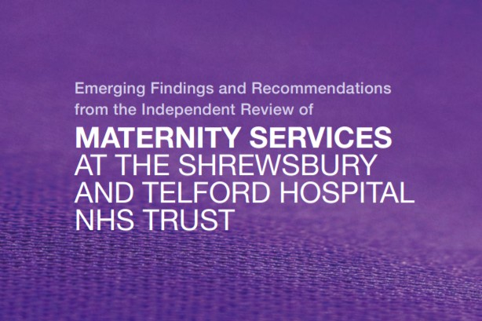 | There was an action for CCG to provide assurance to the Board that they are looking at maternity services regarding the safety and wellbeing of women and babies, following the Ockenden report.

Attendance

Independent Chair | North Yorkshire Police
Sue Proctor | Annette Anderson
North Yorkshire County Council | North Yorkshire Fire Service
Richard Webb | Hannah Oakley
Chris Jones-King
Louise Wallace | Health Trusts and CCGs
Cara Nimmo | Margaret Brett (TEWV)
Claire Webster | Lyn-Marie Waters (AWC CCG)
Abigail Barron | Christine Pearson (NY CCG)
Sheila Hall | Sue Peckitt (NY CCG)
Sarah Abram | Olwen Fisher (NY CCG)
James Parkes | Allison Brown (NY CCG)
Emma Dixon
Aurelie Redpath
 | Services
Borough and District Councils | Fran Wright (Probation)

Tony Clark (Richmondshire) | Caroline O’Neill (Community First Yorkshire)
 | Ashley Green (Healthwatch)
Apologies
Karen Agar, Rachel Bowes, Marrianne Franks, Jill Foster, Helen Hart, Elizabeth Moody, Erin Outram, Bev Proctor, Michelle Turner, Dave Winspear

