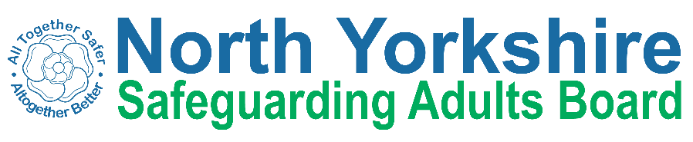

North Yorkshire Safeguarding Adults Board Full meeting minutes
 | Item
 | These are the minutes for the North Yorkshire Safeguarding Adults (NYSAB) Board meeting on Wednesday 17th March, 2021
 | This meeting took place as a video conference
This is because of coronavirus

The Government asked everyone to work from home and not have face to face meetings
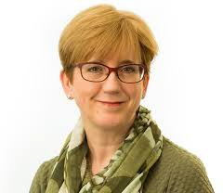 | 1. Welcome and Introductions  Sue Proctor, the Chair of the Board, welcomed everyone to the meeting.

2. Previous meeting minutes
Helen Hart asked that Airedale, Wharfedale and Craven CCG was changed to its new name of Bradford District and Craven CCG

Everyone was happy with the minutes from the previous NYSAB meeting in December
2. Action log
The action log is a list of all of the things that members of the NYSAB have promised to do
Sue Proctor asked for updates on some of the actions of the log.

Laura told the Board that she was working with Ashley Green from Healthwatch on developing surveys.

Laura will bring an update back to the Board in June
 | The Board agreed that actions 2020/05, 2020/27 and 2020/29 were completed and could be removed
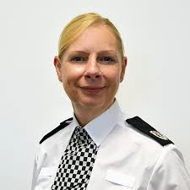 | Annette Anderson said she was still waiting for the Domestic Abuse report from the Home Office
 | Sue Proctor said the Board’s development day will now take place in either October or November 2021
Sue hopes that this will be a face-to-face session.

Planning conversations will take place in the summer ready for the development day
Action 2020/15

Rachel Bowes will provide a deadline for the final report once the reviewer has confirmed the date
Action 2020/26
Chris Jones-King said a dashboard has now been created.

This means that the information needed for this action can now be collected
4. Response and Recovery to Covid-19
Sue Proctor asked for and additional updates to what is already in the Executive report.

 | Richard Webb gave an update for North Yorkshire County Council Health and Adult Services (HAS)

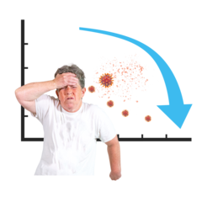 | Richard told the Board that the average rate of infection in North Yorkshire is 47 / 100 000  That means that in a group of 100 000 people, 47 people have Covid  This may seem like a small number but it can still have a big effect
Richard told the Board that the situation in care homes and other care settings has improved a lot.

This is because of people having the Covid vaccine.
 | The NHS are still working really hard and there are still patients in hospitals in North Yorkshire being treated for Covid.
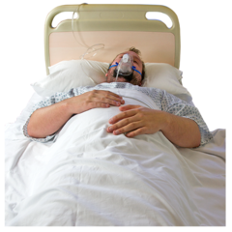 | There are 24 patients in Intensive Care Units (ICU)  There are 105 patients in hospital in total
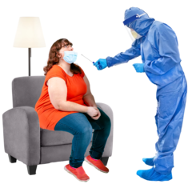 | Richard said that they haven’t had to do surge testing in North Yorkshire.  Surge testing is when there is an increase in testing in a certain area.  It involves testing people who do not have any symptoms of Covid-19.  Surge testing helps the government monitor Covid-19  It also helps them to look at ways of stopping Covid-19 spreading.  It helps the government understand the different types of Covid-19.  If people in North Yorkshire need to take part in surge testing you will be told by NYCC.
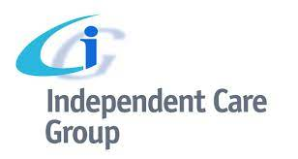 | Bev Proctor gave an update on behalf of the Independent Care Group (ICG)
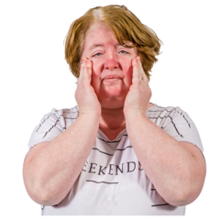 | Bev told the Board that a big issue for people working in the care sector is that they are very tired.
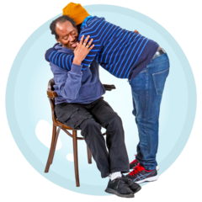 | The sector is happy that people can visit care homes again.  It has not been busy with visitors because some people who live in care homes have not had their second Covid vaccination.  People want to wait until residents have had their second vaccination before they have visitors.
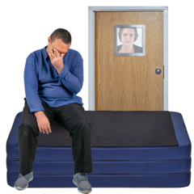 | Bev told the Board that people in care homes have been isolated because they have not been able to have visits or activities.  This is due to the restrictions.  This has had a big impact on peoples’ mental health.
 | Some good practice had been identified during these visits
 | Annette Anderson gave an update on behalf of North Yorkshire Police (NYP)
 | Annette said that the numbers of crimes being committed is starting to increase
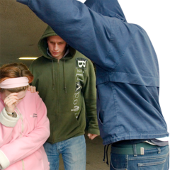 | The police are still concerned about hidden crime and so they are working with other agencies on this  Hidden crimes are crimes that people don’t always see or don’t report.  This might be because they are too scared to report it.  The police are working with other agencies to make sure people feel safe to report crimes and so they are not scared.
 | Suzanne Lamb gave an update on behalf of Harrogate and District Foundation Trust (HDFT)
 | The number of patients with Covid in hospitals has started to go down.
 | Treatments and operations for things that are not an emergency have started again.

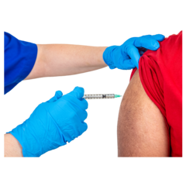 | Nearly all of the staff have received their first Covid vaccine.  The second vaccines will start on 16th March.
Suzanne told the Board that staff are exhausted and this affects how the staff are feeling.

There are also issues with getting staff and also keeping staff.

A recruitment action plan is now in place to help with this problem.
HDFT expect an increase in the number of children safeguarding concerns.

This is due to the huge increase in domestic abuse.
 | Joanne Gamble gave an update on behalf of South Tees Hospitals Foundation Trust
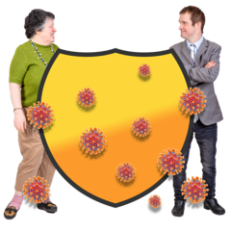 | Some staff were away from work because they had to shield due to Covid.  Staff at the Trust are very tired and exhausted.
 | Joanne told the Board that there are low numbers of people with Covid in the hospital
35,000 people have been given the 1st dose of the Covid vaccine

9,000 people have been given the 2nd dose of the Covid vaccine.
The Trust have some new safeguarding adult concerns relating to discharge.

Discharge is when people are sent back home from hospital.
 | They are doing a piece of work around this.
 | Helen Hart gave an update on behalf of Bradford District and Craven CCG
 | There are now 2 domestic violence advocates at each hospital in Bradford District and Craven CCG
 | This is a part of a 12-month trial to see how this will work.
ACTION
Helen will bring an update on this trial to the Board in September.
 | Sue Peckitt gave an update on behalf of North Yorkshire CCG
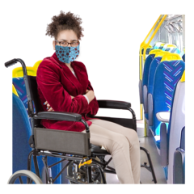 | Sue explained to the Board that some people have had to travel out of their area to get their Covid vaccine.  This has been reported.
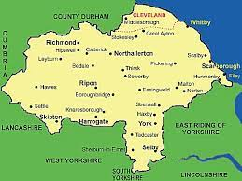 | Some work is being done to help people with learning disabilities and / or autism access places local to them to get their Covid vaccine.  Work is also being done to create some sensory spaces.
The number of people in hospital with Covid has gone down.

But there has been an increase in the number of younger people who are in hospital because of Covid.
Support is being offered to staff who are suffering with anxiety, feeling worried or suffering with vicarious trauma.

Because of the different ways people have had to work and change the way they live due to Covid, this has had a big impact on people.

The restrictions mean we haven’t seen friends or family and for people who work in places like hospitals and care homes, they have seen some really upsetting things almost every day.

It can lead to physical, mental and emotional issues that have a big impact on people and this is called vicarious trauma

Olwen told that Board that the Care Quality Commission. (CQC) are doing a review about people with learning disabilities.

Olwen said this review was set up very quickly.

Safeguarding concerns for people with learning disabilities have increased.

Support has been offered to people
 | Olwen said that the report from the review is due to be published in May.
Sue Peckitt said it was important that the CQC interviewed the right people as part of this review.

By interviewing the right people that means the right lessons learnt will be identified.
 | Claire Byers gave an update on behalf of Tees, Esk and Wear Valleys Foundation Trust (TEWV)
 | Claire said that the work to give out Covid vaccinations are going well
 | Face-to-face appointments are taking place again
 | Most staff and vulnerable patients have had their first dose of the Covid vaccine
Claire will share an update from TEWV with the Board about their COVID-19 contingency arrangements.

Contingency arrangements are is where you make a plan in case something different or unexpected happens to what you had originally planned for.

Safeguarding concerns have remained consistent

This means that safeguarding concerns from are the same as this time last year
There are no specific themes or trends with the safeguarding concerns.

Some new people have been accessing crisis services.
 | James Parkes gave an update on behalf of the North Yorkshire Safeguarding Children Partnership (NYSCP)

5. Report from Executive
The report from the Executive was noted

6. Delivery Plan
Sue Proctor presented the SAB risk register to everyone.
A delivery plan tells everyone what goals the NYSAB wants to achieve over a year.

Each risk is given a colour
Red is for an action that has a lot of risk and needs a lot of work
Amber is for an action that doesn’t have a lot of risk but still needs work
Green is for an action that has no risk.
Green risks can sometimes be taken off the register.
 | The Executive recommended that the NYSAB strategic priorities are rolled over to 2021 / 2022
5. Risk Register
The risk register was noted.
A risk register lists all of the things that could cause problems for the NYSAB when they work through their delivery plan
8. Use of restraint in Care Home settings

Cara Nimmo, Head of Practice at NYCC, gave an update to the Board.
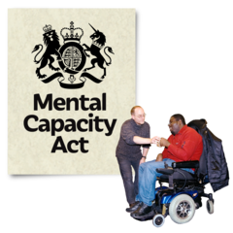  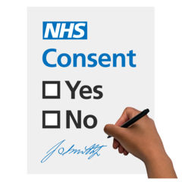 | A small working group looked at how to support testing and isolation in care home settings for people lacking capacity.  Mental capacity means being able to make your own decisions.  When people lack capacity that means they can’t make decisions for themselves.  Sometimes they need help from people who will make decisions in their best interest.  Cara told the Board that the group also looked at ho to support best interest decisions for people at the start of the Covid pandemic.  This same work was carried out around the Covid vaccinations.
 | During Covid there were less safeguarding concerns being reported from care home settings.
Some webinars were offered to discuss the use of restraint for people lacking mental capacity or those with learning disabilities

A restraint is when someone uses forces or threatens to use force a person to do something they don’t want to.

It can also mean restricting a person’s liberty whether or not they are resisting.

No concerns around restraint were identified through safeguarding concerns.

None of the issues identified by the Quality Improvement team were related to the use of restraint.
 | Although the use of restraint in care homes was a concern at one point, it is no longer an area of concern.
9. Voluntary and Community Sector (VCS) Resilience Survey
The report was noted and Caroline O’Neill highlighted the following:

 | A further survey will be done in May / June
Work is starting to build as venues get ready to reopen.

Village halls are due to reopen in May
 | There are issues about how many people can go into venues to attend events.
Caroline told the Board that there had been a drop in the number of volunteers.

Training is being offered to recruit new volunteers

The good news is that more young people are applying to be volunteers
A lot of joint working, particularly youth work, has started again.

It is important to have these relationships.
 | The full VCS survey can be found here: https://communityfirstyorkshire.org.uk/what-we-do/representation/results-of-november-2020-pandemic-impact-survey-unveiled/
 | 10. Improving outcomes for those with Complex Needs
Sue Peckitt told the Board that a new scheme was developed 18 months ago.

This scheme is to share good practice and improve outcomes for people with complex needs.
 | As part of this work, Scarborough Borough Council and NYCC have looked at including a full time mental health worker and a part time psychologist.
 | The council have provided support around rough sleeping with 8 new units of accommodation.
There has been a lot of partnership work between Horizons and council staff.

This has been done to support people through drug and alcohol recovery.
Partnership working has been excellent during Covid.

A longer term plan is needed to build on multi-agency working.
Action
Sue Peckitt to provide a detailed presentation to the Board on September 2021.

11. LeDeR Position Statement
The position statement was noted.
Alison Brown highlighted the following:
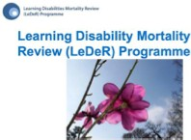 | LeDeR reviews are continuing  LeDer is a Learning Disability Mortality Review
The platform for LeDeR reviews is changing.

The one which is used now will close and a new one put in its place.
 | All reviews and the data from the reviews will be completed
 | The LeDeR group are undertaking schemes to help people such as weight management and annual health checks.
 | The LeDeR policy will be presented in autumn.
Alison told the Board that partners continue to share good practice.

Partners also continue to challenge if something is wrong.
 | A regional LeDeR group is being put together to look more closely at the learning from reviews.
12. Safeguarding Week 2021
Laura presented the Safeguarding Week report to the Board

She told the Board that the campaign would be for professionals and the public.

Because of the restricts the campaign will take place online from 21st – 25th June.

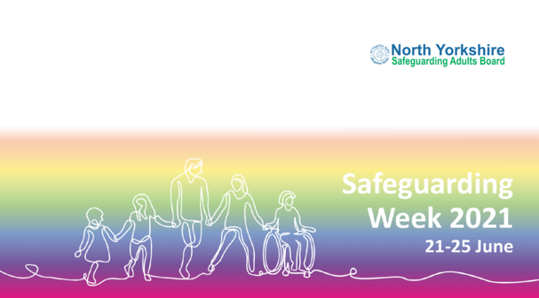 | Laura shared the themes and topics that would be highlighted during Safeguarding Week.
Laura said that she would include the good work partners and communities have done to keep people safe.

People have been very kind to each other and communities have pulled together and it is important to share this.

13. Safeguarding Adult Reviews (SAR) Thematic Analysis Brief

The report was noted
Thematic analysis means looking at information and identifying themes and trends.

For this thematic analysis Joe Smith looked at the recommendations for the SARs the NYSAB had carried out.

 | Joe presented the key points from the brief.
 | This review should be used to encourage partners to work together and have a ‘joined-up’ approach to working.
Sue Proctor highlighted that the following needs to be done:

Recommendations 3 & 8 need to be dealt with by the SAB through the Learning and Review sub-group

Recommendations 1,2,4,5 & 7
Partners need to give a statement to the Board to say have they have carried out the recommendations within their organisations.

This needs to be done in the next 6 months.

Recommendations 4 & 6
Supported housing need to ensure that medication are eligibility are included in the terms of reference.
ACTION

There was an action for Sheila to share this report with other Safeguarding Adult Boards as an example of best practice work.
14. “Anne” SAR Action Plan

The action plan was noted and agreed
 | Sue Proctor told the Board that she, Chris Jones-King, Karen Agar and Laura had met with Anne’s family at the beginning of March.
 | Since that meeting the review of the SAR policy will include how families who want to engage in the SAR process can.
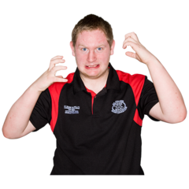 | For all SARs the families who want to be involved with the process will have one person who will contact them and keep them updated.  This person will be from the NYSAB team and will be a ‘single point of contact’.  This will make sure f  amilies have don’t have to go to lots of different people for information.  This can be very confusing and sometimes frustrating.
 | Anne’s family will be contacted in 6 months-time to update them on the progress of the action plan.
15. Current issues

The Board had no further issues to discuss.

Independent Chair | North Yorkshire Police
Sue Proctor | Annette Anderson
North Yorkshire County Council | North Yorkshire Fire Service
Chris Jones-King | Dave Winspear
Louise Wallace
Sarah Abram | Health Trusts and CCGs
Laura Watson | Claire Byers (TEWV)
James Parkes | Helen Hart (AWC CCG)
Joseph Smith | Christine Pearson (NY CCG)
Cara Nimmo | Sue Peckitt (NY CCG)
Services | Olwen Fisher (NY CCG)
Fran Wright (Probation) | Suzanne Lamb (HDFT)
Bev Proctor (ICG) | Joanne Gamble (South Tees FT)
Caroline O’Neill (Community First Yorkshire) | Borough and District Councils
 | Tony Clark (Richmondshire)
Apologies
Sheila Hall, Erin Outram, Emma Dixon, Karen Agar, Ruth Andrews, Rachel Bowes, Marrianne Franks, Michelle Turner, Fran Wright

