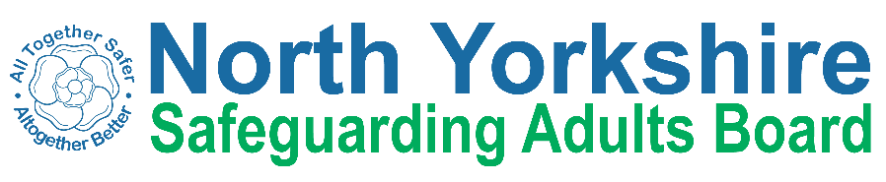

North Yorkshire Safeguarding Adults Board Full meeting minutes

 | Item
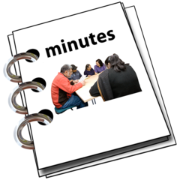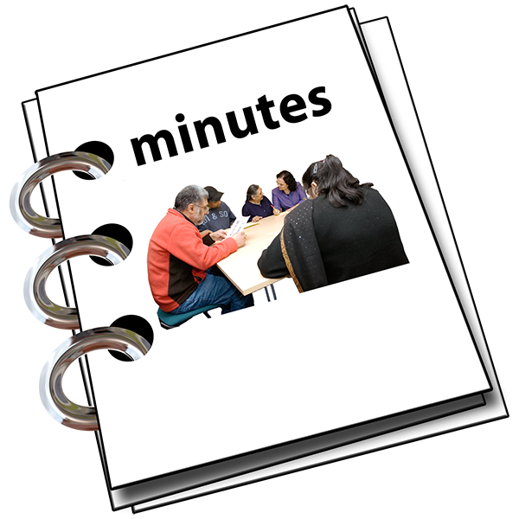 | These are the minutes for the North Yorkshire Safeguarding Adults (NYSAB) Board meeting on Wednesday 18th March, 2020
 | This meeting took place over the telephone
This is because of coronavirus

The Government asked everyone to work from home and not have face to face meetings

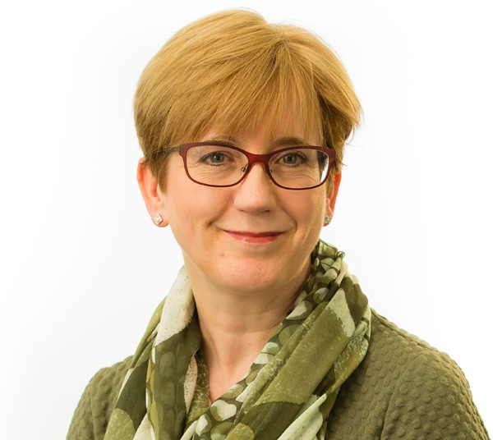 | 1. Welcome and Introductions Sue Proctor, the Chair of the Board, welcomed everyone to the meeting.
 | 2. Previous meeting minutes Everyone was happy with the minutes from the previous NYSAB meeting in December
3. Action Log
Sue told the NYSAB that the action log had been checked at the Executive meeting in February

The NYSAB were happy with this

The action log is a list of all of the things that members of the NYSAB have promised to do.

4. Report from the Executive
Sue told the NYSAB that the report from the Executive included everything that was discussed at the meeting in February.
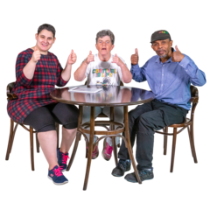 | The NYSAB were happy with what was in the report.
 | Sue told them that they had to decide if they were happy for the Communication and Engagement group to stop meeting.
 | Instead of a meeting the NYSAB with the Safeguarding Children Partnership (SCP) and Community Safety Partnership (CSP) would make a Communications and Engagement strategy.

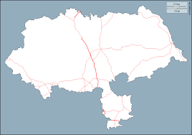 | This would tell members of the Board and Partnerships how they were communicating and engaging with the people of North Yorkshire
 | There would also be a calendar of events to go with the strategy
 | This would list all of the campaigns that the NYSAB, SCP and CSP would work on together to raise awareness
 | The members of the NYSAB were happy with this

5. Delivery Plan
The NYSAB members looked at the delivery plan
A delivery plan tells everyone what goals the NYSAB wants to achieve over a year

We also measure what we are doing so we can see how close we are to reaching our goal

We use a colour system to mark each action
- Red if they haven’t been started
- Amber if they’ve been started but not completed
- Green if they’ve been completed

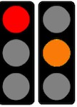 | Everyone agreed that the actions that were marked amber and red would be carried forward  These will be included in the delivery plan for 2020/21
 | Sheila said that because of coronavirus some of the goals might take longer to achieve
 | Everyone agreed with this
 | 6. Strategic Priorities 2020/21
 | Sue said that because of the coronavirus the NYSAB should think about what their priorities should be in 2020/21

 | The NYSAB agreed that they would talk about the priorities at the Executive meeting in May
 | They would also talk about it at the next Board meeting in June
 | This would give them time to see what was happening with the coronavirus so they could make some decisions
 | There was an action for Sue to meet with the Chairs of the NYSAB sub groups
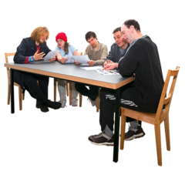 | She would talk to them about the priorities and the delivery plan
 | 7. SAB Development Day Update

Erin presented the report for the NYSAB Development Day that was held in 2019
Sue asked everyone if there was anything in the report that they would like to include in the delivery plan
Karen asked that the NYSAB uses easy read for any guides and annual reports they share
Sue told Karen that the 2018/19 annual report had an easy read summary
Sue also told Karen that the NYSAB had produced easy read Keeping Safe Guides with the KeyRing self Advocates & Inclusion North
Sue talked about the Transforming Care Partnership that Rachel Bowes spoke about at the Development Day
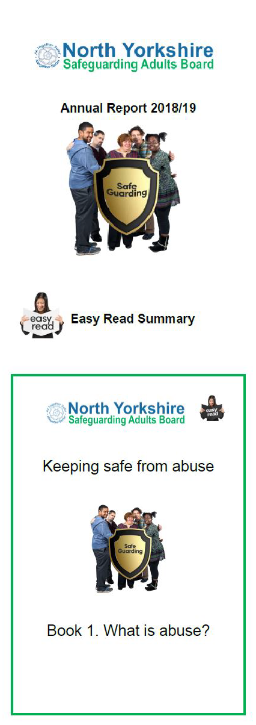

The Transforming Care Partnership (TCP) is a group made up of people from Health and Local authorities.

They work with people with a learning disability, autism or both and their families.

They are working together to change services to make a real diﬀerence to the lives of local people.

This includes making community services better so people can live near their family and friends.

It’s also to make sure that the right staﬀ with the right skills are supporting people.
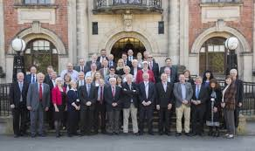 | Sue said that the Councillors in the Districts and Borough Councils of North Yorkshire should be told all about the TCP
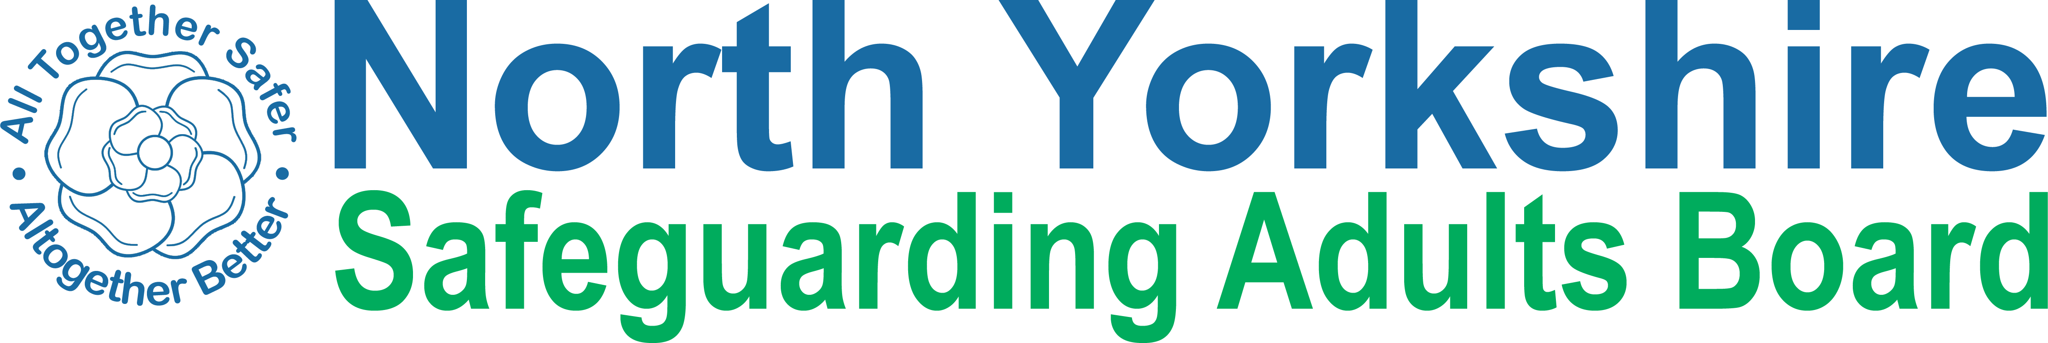 | Erin told the NYSAB that Laura would be reviewing the NYSAB website and all of the information we share with people

Laura will be engaging with people who use our services, professionals, the community and volunteers to see what information they’d like
This will now happen after coronavirus
8. Risk Register
Sheila presented the SAB risk register to everyone

A risk register lists all of the things that could cause problems for the NYSAB when they work through their delivery plan

Each risk is given a colour

Red is for an action that has a lot of risk and needs a lot of work

Amber is for an action that doesn’t have a lot of risk but still needs work

Green is for an action that has no risk. Green risks can sometimes be taken oﬀ the register.
Sheila asked the NYSAB to look at Risk 5 on the register.

This risk was about people from the SAB organisations not attending the Local Safeguarding Partnership meetings (LSPs)
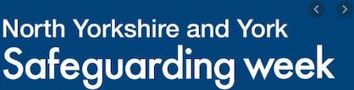 | Because of this it has been diﬃcult to plan for Safeguarding week which is a main job for the LSPs

Karen is the Chair of the Selby LSP. She said that a problem for her group is that they would like to focus on issues for Selby

But they have to focus on issues for the whole of North Yorkshire and that was a lot of work
Sue suggested that Sheila, James and Odette of the CSP should review the LSPs to see how they could improve
Sheila told everyone that the next LSP meetings have been cancelled because of coronavirus
Safeguarding week will now take place online.

Messages and information will be shared on the NYSAB website and social media

 | There was an action for Sheila, James and Odette to have a meeting to talk about the LSPs
 | 9. Improving outcomes for people with complex needs
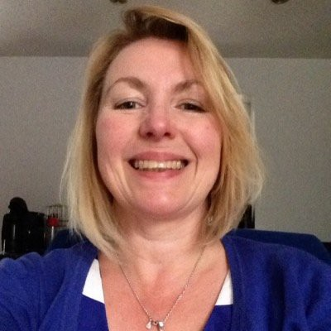 | Sue Peckitt who is the Chief Nurse for the three Clinical Commissioning Groups (CCGs) could not come to the meeting
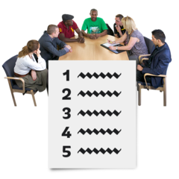 | Sue Proctor asked Laura to add this item to the NYSAB meeting agenda for September for Sue Peckitt to present then
 | 10. LeDeR Annual Report
 | Olwen Fisher from Scarborough and Ryedale CCG presented the LeDer Annual Report
 | A LeDer Annual Report is a Learning Disability Mortality Review

 | Olwen told the NYSAB that the annual report will be updated in April
 | It will have changed so Sue asked Olwen to present the updated report at the NYSAB in September
 | Sue asked Laura to add this to the NYSAB meeting agenda for September
 | 11. DS Lessons Learned Update
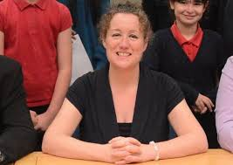 | Louise Wallace from North Yorkshire County Council gave an update on the DS Lessons Learned Update

DS is a person and we can only use their initials because the information is confidential
Louise told everyone that the Learning and Review (LAR) sub- group had made an action plan from the suggestions in the Lessons Learned Report
The LAR had found this diﬃcult at first as there were a lot of actions
But now the LAR have come up with a way to group the actions together

This will make them easy to work through
Olwen told everyone that it was a really diﬃcult job but Louise did a very good job of leading the group

Louise told the NYSAB that this action plan will be completed for the NYSAB meeting in June
Sue asked for this to be an action that Louise brings the complete action plan back to the NYSAB in June.
12. Information Sharing Agreement
Erin told the NYSAB that we are still waiting for some of the NYSAB members organisations to sign the Information Sharing Agreement
An information sharing agreement is a contract between organisations so that they can share information with each other.
There was an action for all of the organisations to sign the Information Sharing Agreement by March 25th

 | 13. COVID-19 Update
 | Sue asked everyone what safeguarding issues they were worried about because of coronavirus
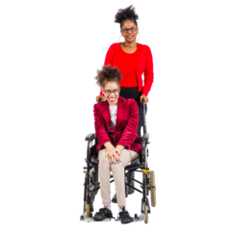 | Matt asked what the NYSAB was doing to support Carers during coronavirus?  Sheila said that there was a lot of work going on in the community to support Carers
 | Katie told everyone that NYCC’s Stronger Communities team is working on supporting isolated households

Sue told the NYSAB about scamming problems around the country

Lots had been posted on Twitter about people trying to take money oﬀ vulnerable people by pretending to help them and be kind
Sheila told everyone that she had spoken to Ruth Andrews from Trading Standards about the scams
Ruth’s team are putting together some guides and advice about scamming
These will be shared on the NYSAB website so people know how to keep safe

Laura is putting lots of messages on the NYSAB Twitter about how to keep safe during coronavirus
Everyone agreed it would be a good idea to have a page of information on the NYSAB website too
Sue asked Louise what NYCC were doing about coronavirus
Louise told everyone that NYCC were having a lot of telephone calls everyday making plans and talking about social care staﬀ
This is to make sure they have enough staﬀ to look after people during coronavirus

Louise also told everyone that the North Yorkshire Public Health team are working closely with Public Health England
They have discussions about making sure that Personal Protective Equipment (PPE) is available
Louise also told the NYSAB that NYCC are working closely with their colleagues in Health to make plans to deal with coronavirus
There was an action for Nigel to share the Healthwatch coronavirus link with Laura so she can put it on the NYSAB website
Laura is going to make a page on the NYSAB website for coronavirus information and guides

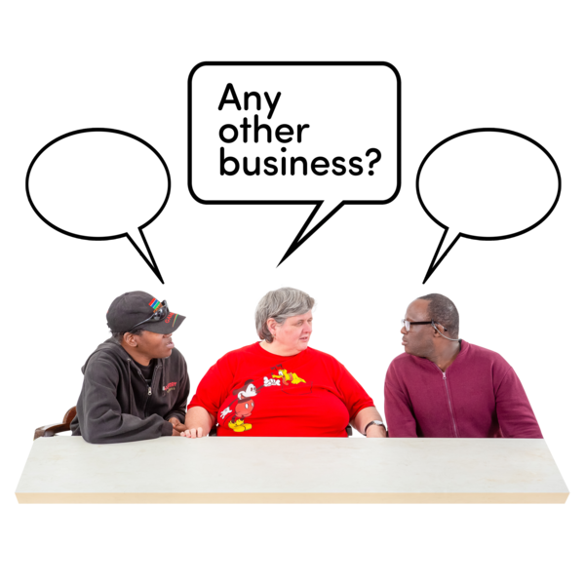 | 14. Any other business  Sue asked everyone to think about having the Care Act as the theme for their development day this year.
 | Sue thanked everyone for coming and told them to take care.

People in attendance

Independent Chair | North Yorkshire Police
Sue Proctor | Annette Anderson
North Yorkshire County Council | North Yorkshire Fire Service
Louise Wallace | Dave Winspear
Katie Needham
Sheila Hall | Health Trusts and CCGs

Erin Outram | Karen Agar (TEWV)
Laura Watson | Matt O’Connor (AWC CCG)
James Parkes | Olwen Fisher (SR CCG)
Services
Fran Wright (Probation)
Nigel Ayre (Healthwatch)
Apologies
Ruth Andrews, Rachel Bowes, Tony Clark, Emma Dixon, Jill Foster, Marrianne Franks, Jacqui Hourigan, Chris Jones-King, Elizabeth Moody, Caroline O’Neill, Christine Pearson, Sue Peckitt, Beverley Proctor, Lincoln Sargeant, Michelle Turner, Richard Webb

