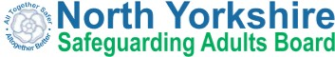

Annual Report 2018/19
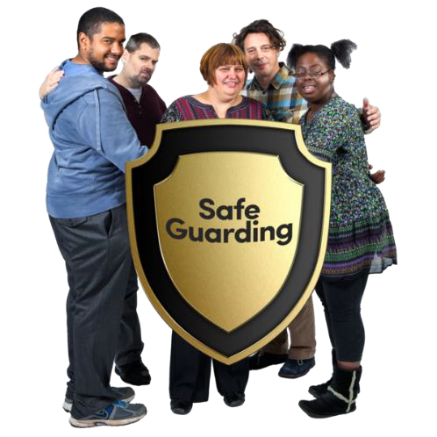

Easy Read Summary

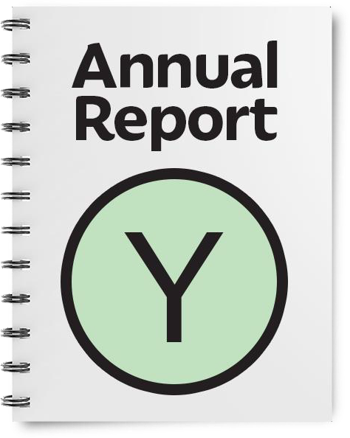
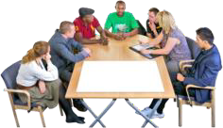

This is the easy read summary of the annual report of the North Yorkshire Safeguarding Adults Board
This annual report tells you about the work that the North Yorkshire Safeguarding Adults Board has done between April 2018 – March 2019
The North Yorkshire Safeguarding Adults Board works with other organisations in North Yorkshire to
make sure that adults with care and support needs are kept safe

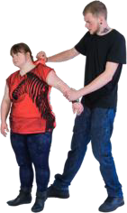
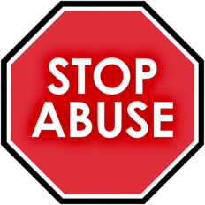
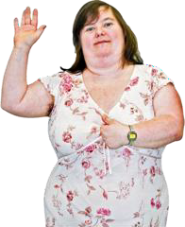
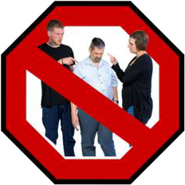
Abuse is when someone does or says things that frighten you or cause you harm

Neglect is when your care and support needs are not being met
Safeguarding means protecting people from abuse and neglect
People should be as independent as possible and make choices about how they want to live and still be safeguarded
Abuse and neglect are wrong

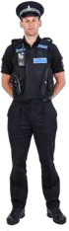
The North Yorkshire Safeguarding Adults Board is made up of lots of different organisations including the Police

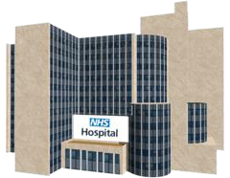
Hospitals

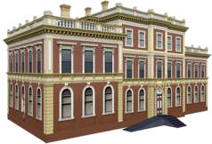
North Yorkshire County Council

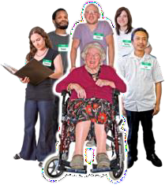
Health and care providers

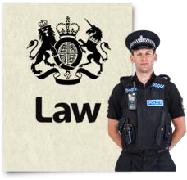
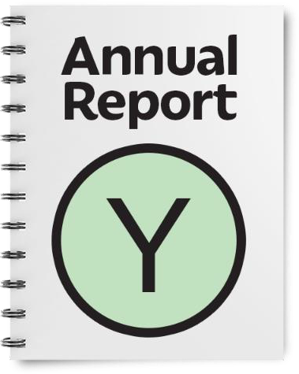
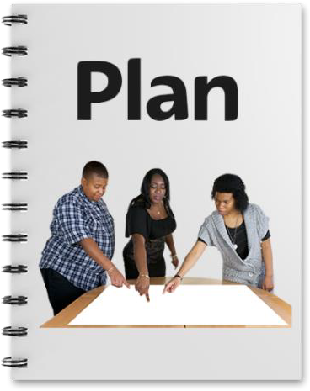

The Board also has legal responsibilities – things they must do
One of these things is to write a report every year about what it has done. This is called an Annual Report.
The Board must also have a plan for what it will do for the next year to
keep people safe.

All organisations have a duty to work together to keep people safe from abuse
We also want to make sure that adults who are abused or neglected are asked how they want to be kept safe in the future. This is called ‘Making Safeguarding Personal’.
We want all of our partners to work this way

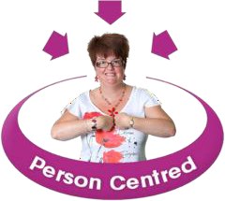
What the Board has done in 2018/19

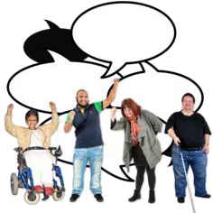
Talking to people about the Mental Capacity Act

In 2018 we spoke to lots of people about their experience of the Mental Capacity Act

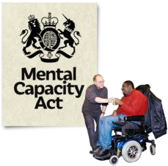
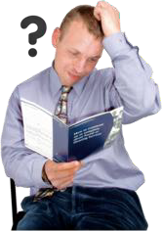

The Mental Capacity Act is a law that protects people who may not be able to make all or some decisions for themselves.
Most people told us the Mental Capacity Act was confusing
No one we spoke to knew where to get support.

Half of the people we spoke to didn’t know their rights

What are we doing about the things people told us?
We are working with Self Advocacy groups to make easy read guides to help people understand the Mental Capacity Act and Safeguarding
We have updated our training so people who work in social care know more about the Mental Capacity Act and how to support people with making decisions
We have put helpful guides and
videos to the Mental Capacity Act on our website
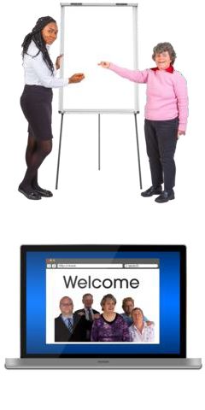

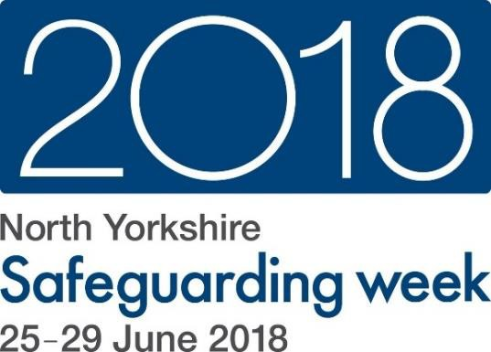
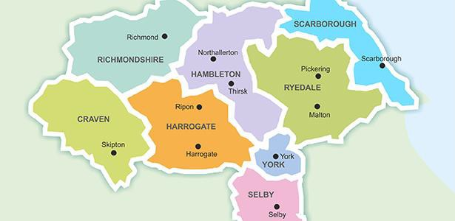
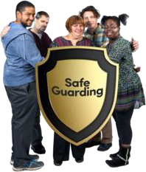
Safeguarding Week 2018

Safeguarding Week took place in June 2018
Safeguarding week raises awareness to help people keep themselves and other people safe from abuse and neglect
Lots of events went on across North Yorkshire

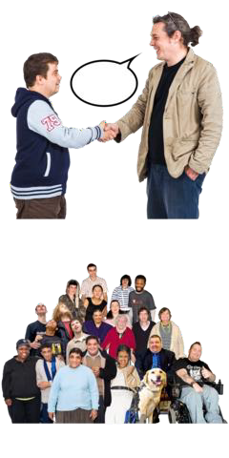
People from the local authority, health, police and many others gave advice on what you should do if you or someone you know has been abused or neglected
Lots of people attended the different events and said that
they were very useful and there was a lot of helpful information

What else did the North Yorkshire Safeguarding Adults Board do last year?

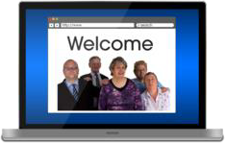
We have created a new website full of information and advice on how to keep safe www.safeguardingadults.co.uk

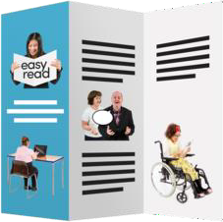
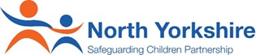
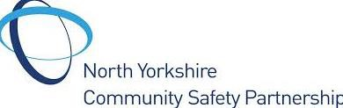

We have a One Minute Guide about the Board that has been shared with partners and organisations
We have worked really closely with the North Yorkshire
Safeguarding Children’s Board and Community Safety Partnership
Working together means we can share help and information with each other to help keep people
safer in their areas

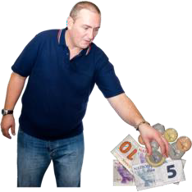
In 2019/20 we will:
We have also worked with Trading Standards to help understand how we keep people safe from fraud, online crime and scams that can lead to financial abuse

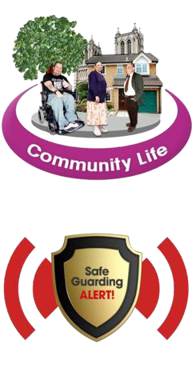
Work closely with communities in North Yorkshire to keep people safe
We will have a new way to make sure people are safe when they make a safeguarding alert.

We will listen to you and listen to what you want.

It will put the person at the very centre.

We will create more easy read guides with self-advocates to help people understand how to keep safe

How to contact us about this report

North Yorkshire County Council, County Hall, Northallerton DL7 8DD

Email: nysab@northyorks.gov.uk www.safeguardingadults.co.uk
This easy read summary was made using Photosymbols

Copyright © 2019 North Yorkshire Safeguarding Adults Board

