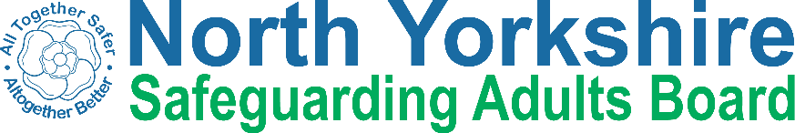

North Yorkshire Safeguarding Adults Board Full meeting minutes

Item
These are the minutes for the North Yorkshire Safeguarding Adults (NYSAB) Board meeting on Wednesday 17th June, 2020
This meeting took place as a video conference
This is because of coronavirus (sometimes called Covid-19)

The Government asked everyone to work
from home and not have face to face meetings

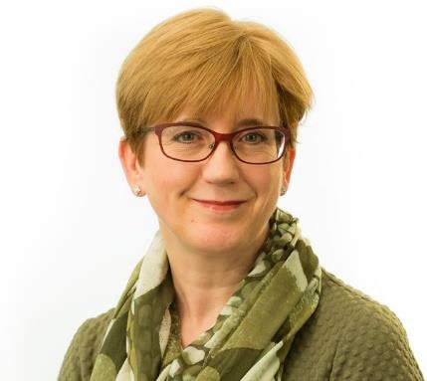 | 1. Welcome and Introductions Sue Proctor, the Chair of the Board, welcomed everyone to the meeting.
 | 2. Previous meeting minutes Everyone was happy with the minutes from the previous NYSAB meeting in March
3. Action Log
The action log is a list of all of the things that members of the NYSAB have promised to do.

Sue asked that we could move the completed actions to the bottom of the log so it was easier to see what had been done.

Sue asked Laura to send the information sharing agreement to partners who had not signed it yet
4. Response and Recovery to Covid-19
Sue asked the partners to give an update on what their organisations are doing about coronavirus

Chris Jones-King from North Yorkshire County Council (NYCC) told everyone that there has been an increase in mental health assessments

A mental health assessment is a meeting to find out what help and support a person needs with their mental health
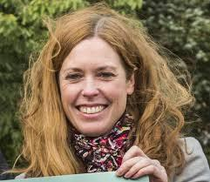 | Katie Needham provided an update on behalf of Public Health
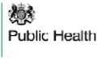 | Public Health are communicating with services to let them know what help and support it available.
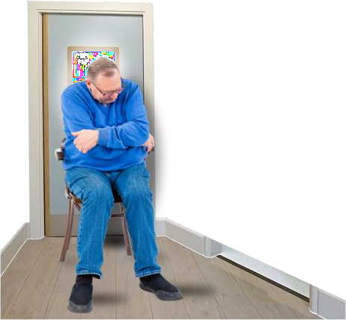 | Some people are struggling without having contact with other people

 | Louise added that there is a lot of other work going on to make sure Public Health services are working.
Richard Webb from Health and Adult Services (HAS) at NYCC asked the Board to think about inequalities that we have been made aware of during coronavirus.

Some examples of inequalities are:

People being treated unfairly because of their race or religion or disability

or

Not having access to things like care and medicine because of where they live
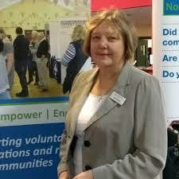 | Caroline O’Neill from Community First Yorkshire told the Board about the main findings of a survey North Yorkshire voluntary groups and charities

 | The survey asked voluntary groups and charities how coronavirus had affected their organisations.
 | The main points and summary reports can be found at https:// communityfirstyorkshire.org.uk/ pandemic-impact-survey-shows-fears- for-charities-future
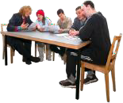 | Caroline also told the Board that meetings are being held with the local authority, NHS and other partners
 | These meetings are being held to put a next steps plan together using the feedback from the survey

Sue Peckitt, from the North Yorkshire Clinical Commissioning Group
(CCG) ,provided an update on behalf of the CCGs.
 | There has been a drop in people reporting safeguarding
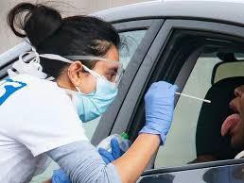 | People have been visiting testing drive in centres to tell people they are being abused or need help.  A testing drive in centre is a place where people can go in their car to be tested to see if they have coronavirus
 | Olwen Fisher, also from North Yorkshire CCG, told the Board that there is lots information to help people in North Yorkshire
 | Before, people were given a phone number to a national helpline for help and support
 | Now they are given contact information for services in North Yorkshire to get local support

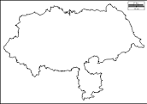 | We can now see how many safeguarding referrals were made for people in North Yorkshire
 | Sue Peckitt told the Board that there had been a lot of concerns about care homes.
 | The CCG safeguarding team have been working with NYCC Quality Improvement team to look into these concerns
 | Matt O’Connor provided an update for Airedale, Wharfedale and Craven CCG
 | He told the Board that they have seen similar issues as other health partners across the NHS.
People have been complaining about Personal Protective Equipment (PPE).

The complaints have been about people not using PPE when they should or not using it properly
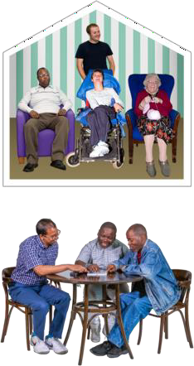

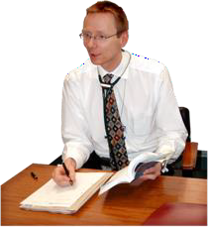 | There have also been complaints about when GPs (General Practitioners) visit people
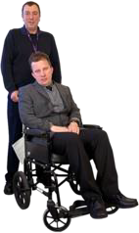 | There have been complaints about people leaving hospital to go back home or into a care setting
 | Lots of the complaints seem to be around coronavirus
Matt told the SAB that there had been some issues around DNA CPR

DNA CPR means Do Not Attempt Cardiopulmonary Resuscitation an is a written agreement to say a person does not want to be helped if their heart stops beating.
This is a decision made together with the doctor, patient and their family.

 | Lots of work is going on to help GPs with these issues including putting together some Top Tips about DNA CPR to share with people
 | The GPs have also been supported with the way they communicate with people and what they are communicating with them about DNA CPR
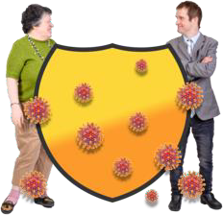 | Matt said that there have been concerns around shielding and isolation as the government rules keep changing  Some care homes are not always following the rules around shielding and isolation and Matt pointed out that the Board needs to be aware of this.
 | Karen Agar told everyone that Tees Esk and Wear Valleys (TEWV) had no particular safeguarding issues
 | Jill Foster from Harrogate District Foundation Trust (HDFT) told the SAB that there had been less safeguarding referrals coming into the service.

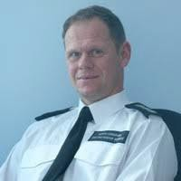 | Dave Winspear reported the North Yorkshire Fire & Rescue Service (NYFRS) had less calls coming into his team
 | NYFRS are working closely with NYCC to help people in North Yorkshire who are on the shielding list
 | People have told the teams from NYFRS that they feel lonely and isolated from other people
 | Dave said that NYFRS would like more information about how we can use virtual and digital technology to stay in touch with people

Laura contacted Dave after the meeting to give him Robert Ling’s contact details

Robert is the Assistant Director for Technology and Change at NYCC and told Laura he would be happy to help Dave
 | Dave also told the Board that NYFRS were telling people about where to get help for domestic abuse
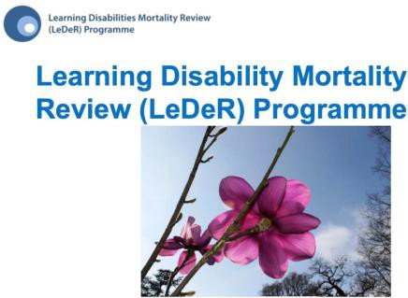 | Olwen gave an update of the recent LeDeR cases  LeDer is a Learning Disability Mortality Review
This time last year there were 3.5 deaths

For the same time this year there have been 10.5 deaths
Since March 1st 2020 there have been 25 LeDeR cases

11 of these cases are coronavirus related

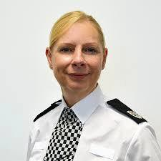 | Annette Anderson from North Yorkshire Police (NYP) gave an update to the SAB
 | Even though the Police thought that there would be a lot more people needing their services this hasn’t happened
NYP have been working with partners to identify themes and trends

Themes and trends are when something happens at certain times or because of certain things, certain people or certain places

These are usually the same things

By identifying themes and trends it helps the police to plan to respond or plan to stop something from happening

It can also help the police warn people what signs to look out for to keep safe
NYP is one of five police forces in the England that is working with the Home Office to look into domestic abuse during coronavirus

This is called a ‘deep dive’

Annette will report back from the deep dive to the SAB at the beginning of August
Annette will share the feedback from the deep dive and any recommendations and data
Sue updated partners that at the Executive meeting in May it was agreed that this years’ SAB Development Day
would look at how and what we can learn from coronavirus.
Before the development day Sue asked that the SAB has a discussion at the September Board meeting
Sue asked for a representative from a Public Health to lead this discussion around inequalities such as:

Health inequalities; Financial inequalities and:
Inequalities in the voluntary and; community sector

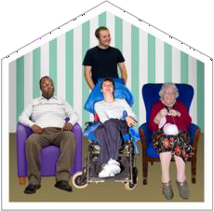 | The discussion will also include talking about the risks for the Care Home sector
 | The discussion should also look at other risks that may come up for the SAB because of coronavirus
 | The feedback from this discussion can then be shared at the Development Day in November
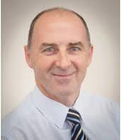 | Tony Clark gave an update for Richmondshire District Council.
 | Tony talked about housing in Richmonshire
 | People did not want the housing wardens going into their homes because they were worried about coronavirus

 | They also didn’t want tradespeople like electricians or plumber going into their house to do repairs
 | Tony said that has now changed because people miss seeing other people face to face and they want to spend time with others
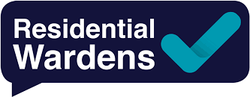 | In the sheltered housing schemes wardens are engaging with people in those houses
 | Lockdown has made many people feel lonely and isolated
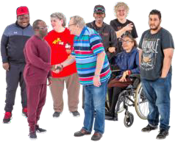 | Being isolated because of Coronavirus has shown just how important it is to engage with people all of the time

LSP Report | Feedback from Local Safeguarding Partnerships (LSPs)  Sue asked Laura to share the feedback from Harrogate & Craven with James  Parkes of the Safeguarding Children’s Partnership
HAS Safeguarding Data

Chris updated that he has contacted lots of organisations to see if they can answer the question ‘what is a concern?’
 | There are lots of different meanings to what a concern is and we would like to make sure the SAB uses the right one
 | The data presented is more up to date however there is nothing significantly different.
 | Sue told partners that she has a weekly update where she sees the safeguarding data
 | She would let the SAB know if there were any big and important changes that they needed to know about

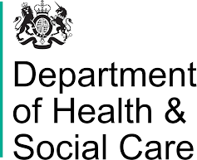 | Sue to talk to Richard and Councillor Harrison about inviting the Director of the Department of Health and Social Care, Ros Roughton, to the SAB
SAB Covid-19 SAB  Managers Self- Assessment Tool | 5. SAB Covid-19 SAB Managers Self- Assessment Tool  Sheila told the SAB about the SAB Covid-19 SAB Managers Self- Assessment Tool  The SAB Covid-19 SAB Managers Self- Assessment Tool helps Safeguarding Adult Boards to see how they are working and what things they may need to change during the coronavirus
 | Sue updated the Board that the document had been discussed at the Executive meeting in May
 | Everyone agreed that it was a very helpful document with lots of really good information

 | Sheila told the Board that this tool had been updated since the Executive meeting in May
 | It now includes the next steps on how all Safeguarding Adults Boards will work as we come out of the coronavirus lockdown
 | Sue told partners that the document would be reviewed and added to as things changed because of coronavirus
 | The SAB agreed to accept the document and said that it was very useful
 | Sue asked SAB members to send any changes or comments they’d like to make to Sheila and Erin
EXECUTIVE REPORT | 6. Report from Executive  The report from the Executive was noted.

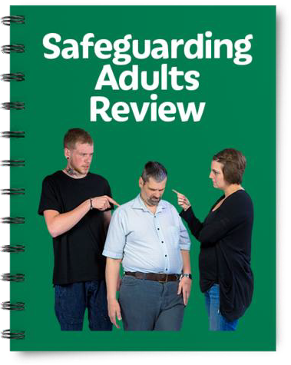 | Erin told the SAB about a SAR referral that the Board had received from NYP  A SAR is a Safeguarding Adults Review
 | The first panel did not think this case should be a SAR and Sue, as the Independent Chair of the Board, agreed with their decision
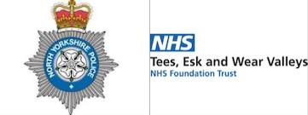 | It was agreed that both NYP and TEWV would carry out their own investigations in their organisations
They will then share any learning with the SAB

This is called single agency learning
 | The Deputy Police and Crime Commissioner contacted the SAB to say that the family of the person the SAR referral was for were upset

They think that it is a SAR and asked that the SAB think about its original decision
Sue has agreed to this and 3 different partners from 3 different agencies are reviewing the information for a second time

They will decide whether this case is a SAR or not

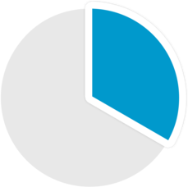 | 6b. Performance and Quality Improvement (PQI) data report  The PQI data report was noted by the SAB  A PQI report is a collection of all of the safeguarding data from Health and Adult Services (HAS) and partner agencies such as:  Health;  Police;  Trading Standards and; Public Health  The report shows the SAB information about safeguarding  It also helps the SAB to see where improvements need to be made or to ask questions or for more information if something is not right
There was an action for all partners to send their information for the annual report to Laura by 26th June.

There were two actions for Laura:

- To bring the final draft of the Annual Report to the Board in September and;

- To bring the SAB engagement plan to the Board in September

RISK REGISTER | 7. Risk Register  Sheila presented the SAB risk register to everyone
A risk register lists all of the things that could cause problems for the NYSAB when they work through their delivery plan

A delivery plan tells everyone what goals the NYSAB wants to achieve over a year
Each risk is given a colour

Red is for an action that has a lot of risk and needs a lot of work

Amber is for an action that doesn’t have a lot of risk but still needs work

Green is for an action that has no risk.

Green risks can sometimes be taken off the register.
Sheila asked SAB members to note that the form had been updated

Following the Executive in May, risk 5 has been updated

The updated sections of the register are in red.

 | There was an action for Sue and Sheila to update the risk register between the September Board meeting and the development day in November
 | The updates will be about how the Board will recover and respond to coronavirus
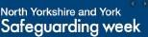 | 8. Safeguarding Week  Because of Coronavirus Safeguarding week will be taking place online on the SAB Twitter account and the SAB website
SAFEGUARDING WEEK BRIEFING PACK  SAFEGUARDING WEEK  BRIEFING PACK SAFEGUARDING WEEK  BRIEFING PACK | Sheila told the Board that a pack of information and messages for people to use will be shared with the SAB
 | Sheila asked the SAB that they shared these guides and messages during safeguarding week
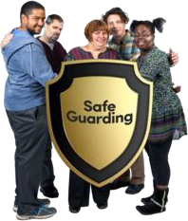 | The main message of the week is how people can report safeguarding and keep themselves and others safe

 | There was an action for Karen to share the contact details of the TEWV communication person with Nicola Webb
9. DS Update
The DS Update report was noted.
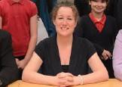 | Louise gave the SAB an update on the DS action plan
 | Louise reassured that lots of work has taken place and many of the actions have been completed
 | But some of the actions need face to face meetings and this cannot happen because of the coronavirus
 | Louise asked the SAB requested that the position statement is brought to the Executive in August and the SAB in September

POSITION STATEMENT | A position statement tells people where you are in a process and what you plan to do next  For example, the position statement for DS will tell the SAB where we are with the learning from the action plan and what we plan to do next
The family of DS will be contacted to let them know there is delay because of coronavirus

The family will also be told that they can expect an update report in September

The report will also be put onto the NYSAB website
 | The SAB agreed with these actions
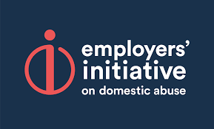 | 10. Employers Initiative on Domestic Abuse  Chris shared a link to a website about Domestic Abuse for employers  Sue asked that people shared this within their organisations For information for SAB partners

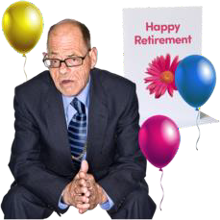 | 11. Current Issues  Matt told the Board that he will be retiring from his job in the autumn  Helen Hart will do Matt’s job starting from September  The SAB partners gave a big thank you to Matt for all of his work and his help to the Board over the years.  An action for Matt was to send Helen’s contact details to Laura so she could be invited to the Board and Executive meetings

People in attendance

Independent Chair | North Yorkshire Police
Sue Proctor | Annette Anderson
North Yorkshire County Council | North Yorkshire Fire Service
Richard Webb | Dave Winspear
Chris Jones-King
Louise Wallace | Health Trusts and CCGs
Katie Needham | Karen Agar (TEWV)
Sheila Hall | Matt O’Connor (AWC CCG)

Erin Outram | Olwen Fisher (NY CCG)
Laura Watson | Sue Peckitt (NY CCG)
Emma Dixon | Jill Foster (HDFT)
Services | Borough and District Councils
Fran Wright (Probation) | Tony Clark (Richmondshire)
Caroline O’Neill (Community First Yorkshire)
Apologies
Ruth Andrews, Rachel Bowes,, Marrianne Franks, Jacqui Hourigan, Nigel Ayre, Elizabeth Moody, Christine Pearson, Beverley Proctor, Lincoln Sargeant, Michelle Turner, James Parkes

