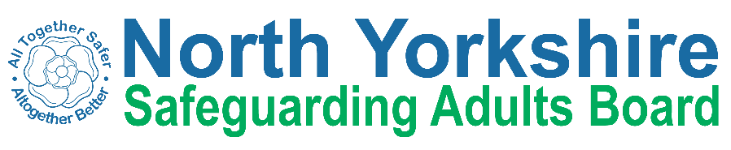

North Yorkshire Safeguarding Adults Board Full meeting minutes

 | Item
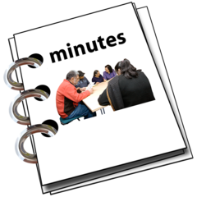 | These are the minutes for the North Yorkshire Safeguarding Adults (NYSAB) Board meeting on Tuesday 8th September, 2020
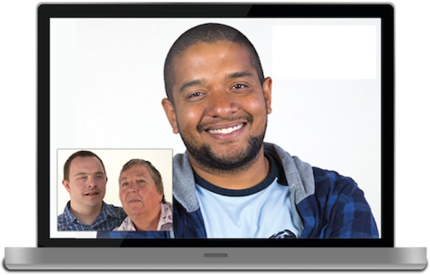 | This meeting took place as a video conference
This is because of coronavirus

The Government asked everyone to work from home and not have face to face meetings
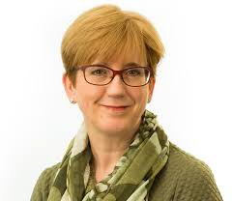 | 1. Welcome and Introductions  Sue Proctor, the Chair of the Board, welcomed everyone to the meeting.

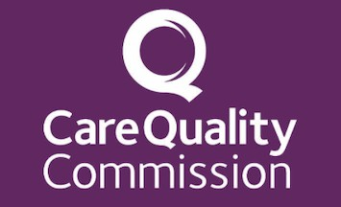 | 2. Care Quality Commission (CQC) Presentation  Helen Vine from CQC gave a presentation about the use of Private Independent Ambulance Services  The presentation highlighted the safeguarding issues related to this  Private Independent Ambulance Services  These are private ambulance services that are provided at large events like festivals and sports events.  These are not ambulances used for patient transport or ambulances in health settings.
 | Helen highlighted the main areas of focus from the slides of the presentation
Slide 7 looked at how important it is for organisations to do checks on new members of staff working in health and social care.

These checks make sure people are safe to work in health and social care
 | Slide 12 focused on the impact Covid-19 has had on the health and social care settings
A lot of people who work in health and social have zero hour contracts

That means the person does not know if or when they will work during a week

Sometimes they are working no hours a week and other weeks they might work everyday

If they don’t work any hours during the week, they don’t get paid
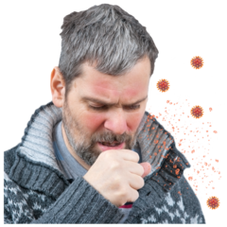 | Some carers may work in lots of different organisations to get enough hours of work  This would cause a risk around spreading infection from one location to another  The situation could make people feel sad, anxious, stressed and even depressed
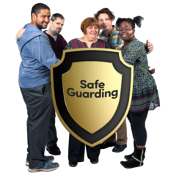 | Another risk is that it has been difficult for staff and organisations to access safeguarding training during Covid  It means staff who are not trained do not understand the changes and their responsibility
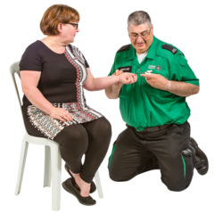 | Slides 15 and 16 of the presentation looked at sexual safety  Ambulance services are often delivered to people on a one to one basis  These people may not usually be classed as vulnerable  In this situation, where they need to use an ambulance, they would be vulnerable  This can mean that workers could take advantage of the situation and abuse their position

There have been cases where workers have acted inappropriately with people who are using the private ambulance service

This can be due to the risks around lack of checks when employing people and not following the right policy and processes
 | Helen asked the SAB if they had any questions or comments about the presentation
 | What practices are in place particularly around recruitment, training and making referrals?
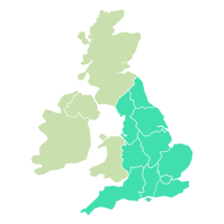 | Many providers, who may not be registered, operate over a different parts of the country  This means training and recruitment may be different from region to region which
 | How many providers are in North Yorkshire?
There are approximately 300 providers in England

There are approximately 100 registered providers in the North

Some providers may be registered in the South but carrying out their work in the North

 | This can make it difficult to understand how many providers are in each area of the country
CQC do have concerns around the governance of some providers

Mental Health Trusts / Community Trust & acute trusts are commissioning these services
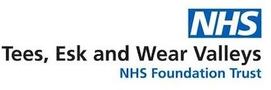  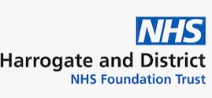 | Sue Proctor highlighted that this was an opportunity for a piece of work to get some feedback Tees, Esk and Wear Valleys (TEWV) and Harrogate District Foundation Trust (HDFT)  TEWV is a Mental Health Trust HDFT is an acute trust
 | Are St Johns Ambulance and AGE UK registered?
St Johns Ambulance are not registered when they provide their services at events

They are a registered provider in urgent and emergency areas and they have very high standards
 | AGE UK are not registered with CQC for transporting patients

 | There was an action for Helen to provide a list of those providers who are operating in the North of England
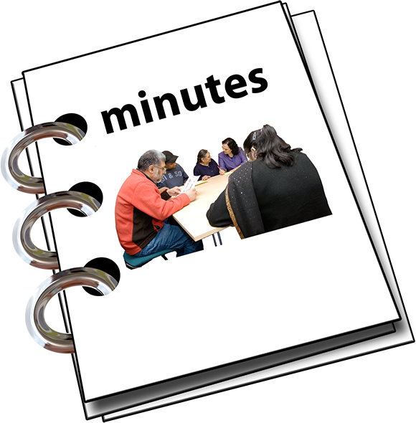 | 3. Previous meeting minutes  Everyone was happy with the minutes from the previous NYSAB meeting in June
Everyone agreed that producing the minutes in an easy read format set a good example

It shows people how we want to be accessible and inclusive as a Board
4. Action Log
The action log is a list of all of the things that members of the NYSAB have promised to do

Sue Proctor asked Laura to separate the completed actions from the other actions

She also asked Laura to separate the actions that were paused because of COVID-19

This will make reviewing the log much easier

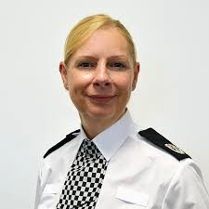 | Annette will bring an update to the SAB in December on the domestic abuse ‘deep dive’ action
5. Response and Recovery to Covid-19
Sue Proctor asked for updates on the following areas:

- The care home situation in Selby, as discussed at the Executive

- Care homes applying for financial hardship assistance

- Public Health
 | Chris Jones-King updated on the care home situation in Selby
One of the care homes in Selby was due to close

Due to the situation around Covid-19 the care home remained open
A number of safeguarding concerns were raised around the nursing element of the second care setting

The home was registered for both nursing and residential care
CQC carried out an inspection

The inspection found there were risks around the nursing care

A decision was made to move everyone out of the care setting

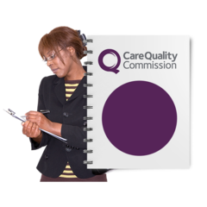 | CQC went back to inspect to the residential care in the home  Due to the findings of the inspection, CQC issued a notice for the home to close
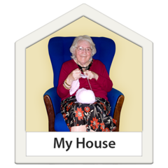 | NYCC worked hard to support people to find new accommodation
People who were in the home for residential care were funded by City of York and North Yorkshire County Council

Some people paid for their own care. This is called self-funding
Everyone was safely placed in new accommodation.

Some of those people were admitted into hospital

The local authority have followed up on those people that were moved out of the home to see how they are doing
A lessons learned piece of work has been commissioned to look at how the whole situation was managed

Lessons learned is looking reviewing an event or incident to see if things could have been done differently or if there are things we have learned to change the way we do things in the future

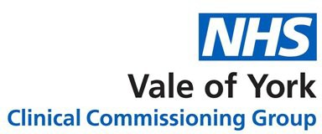 | Sue Peckitt told the SAB that Vale of York CCG and the local authority worked really closely with both the CQC and the care home
Jill asked that if we have to exit a care home quickly, is there standard guidance as to how the local authority and health should deal with the response

Chris will discuss this further with Jill outside of today’s meeting
 | There was an action for Chris to share any safeguarding that is highlighted from the Lessons Learned Review with the Learning and Review sub-group and all relevant partners
Abi Barron, Head of Service Development at NYCC, gave an update on the care home requests for assistance for financial hardship

Financial hardship is when people or organisations do not have enough money and are struggling to pay their bills or run their businesses
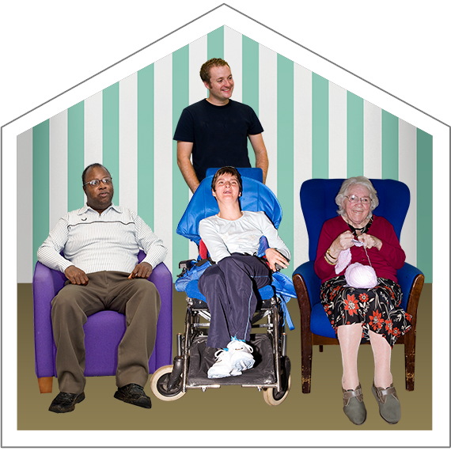 | She also updated on the other support provided to care homes throughout the pandemic

 | Care homes have also been supported by a team of Care Home Liaison Officers from NYCC to help them with advice and resources to keep their care settings running during the pandemic
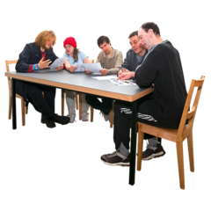 | NYCC has set up a supplier board to look at financial areas such as provider relief
 | One care setting that has gone through the process for financial assistance
 | There has also been one care setting that had a successful application for financial assistance
A care market strategic board has been set up

To board will look at how it can support providers so that their organisations can still operate
 | There was an action for Abi to bring an update to the SAB in December

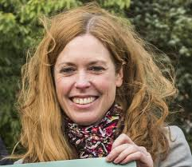 | Katie provided an update on Public Health work
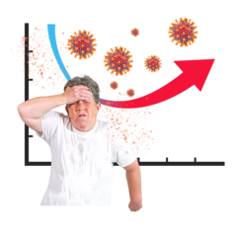 | Covid-19 cases in North Yorkshire have increased to 147  There is an average of 11 cases per day  Half of the people who test positive for Covid-19 are aged 20 to 30 years old.
Public Health are working closely with Environmental Health and Public Health colleagues to understand what is going on in terms of transmissions.

A transmission is how something, such as Covid-19, spreads from one person to another
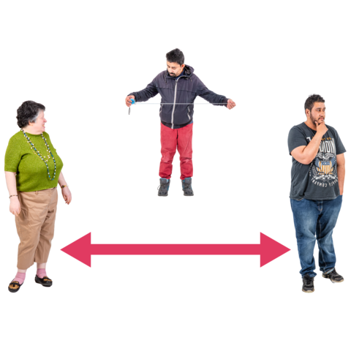 | The NYCC communications team are working with Public Health to share messages.  These messages will:  Remind people to social distance and;

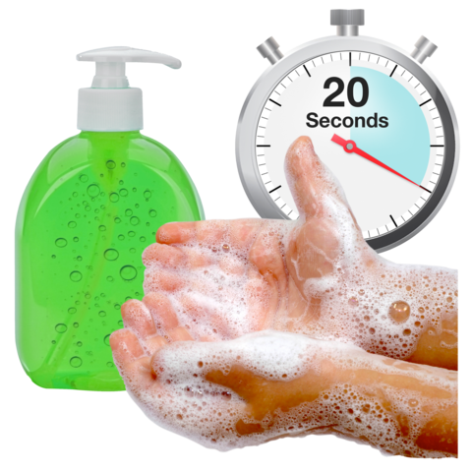 | Make sure people continue to wash their hands
 | Work is still ongoing to manage outbreaks in care homes
Public Health are also working closely with Safeguarding Advisory Groups

These groups look at large scale events such as sport events, fairs or live music events
Katie told the SAB that more Public Health advice is needed

This will help event organisers understand if it is safe for their event to go ahead

It will also help them make sure their event is Covid-19 secure

 | There was an action for Katie to share the events guidance with Caroline
EXECUTIVE REPORT | 6. Report from Executive  The report from the Executive was noted
RISK REGISTER | 7. Risk Register  The risk register was noted
8. SAB Development Day
Sue updated everyone on the arrangements for the SAB development day
 | The session will take place on Tuesday 24th November

Because of the ongoing restricts around Covid the development day will take place virtually
The day will look at what we have learnt during Covid-19

Public Health will lead a conversation around new risks that have been identified during Covid-19

We will also look at inequalities that have been highlighted during Covid-19

Some examples of inequalities are:
People being treated unfairly because of their race or religion or disability
or
Not having access to things like care and medicine because of where they live or not having enough money
There was an action for Laura to work with health partners to set up the development day session using Microsoft Teams

There was also an action for Louise to talk to Public Health colleagues to make sure local economics is part of the discussion.
9. DS Delivery Report
The DS delivery report was noted.

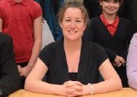 | Louise asked the SAB to approve the report so it could be shared on the NYSAB website
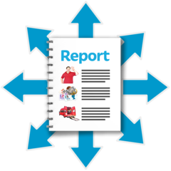 | Sue Proctor asked that someone who has not been involved with the case reads the report and;  That once the report has been updated that Richard Webb looks over it before it is put onto the NYSAB website
 | The SAB agreed that this could be shared and put on the NYSAB website following the updates and review
 | Louise told the SAB that any further action from the action plan will be monitored by the Learning and Review group
There was an action for Louise and her team to update the report

Laura will share the report with Cara Nimmo, Head of Practice and Safeguarding at NYCC, so that Cara can check the report

Richard Webb will review the report after Cara has checked it and Laura will then put the updated report on the NYSAB website
10. SAR ‘Ian’ Delivery Report

The SAR ‘Ian’ Delivery Report was noted

Louise asked the SAB to approve the report so it could be shared on the NYSAB website

The SAB agreed to this
 | Louise told the SAB that any further action from the action plan will be monitored by the Learning and Review group.
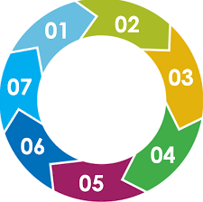 | Louise also presented the 7-minute briefing  for SAR ‘Ian’  A 7 minute briefing captures the key points following a Safeguarding Adult Review or Lessons Learned Review
 | The SAB agreed that this could be shared and put on the NYSAB website following some slight changes
There was an action for Laura to put the delivery report on the NYSAB website

Laura will also update the 7 minute briefing and share this with the SAB and put on the website
 | 11. Update on improving outcomes for people with complex need

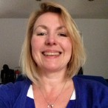 | Sue Peckitt gave an update on improving outcomes for people with complex needs
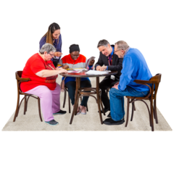 | A multi agency meetings is running regularly  There are now dedicated points of contact for all of the agencies
Support networks are in place for those most vulnerable adults

This will help to prevent these adults going from service to service
 | Strategy meetings are held to talk about those adults with the most complex needs
The service is looking to share peoples records between primary care and substance misuse providers

Substance misuse providers support people who have problems with drugs

By sharing records the agencies involved can help and support people in a more joined up way

Sue Peckitt highlighted a positive piece of work

It involved 2 people who regularly attended Scarborough Hospital Emergency Department (ED)

One individual is very vulnerable

The work carried out by TEWV, the CCG and the hospital highlighted really positive work

It also highlighted how well the different agencies worked together
The service is working really well

The agencies involved would like to use the services in other places across North Yorkshire

This is called roll-out

Plans are in place to see how this can happen
There was an action for Sue Peckitt to provide a further update to the Board in December
12. Primary Care Network (PCN)
Sue Peckitt gave an update on the Primary Care Network

A Primary Care Network is made up of people who provide primary care, such as GP practices, across North Yorkshire

The PCN is now a year old

The GP practices have come together to create a 30,000 - 50,000 practice list
The networks are working to support care homes.

They are also working to provide extra support to care homes
Every care home has a person that will work with them to help and support them

This person is called a clinical lead

The clinical lead will also help the care home how the services they will provide will work

This has really improved the way the care home and networks work together
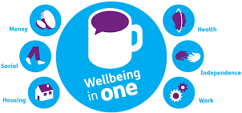 | Caroline spoke about social prescribing  Social prescribing uses services and organisations in society and community settings to help people  This is used when people do not need medical treatment. This is sometimes called clinical treatment
The community and voluntary sector (CVS) have done a lot of work around social prescribing

They have worked closely with GP practices on this and it has been successful

The CVS are going to share a guide to social guidance.

Sue Peckitt agreed that it would be a helpful tool to share throughout the PCN
Caroline to share the social prescribing guidance with Sue Peckitt
13. PIPOT Update
The PIPOT update was noted and Chris highlighted the following points:
The PIPOT policy was a piece of work that had to stop because of COVID-19

A group is now working together to finalise a policy
This policy will be shared with members for their comments
The policy will then be brought to the SAB meeting in December for approval

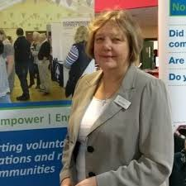 | Caroline highlighted the situation around providing debt advice for people, particularly during COVID-19  Some people may have lot their jobs because of COVID-19 and that means they have less money to pay bills  If they struggle, they might borrow money from organisations but then find it difficult to pay it back
There are financial scams that are taking place too. People are being asked to pay for things that don’t exist or give their bank details to people

These people who ask for details may say they come from a trusted organisation, but they don’t
 | Caroline told the SAB that lots of people have been contacting the local citizens advice bureau for advice around debt and scams
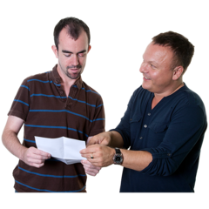 | There is a local forum which is made up of different agencies who share information and guidance around debt advice
 | Sue Proctor asked Louise to speak with Katie about this as something to think about for the SAB development day

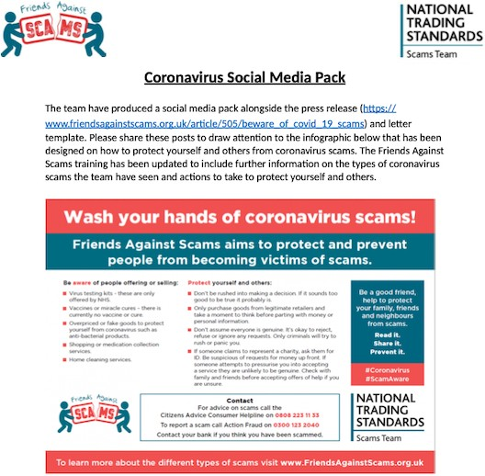 | Laura told the SAB that she had linking in with a number of organisations to share information on the SAB website
 | Laura will speak to Ruth Andrews at Trading Standards to make sure the SAB is sharing the most helpful and up to date information to keep people safe
14. LeDeR Update
The LeDeR position statement was noted and Christine highlighted the following points:
NHS England have completed all of the priority
LeDeR reviews

LeDer is a Learning Disability Mortality Review
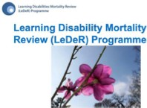 | A specialist practitioner has been recruited to work on the LeDeR reviews
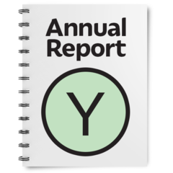 | The local LeDeR annual report will be shared with the SAB via email. It will then be shared at the Board in December

 | Sue Proctor noted that the report identified a particular serious point to highlight
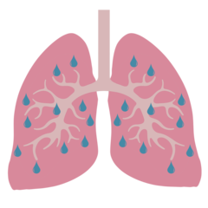 | The biggest cause of death for adults with learning disabilities is respiratory issues  Respiratory issues are medical conditions that affect peoples lungs and breathing
 | These issues can result in people dying early and this has been made worse by Covid-19
Sue Peckitt agreed with these comments. She updated that less people with a learning disability were having their annual health check

This may be because of the restrictions during Covid-19. People can’t get to the doctors or they are worried about going to the doctors
 | Sue Peckitt suggested that different agencies should communicate with each other and share information shared so that this can feed into a person’s health check
15. Joint Engagement and Communication Strategy
The Joint Engagement and Communication Strategy was noted
 | Laura asked the SAB for approval to start using the strategy and the toolkit
 | The SAB agreed and highlighted what a good piece of work this is to move forward with engagement and communication

The SAB thanked Laura, Jonathan and Lesley for the work that had gone into the strategy and toolkit
Laura explained that as it is a joint strategy it needs to go to the Safeguarding Children’s Partnership and Community Safety Partnership for approval before it can be used
Laura presented the SAB engagement plan and asked the Board for approval to carry out the engagement work highlighted in the plan
The SAB agreed and thanked Laura for the work that has gone in to the plan
16. Annual Report
The Annual Report was noted
Laura asked the SAB for approval to send send the draft report to the design team ready for it to be shared on Monday 5th October
The SAB agreed to this and thanked Laura for putting the report together

 | Laura will send the draft report to the design team and share it on Monday 5th October
 | 17. Current Issues
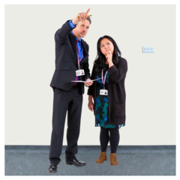 | Annette told the SAB that all 43 police forces are to be inspected
 | The inspections will identify areas of learning from Covid-19
 | The full report will be due in January 2021 Annette will share this report with the SAB
 | Dave added that North Yorkshire Fire and Rescue Service are being inspected in November
 | Dave will feedback any findings that the SAB should be aware of
 | Sue Proctor told the SAB that Jim Hopkinson, Director of Safeguarding at Ampleforth had contacted her

He asked if the SAB could support the review of Ampleforth’s policies

He also asked if there was an opportunity for their staff to access training
Sue Proctor asked that Sarah organises a meeting for herself, Sarah, Sheila, James and Jim to discuss what support and assistance the SAB can offer
Following this conversation, Sue Proctor or James will link in with Maggie Atkinson, Chair of the Safeguarding Children’s Partnership
Caroline offered to share information for training that would be available for Ampleforth

Attendance

Independent Chair | North Yorkshire Police
Sue Proctor | Annette Anderson
North Yorkshire County Council | North Yorkshire Fire Service
Chris Jones-King | Dave Winspear
Louise Wallace
Katie Needham | Health Trusts and CCGs
Sarah Abram | Karen Agar (TEWV)
Laura Watson | Helen Hart (AWC CCG)
James Parkes | Christine Pearson (NY CCG)
 | Sue Peckitt (NY CCG)
Services | Jill Foster (HDFT)
Fran Wright (Probation)
Caroline O’Neill (Community First Yorkshire) | Borough and District Councils
 | Tony Clark (Richmondshire)
Apologies
Richard Webb, Sheila Hall, Erin Outram, Emma Dixon, Ruth Andrews, Rachel Bowes, Marrianne Franks, Elizabeth Moody, Olwen Fisher, Lincoln Sargeant, Michelle Turner

