Hate Crime
Easy Read

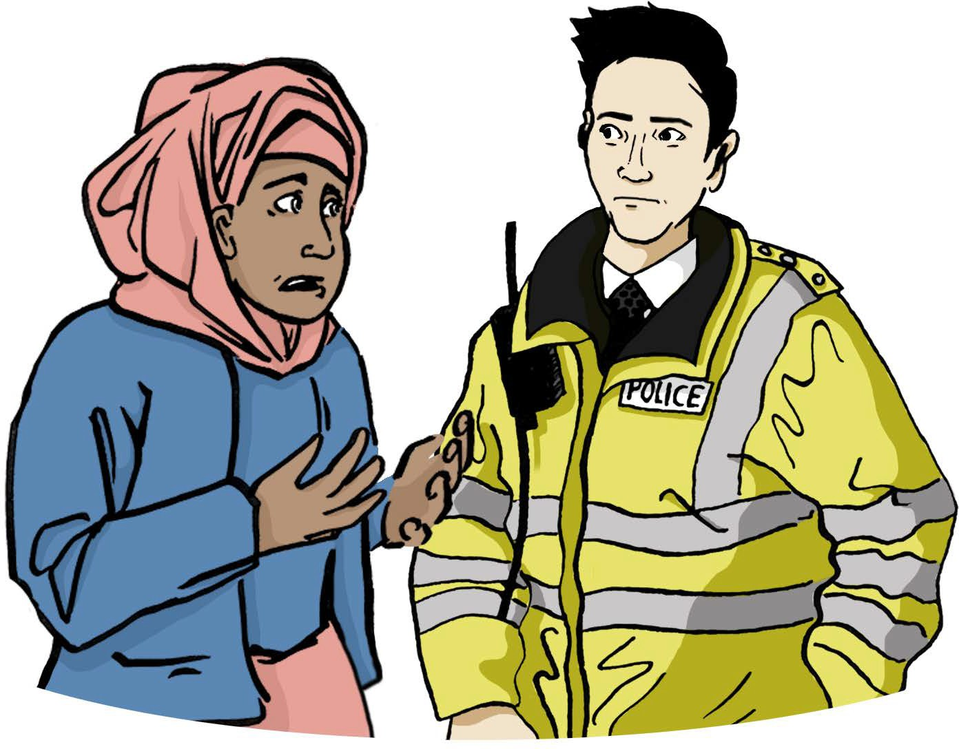

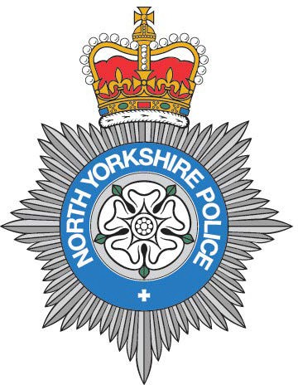

What is hate crime?

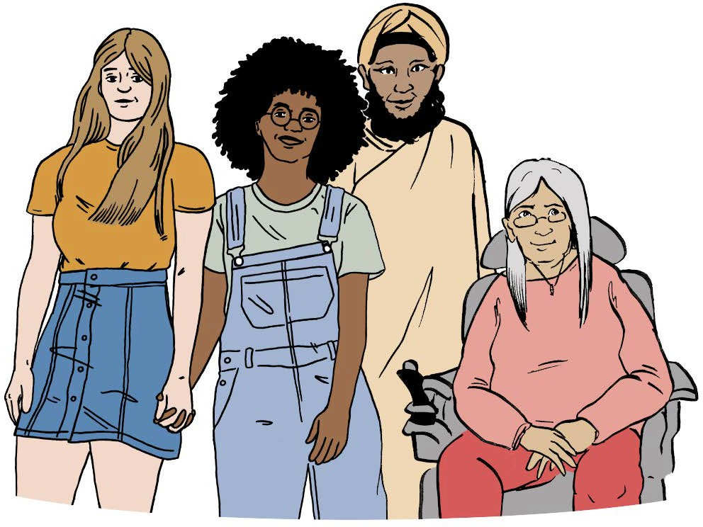
Hate crime is a crime which happens because of someone’s hatred of disability, race, sexuality, religion, gender or people who are transgender.

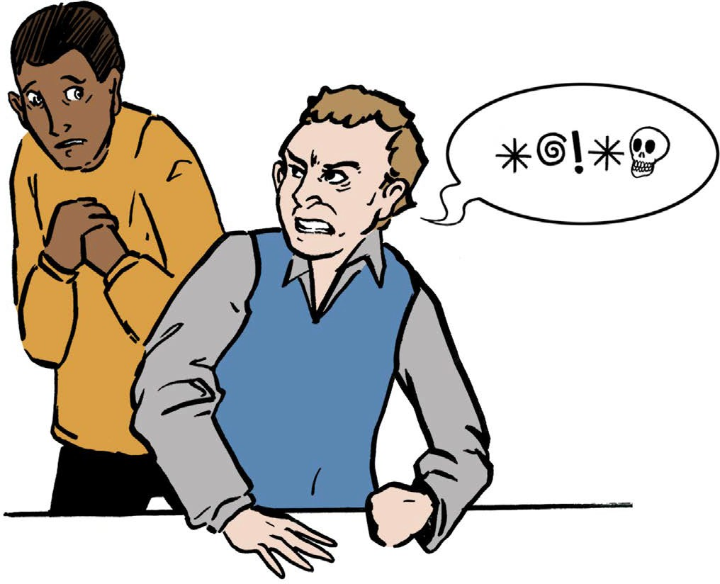
Hate crime can be:

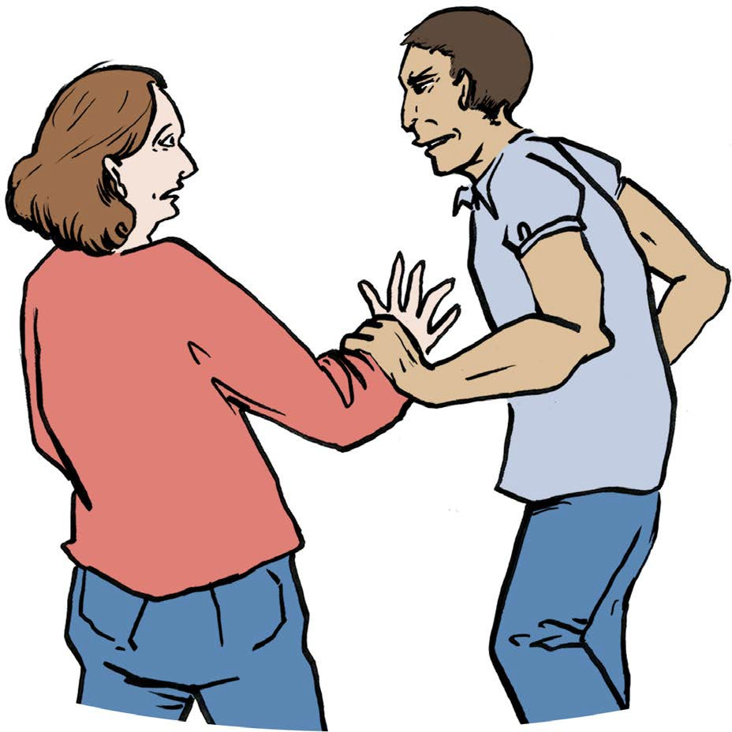
verbal abuse, like someone calling you names

attacks or violence

2

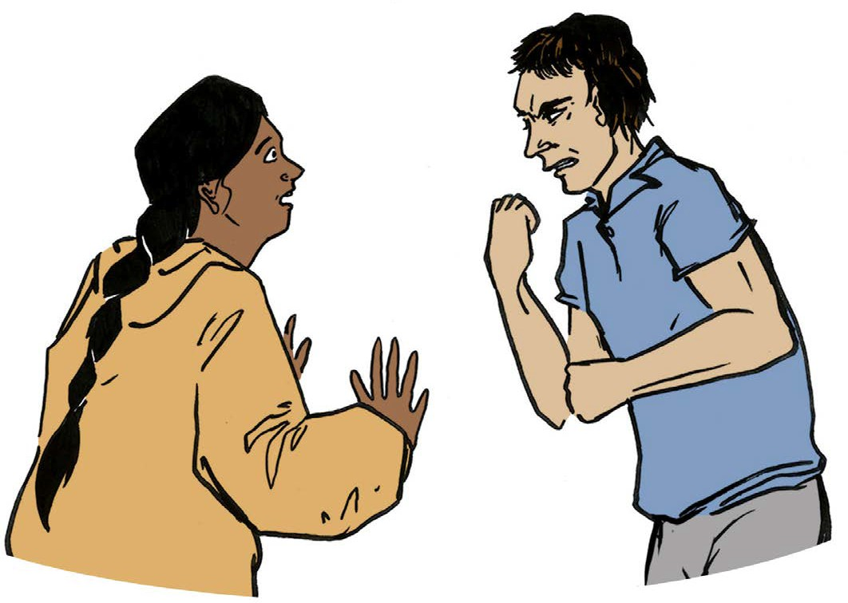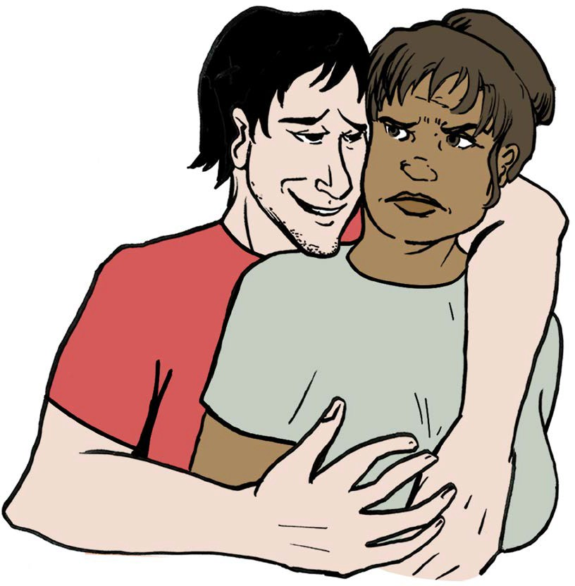sexual abuse

threats of violence towards you

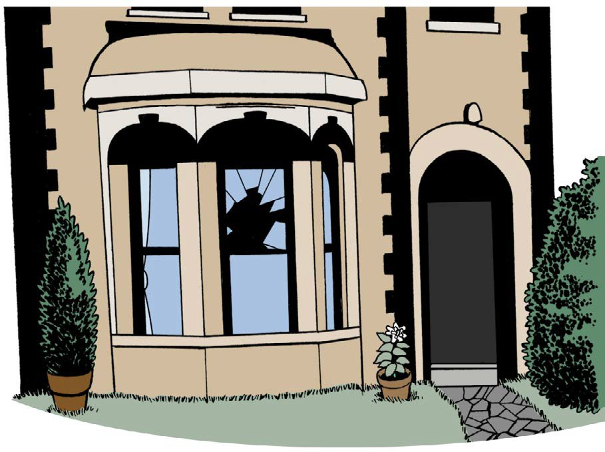
damaging your property.

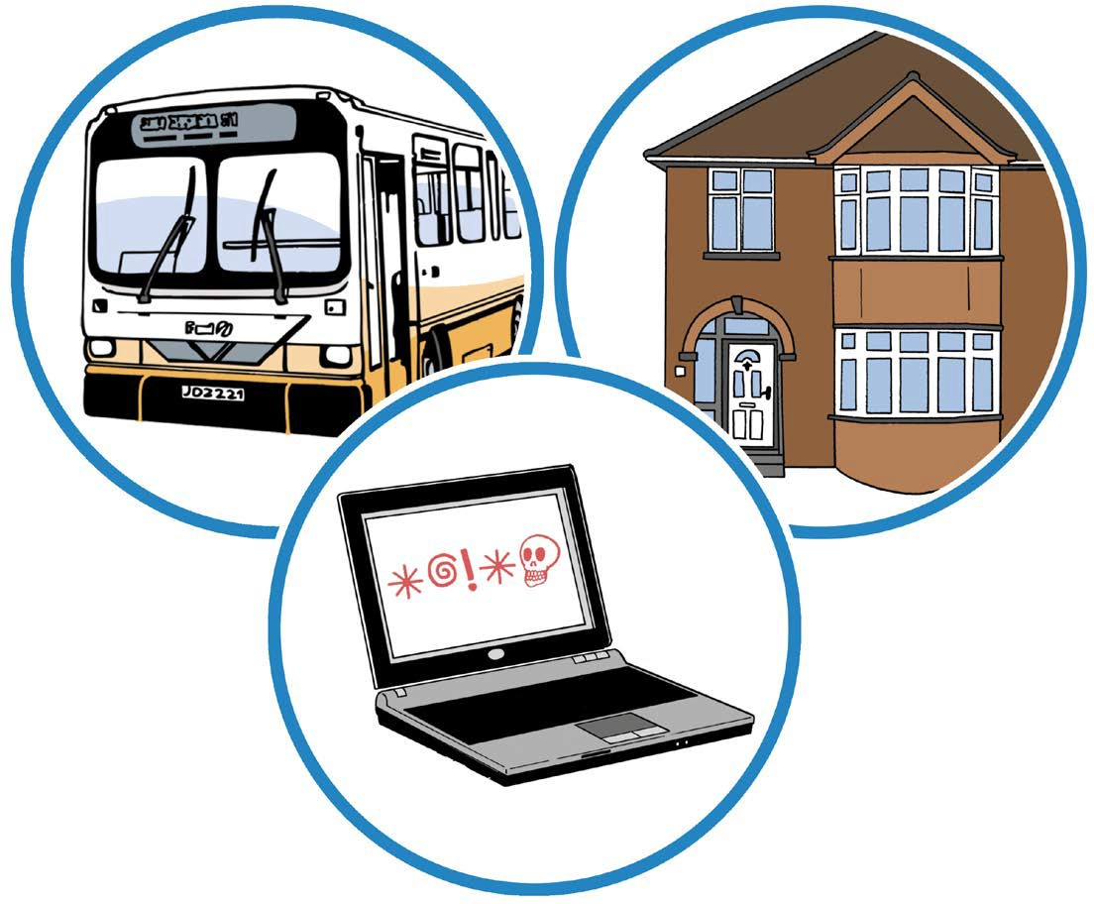
Hate crime can happen anywhere. It can happen at home, when you are on public transport, at work, when you are out socially or even online.

3

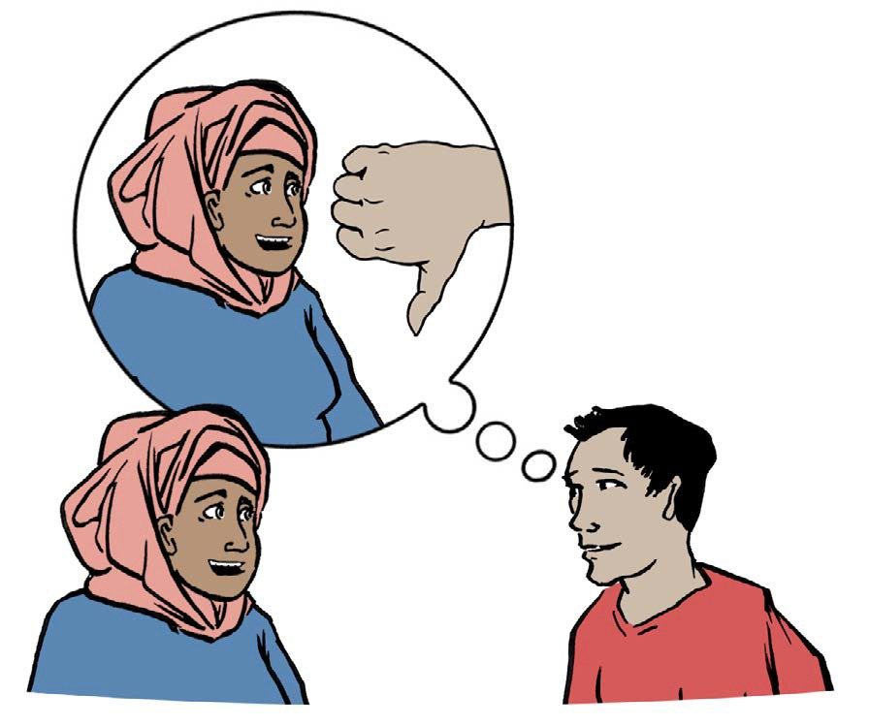

Mate Crime

Mate Crime is when someone pretends to be your friend so they can abuse you.

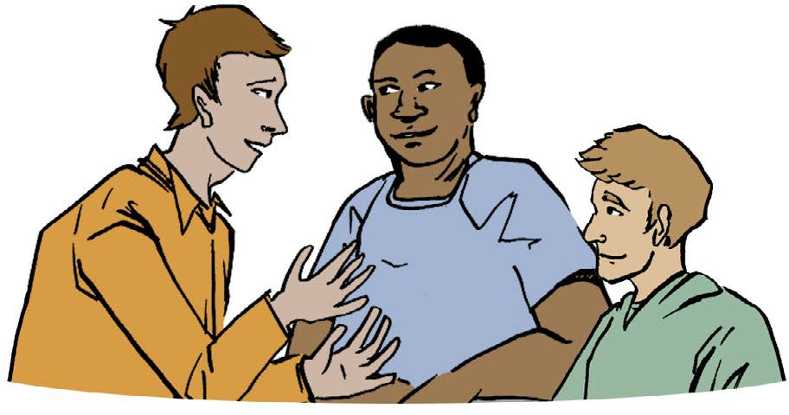
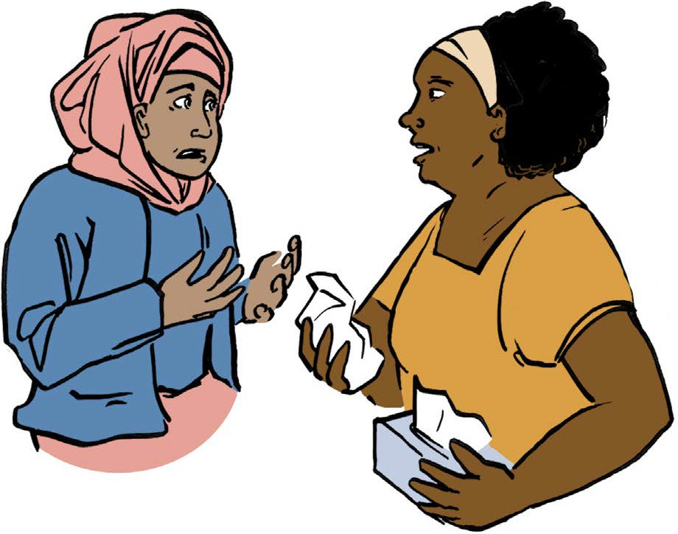People should treat you fairly and kindly.

If anyone treats you badly you must tell someone you trust.

Most friends are really friends they will care about you and treat you fairly.

4

How to report hate crime

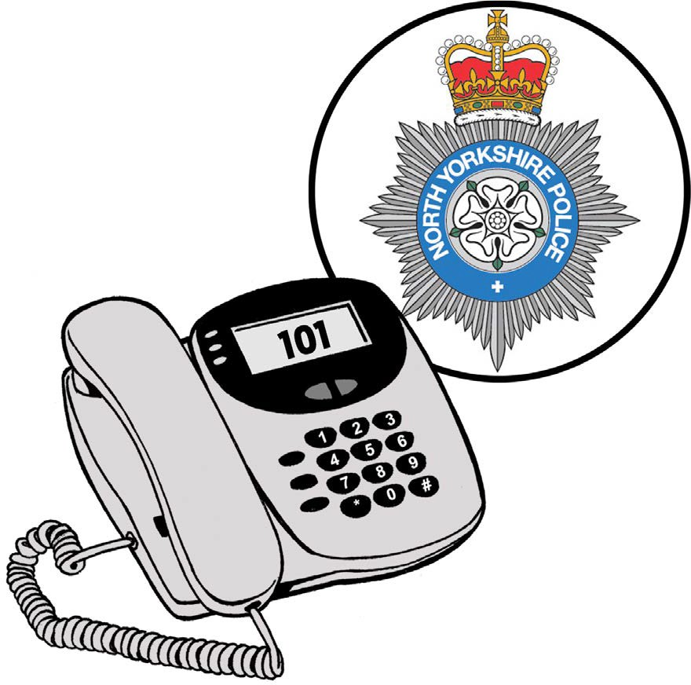
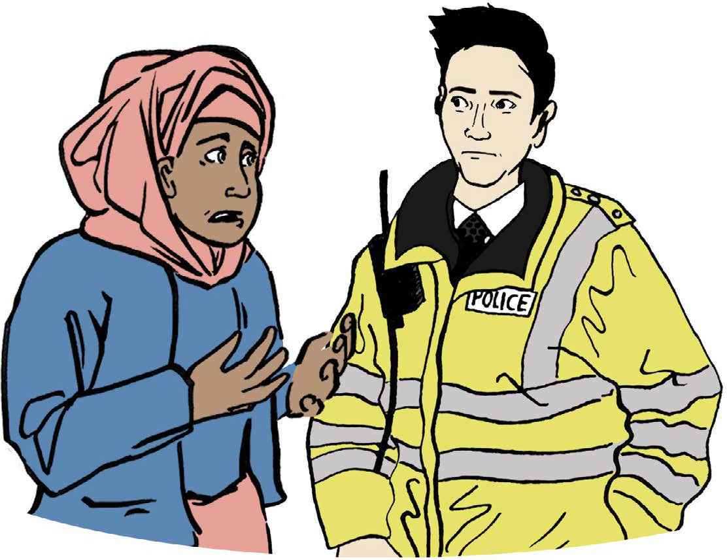
All crime is wrong. You should tell the police if a crime happens to you.

Call North Yorkshire Police on 101
to report a crime.

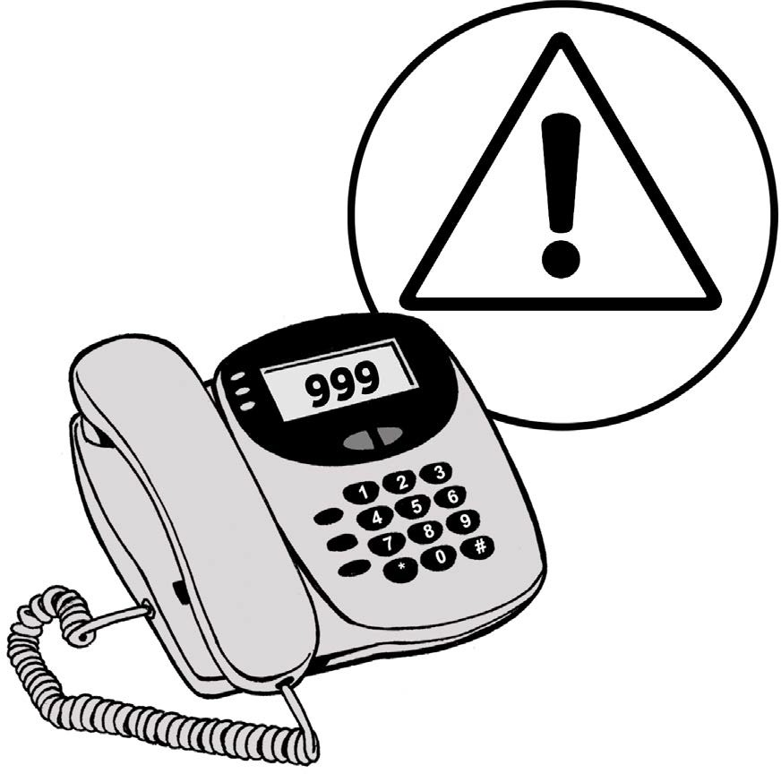
Call 999 if it is an emergency.

5

Call Supporting Victims in North Yorkshire on
01609 643100

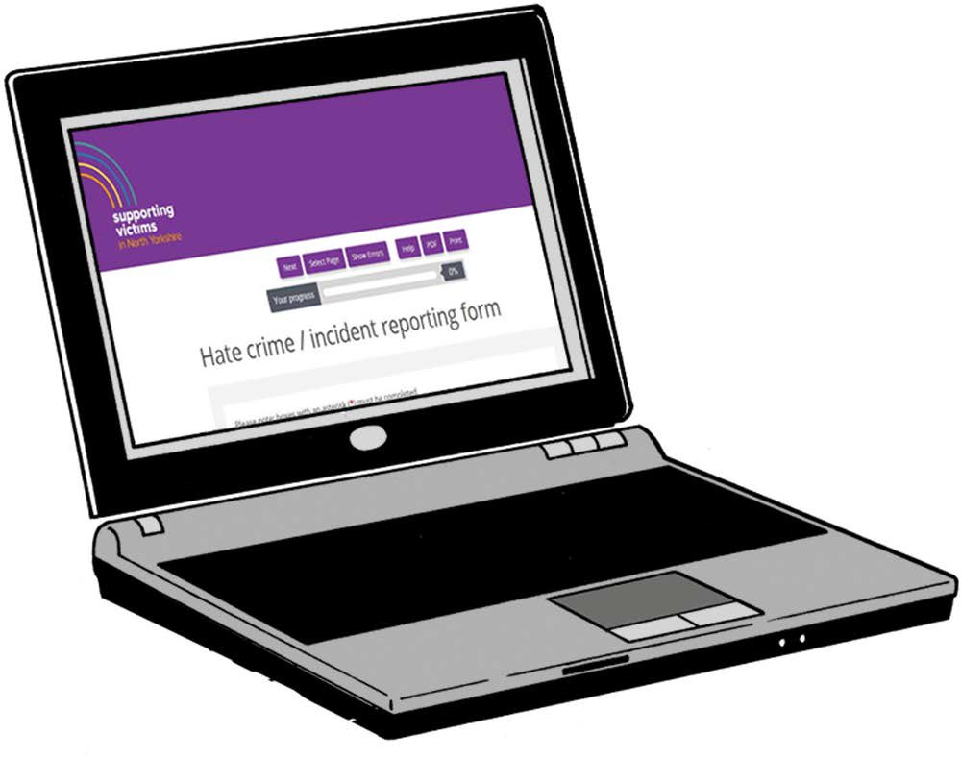
Find Supporting Victims in North Yorkshire online at www.supportingvictims.org

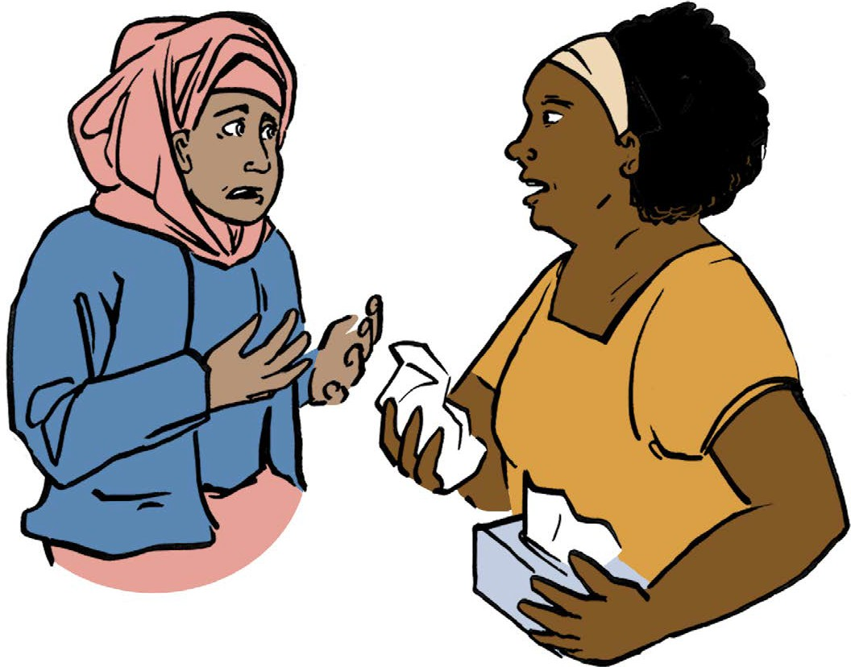
You can speak to a friend if you need help or support to report a crime.

6

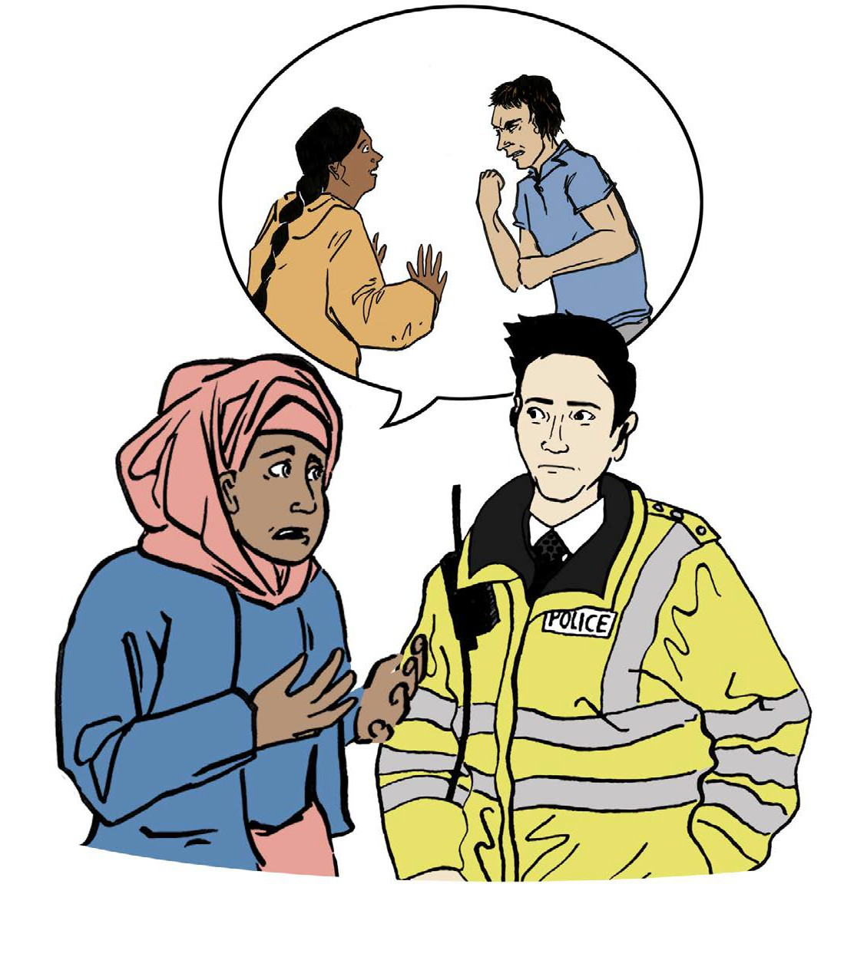

If you have witnessed hate crime

You do not have to be the victim of hate crime to report it to police.

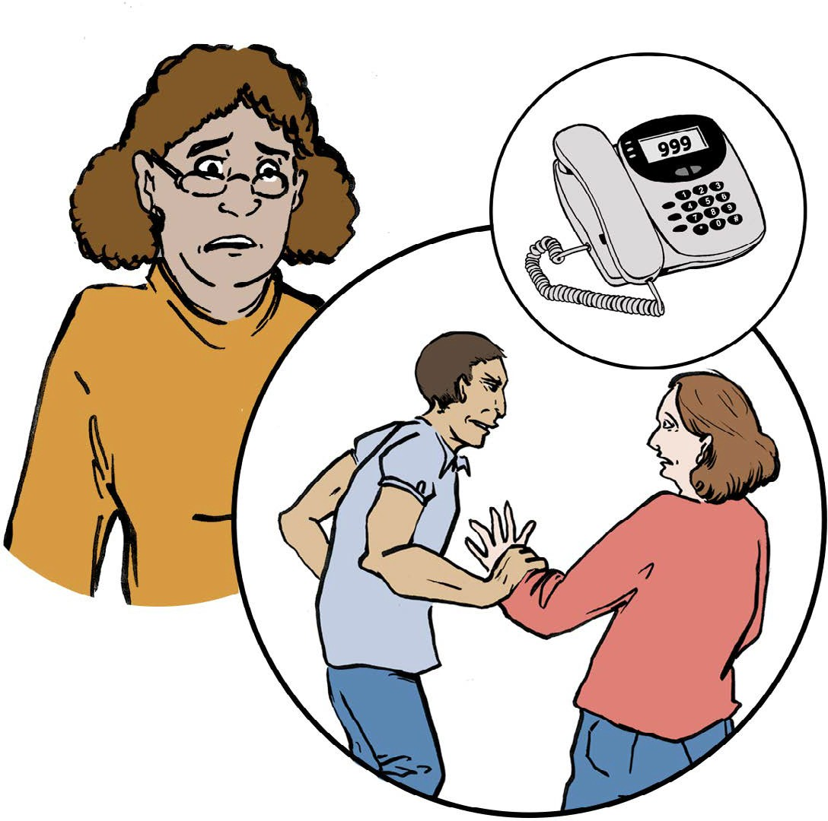
If you have witnessed an incident, you can still make a report to the police on 101 or 999 if it is an emergency.

7

