NORTH YORKSHIRE
SAFEGUARDING ADULTS BOARD

ANNUAL REPORT 2013 – 2014

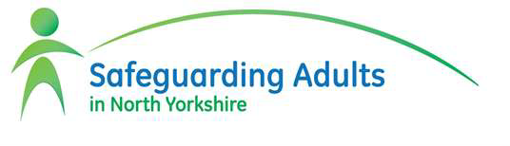

Keeping people safe from abuse and neglect

Contents Page

Foreword by Chair of Safeguarding Adults Board Jonathan Phillips
2 – 3

Our strategic plan: Big pieces of work and big challenges 4 – 7

A safeguarding story – Mrs S 8

Training in Safeguarding and Mental Capacity Act. 9

Mental Capacity Act/Deprivation of Liberty Safeguards Forum. 10

What does the data tell us about safeguarding? 11 – 18

- Safeguarding partners: keeping people safe from abuse and neglect.
19 – 30

Foreword by Jonathan Phillips

Independent Chair for the North Yorkshire Safeguarding Adults Board
At the end of my second year as Independent Chair, I am happy with the steps the Board has taken to be as effective as possible at protecting the vulnerable people of North Yorkshire from abuse and neglect.
The Board continues to review safeguarding arrangements in the light of the Winterbourne View Concordat and Francis recommendations and the Serious Case Review in respect of ‘Robert’. Each of these significant
reviews has an impact on the way that agencies work together to promote safeguarding in a culture of candour and openness.
Adult social care and health partners have worked well together to assure the Health and Wellbeing Board that services for people with learning disabilities are safe and of a good quality and that people are supported to move to community based support where appropriate.
I have continued with my ‘arm’s length’ overview of safeguarding activity with a review of governance of the Board and effectiveness of each agency. As a result of my meetings with each of the key partners, I have introduced some changes to the way the Board is organised. From September, there will be a smaller, more strategic arm of the Board with those key statutory partners that are required in the Care Act regulations, including the local authority, the NHS and the police.
This group will work to deliver our strategic plan more effectively and strengthen accountability with the development of a strong quality and performance framework and shared funding of the Board. Core to this will be assurances from commissioners that services have sufficient safeguards to protect people at risk of abuse.
Alongside this, we will continue to enhance participation in the wider partnership and reflect the crucial work of the locality focussed groups and the voluntary, community and independent sectors. This puts us in a strong position to respond to the Care Act requirements for understanding our local community.
The Board has prepared for the requirements for safeguarding in the Care Act; by setting out a three year Strategic Plan around the government’s principles of empowerment, prevention, proportionality, protection, partnership and accountability. Key to this has been developing new links to the Health and Wellbeing Board and Healthwatch and with the Police and Crime Commissioner. Crucial to effective safeguarding is a clear application of the Mental Capacity Act so developing better links with the MCA Forum has been a priority this year.

Empowerment at the heart of safeguarding was the subject of our workshop held in July with representatives from partnership boards and reference groups for carers and people who use services. Together we have made a plan for what needs to happen locally for safeguarding and how to increase user influence on the board. We will be taking this further next year using ‘Making Safeguarding Personal’ as the benchmark we strive to measure ourselves against.
We continue to raise awareness of safeguarding concerns amongst vulnerable adults, their family and friends through promotion of our awareness campaign. The aim is to help people to be resilient and to protect themselves from abuse or exploitation and to encourage more self-reporting.
The Care and Independence Overview and Scrutiny Committee has conducted a review of the issues associated with financial abuse and it will be taking action to ensure that awareness and understanding of the risks of financial abuse are included in the council’s work on prevention and joint working with community organisations.
In the coming year our key priorities will be responding to the Care Act requirements for a Board to develop and publish shared plans for safeguarding and working with local people to decide how best to protect adults in vulnerable situations.
We will continue to promote dignity and respect for all care and support that is provided in North Yorkshire and use information from our quality and performance framework to tell us how well we are doing.

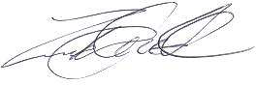

Jonathan Phillips OBE

Independent Chair – North Yorkshire Safeguarding Adults Board

Our strategic plan

In 2013 we agreed a vision for the Board for adult safeguarding. It is to

Provide leadership, challenge and direction to ensure that the partner agencies improve outcomes for adults at risk of harm or abuse.
Members of the Board agreed to promote values of openness, trust, respect and learning.

The Department of Health’s six principles for adult safeguarding are important to us:

Empowerment – people feeling safe and in control, being more able to share concerns and manage risk of harm either to themselves or others
Protection – support and help for those adults who are vulnerable and most at risk of harm

Prevention – working on the basis that it is better to take action before harm happens

Proportionality – responding in line with the risks and the minimum necessary to protect from harm or manage risks
Partnership – working for local solutions in response to local needs and expectations

Accountability – focusing on outcomes for people and communities and being open about their delivery
Taking further steps towards making this vision a reality, in partnership with one another, local people and communities, is what our three year strategic plan is all about.

Our big priorities

There are four main outcomes, things we want to be different from now, that make up the strategy to achieve delivery of our vision. They are:

Awareness and Empowerment
- People in North Yorkshire know what to do if abuse or neglect happens

Prevention
- Abuse of people with care or support needs is prevented whenever possible

Protection
- Adults are protected from harm when they need to be
- Skilled staff and volunteers spot abuse and take timely, compassionate and

proportionate action to ensure protection
- Safeguarding Adults Policies and Procedures work for local people

Partnership Effectiveness
- Partners work together and link well with others

Big pieces of work last year

People in North Yorkshire know what to do if abuse or neglect happens

    - We promoted our posters and our booklets to make people aware of safeguarding and how to report abuse when they see it. Our aim is for more people to protect themselves from abuse or exploitation and for people to feel confident to report abuse themselves.

Abuse of people with care or support needs is prevented whenever possible
    - We made sure that North Yorkshire responded properly to the Winterbourne View Concordat and Francis Report. We asked the Winterbourne group to make sure that services for people with learning disabilities are safe and of a good quality and that people are supported to move to community based support where appropriate.
    - We talked to other groups that are working on keeping people safe such as the Domestic Abuse and Community Safety groups.

    - Healthwatch is now on the Board so that we can learn from what they find out.

Adults are protected from harm when they need to be

    - We made sure that all staff who provide care and support had the right training in safeguarding and Mental Capacity Act. We made sure that our training plan was up to date.
    - Organisations and staff changed the way they worked together based on the Serious Case Review about ‘Robert’ that was published in 2013.

Partners work together and link well with others

    - We got ready for the new Care Act which tells us what the Board should look like and how it should work in 2015.

    - Our chair listened to the people on the Board about what was working well and not so well. The Board changed the way it was organised so that it could work

better.

    - We made sure that we had the right people on the Board who could make changes in their organisations.

    - We made sure that our Local Safeguarding Adults Groups had a say in the work of the Board by having three Board meetings a year which focus on the way that these groups are delivering services to keep people safe.
    - We agreed a way to measure how well the Board is doing. This is called the Performance and Quality Framework.

    - We held a workshop to talk with other Partnership Boards or organisations in North Yorkshire to find out what people who need care and support think is most important for safeguarding and make a plan together so that we can keep sharing information and ideas.
    - We agreed a plan for three years to work towards our big priorities. We measured how well we were delivering the plan.

Big Challenges for this year

People in North Yorkshire know what to do if abuse or neglect happens
- We will work on our plan to keep sharing information and ideas with people who have care and support.

Abuse of people with care or support needs is prevented whenever possible
- We will use information from our audit and our Quality and Performance framework to find out how well providers are treating people with dignity and respect.

Adults are protected from harm when they need to be
- We will work with our partners to make sure that people with care and support say that they have a real say in their safeguarding investigation and can comment on the outcome. We will use Making Safeguarding Personal as a benchmark to measure ourselves against.
- We will make sure that our safeguarding procedures are up to date, clear and accessible.

Partners work together and link well with others
- We will make sure that our Board is following the national guidance for the Care Act. This means that we will be a statutory board from April 2015 and that we will publish our plans

- We will do an audit to measure how well each partner organisation is meeting the national and local standards.

- We will use our Quality and Performance Framework to measure how well the Board is doing and will act on what it tells us for these three questions.

  - How safe are local people?
  - Are local agencies working well to safeguard people?
  - Do people feel better and safer as a result of our work?

A safeguarding story (Mrs S)

Mrs S is 99 year old lady who lives alone, she receives support from her family with practical tasks such as shopping and cleaning; her son also helps her with managing her finances. Mrs S has a care package consisting of twice daily visits to assist with personal care from a local domiciliary care provider.

Mrs S reported to her son that £10 had gone missing from her purse; when Mrs S’s son puts money into his mother’s purse he writes the amount in her diary. Mrs S did not want to make a complaint to the police but agreed for the matter to be looked at under safeguarding adult’s procedures to enable a protection plan to be agreed. Mrs S and her son were suspicious of a care worker employed by the domiciliary care service but did not want to get her into trouble, Mrs S felt sorry for the care worker because she was having financial problems and had grown children who lived at home that she was supporting.

At the safeguarding strategy meeting Mrs S was represented by her son where he repeated his mother’s wish not to make a formal complaint to the police. The meeting agreed to respect Mrs S’s wishes but had to consider the risk to other vulnerable people if the allegation against the care worker was substantiated. It was agreed that the care worker’s employers would be consulted around completion of a disciplinary investigation if the safeguarding investigation was able to provide sufficient evidence to support the allegation against their care worker.

A safeguarding investigation took place and the care worker was asked for her response to the allegations which she denied but could not give a clear account of her actions. There was strong evidence to suggest that the care worker was responsible for stealing the money. A protection plan was agreed with Mrs S and her family. The domiciliary care provider changed its finance policy and dismissed the care worker on grounds of reasonable suspicion. It also referred the care worker to the Disclosure and Barring Service because of the risk of further financial abuse of other vulnerable adults.

3.0 Training in Safeguarding and Mental Capacity Act.

Delivering Training

A comprehensive multi-agency training programme which is managed and coordinated by North Yorkshire County Council (NYCC) remains in place. The training continues to be free of charge to the Independent and Voluntary Sector. The number of sessions has been reduced for 2014/15; however maximum course numbers have been increased so that the number of places stays about the same.
The Alerter Champions course continues to be delivered, however demand for this has reduced in the past 12 months.
Numbers undertaking the Kwango on-line learning packages remain consistent. This includes the courses; safeguarding alerter, MCA awareness and DoLS awareness. Some NYCC staff took the new Alerter Plus course as a refresher this year so did not need to do the Kwango refresher module.
The multi-agency training group meets quarterly and leads the implementation of the Training and Development Strategy in North Yorkshire, working to ensure good practice and a coherent approach across organisations.

Last year the multi-agency Training Sub Group:

- Made sure that the safeguarding adults training strategy was up to date. It now includes the Mental Capacity Act training strategy.

- Developed a new pack for our Alerter Champions to use for training staff and volunteers. The pack now includes the Police hate crime DVD’s, domestic abuse and Prevent. There were many positive comments made about these improvements. Alerter Champion refresher sessions were held in April and May 2013.

- Re-procured Kwango to deliver the online learning programmes for safeguarding, Mental Capacity Act and Deprivation of Liberty Safeguards.

- Worked on priorities from the Safeguarding Adults Board strategic plan and worked to
  - Review the existing North Yorkshire Safeguarding Adults competencies and the ‘Learn to Care/Bournemouth’ competencies; this will continue during 2014/15.

  - Develop a plan to review the Safeguarding Adults and Mental Capacity Act training provision.

This year the multi-agency Training Sub Group will:

- Make sure that the Safeguarding Adults and Mental Capacity Act training is reviewed to be sure that it is of good quality and that it is the right training.

- Make sure that the Safeguarding Adults and Mental Capacity Act training is changed to get ready for the Care Act.

- Make sure that the Safeguarding Adults and Mental Capacity Act training is changed to take account of the changes to DoLS following the Cheshire West Ruling.

- Continue to look at opportunities to include feedback from individuals who have been through the safeguarding process into the training programme.

Mental Capacity Act/Deprivation of Liberty Safeguards Forum.

This multi-agency group meets quarterly and leads the implementation of the Mental Capacity and Deprivation of Liberty Safeguards in North Yorkshire, working to ensure good practice and a coherent approach across organisations. It became a sub group of the Safeguarding Adults Board in January 2013.
During 2013/14 the Forum considered the SCIE document (Report 66) ‘Deprivation of Liberty Safeguards: putting them into practice’. This helped the group to work out which areas were working well in North Yorkshire and which might need attention.
Some of the areas that the Forum agreed to work on are:

    - Making a plan to make sure that the referrals and assessments process is managed as well as possible; that the experiences of the person, their carer or family are recorded and that there is some independent scrutiny of the process.

    - Finding a simple way to make sure that providers are meeting commissioning requirements and that the right level of training is delivered. Mental Capacity Act training is now included in the safeguarding adults multi-agency training strategy.

    - Promoting the use of Independent Mental Capacity Advocates in safeguarding cases. The Forum looked at national statistics and considered recommendations for North Yorkshire.

Following the Cheshire West Ruling by the Supreme Court in March, the focus for partners is on responding to the sharp increase in authorisation requests. This has made it more difficult to continue with the work plans described above.
The MCA/DoLS Forum has developed an action plan jointly between commissioners and providers to address the implications of this judgement in North Yorkshire and is following the

advice of ADASS. This includes steps to change and expand the system.

The Safeguarding Adults Board will continue to review this activity and to focus on how the people who most need the protection of DoLS are having their rights protected.

The Cheshire West Ruling in brief

In March this year the Supreme Court confirmed that to determine whether a person is objectively deprived of their liberty there are two key questions to ask, which it described as the ‘acid test’:
- Is the person subject to continuous supervision and control? AND

- Is the person free to leave? (The person may not be saying this or acting on it but the issue is about how staff would react if the person did try to leave).
This now means that if a person is subject both to continuous supervision and control and not free to leave they are deprived of their liberty.
The Supreme Court also held that a deprivation of liberty can occur in domestic settings where the State is responsible for imposing such arrangements. This will include a placement in a supported living arrangement in the community. Hence, where there is, or is likely to be, a deprivation of liberty in such placements it must be authorised by the Court of Protection.
The judgment has led to a significant increase in the number of applications for DoLS Authorisations which is placing pressure on all local authority DoLS Teams and on the capacity of Best Interests Assessors.
The full judgment can be read by following the link below:

https://www.gov.uk/government/uploads/system/uploads/attachment_data/file/300106/DH_N ote_re_Supreme_Court_DoLS_Judgment.pdf

4.0 What does the data tell us about safeguarding in North Yorkshire?

Data is collected from local authorities through the national Safeguarding Adults Return and we use this data to see the patterns of safeguarding work in North Yorkshire. Changes were introduced from April 2013 to reduce the burden of data collection on local authorities. New information was collected on the management of risk in safeguarding and the use of the Mental Capacity Act in safeguarding. The data focussed on safeguarding referrals; that is those safeguarding concerns where there was further action taken.
The new return was submitted in June 2014 and we expect the formal feedback report by November 2014. We will then be in a position to compare ourselves with other local authorities.

We have used the data from the Safeguarding Adults Return to begin to measure whether people know what to do if abuse or neglect happens and how well adults are protected from harm if they need to be.

Awareness and Empowerment: People in North Yorkshire know what to do if abuse or neglect happens
One way to measure this is by counting how many reports (called alerts) of abuse are made by people in North Yorkshire. We have been getting more alerts every year since 2008 when the Safeguarding Adults Board was founded. Last year (2013/14) we received 2819 alerts which is 4% more than the year before and more than doubled since 2009 when there were 1062 alerts.
Nearly 1000 (989) of these alerts come from our partners, including the police, NHS, housing organisations and the Care Quality Commission. This is an increase on last year and is positive as it shows that all the agencies that work with vulnerable people understand what to do to report abuse and neglect. We believe this continued increase is due to increased awareness of
safeguarding issues and better training for our own and other organisations’ staff.

The Safeguarding Adults Board wants to encourage reporting of abuse from members of the public, adults at risk of abuse, their family, neighbours and friends. For the year 2013/14 the proportion of alerts from these groups remains very low at 4%, which indicates that there is more work to do to encourage reporting. The Board will continue to promote the awareness campaign.

Protection: Adults are protected from harm when they need to be

For each of the alerts, a risk assessment is done by qualified staff who decide the most appropriate way to respond. For most of the alerts (2114), the decision was made to respond to the concern by providing care and support, assessment or by offering the person help from another agency. A quarter of the alerts (705) resulted in a safeguarding strategy meeting or discussion to decide what further action was required in safeguarding.
Of the 482 cases completed during the year, it was found that abuse was found to be fully or partly proven in 124 cases (26%) with appropriate protection plans put in place. The remaining 358 (74%) were found to be not substantiated or inconclusive and no further safeguarding action was required. These figures show a slight decrease in the numbers of strategy meetings and cases found to be fully or partly proven when compared to last year.

People at risk of abuse

The chart below shows that most of the safeguarding referrals relate to people with a physical disability or frailty (36%), people with mental health problems of which the majority have dementia (22%) and people with learning disability (18%). A smaller number relate to people with sensory impairment (5%) and other circumstances.

The majority of all referrals relate to people already known to the local authority when the referral was made.
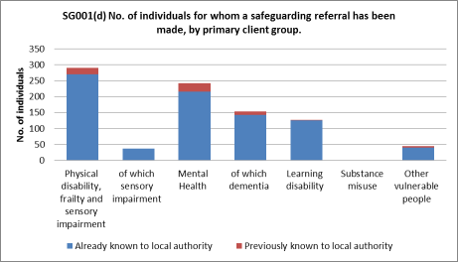

Type of abuse or risk

The chart below shows that most of the referrals relate to neglect or acts of omission, followed by physical abuse and financial and material abuse.
Where neglect is suspected, the individual believed to be the source of risk or abuse is more likely to be employed by social care services, such as residential or domiciliary care.
Where physical, psychological and financial abuse is suspected, the individual believed to be the source of risk or abuse is more likely to be someone known to the person, such as family members and friends. With financial abuse there was an equal number of referrals where the source of abuse or risk was known to the individual as there was when the source of risk was unknown or a stranger.

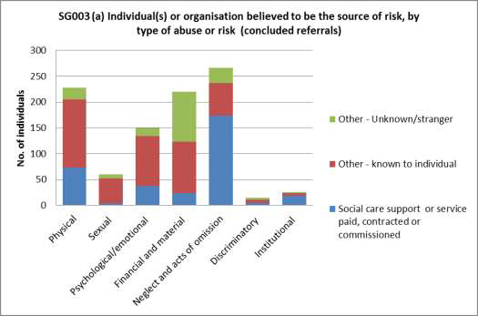

Location/setting of abuse or risk

The chart below shows that nearly all of the referrals received relate to abuse or risk in care homes (which includes residential and nursing homes) or a person’s own home. In care homes the source of risk is more likely to be from staff employed within the care home. Where it is suspected that the abuse took place in a person’s own home, the source of risk is much more likely to be a person known to the individual such as family or friend.

A small number of referrals relate to abuse suspected to take place in hospital.

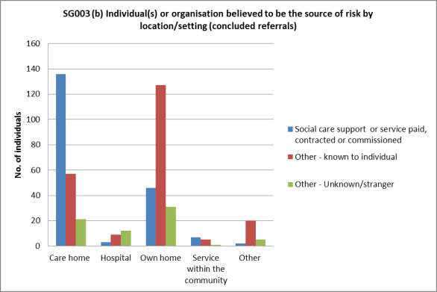

Action taken to support management of risk
For the first time this year we reported on the action taken as a result of the safeguarding work and whether risk was removed, reduced or remained. For nearly half of the completed safeguarding cases (47%) there was no further action under safeguarding.

The chart below indicates that where the source of risk is from social care support or paid service (which includes residential, nursing and domiciliary care) the safeguarding action removes or reduces the risk in nearly all cases (98%). Where the source of risk is another person known to the individual (this includes family members and friends but also includes GPs, other health workers and social workers) the safeguarding action still removes or reduces the risk in most cases (86%) but there is a greater proportion where the risk is reduced rather then removed.

There may be valid reasons why a risk is reduced rather than removed, and so this is not meant to be used as a stand-alone measure of performance. There may on occasion be cases where the abuse was not proven or it was inconclusive, but where action, for example of a preventative nature, was still taken.

Likewise there may be valid reasons why a risk remains, one of these being individual choice, and

so this is not meant to be used as a stand-alone measure of performance.

As this is the first time this has been measured in this way, it is important for us to exercise caution when considering what it tells us about our safeguarding work.
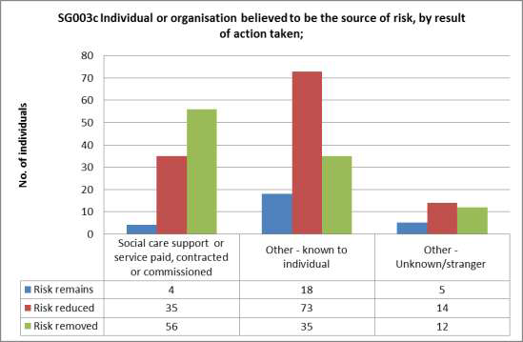

Assessment of capacity

The chart below shows the proportion of people who were assessed as lacking capacity to make one or more decisions in relation to safeguarding.

The chart shows that the proportion of people assessed as lacking capacity is relatively even across the age groups; however, there is a slightly higher proportion of people assessed as lacking capacity in the 65 to 74 and 75 to 84 age groups. In the younger age group 18 to 64, there is a higher proportion of people who did not lack capacity, that is they had capacity.

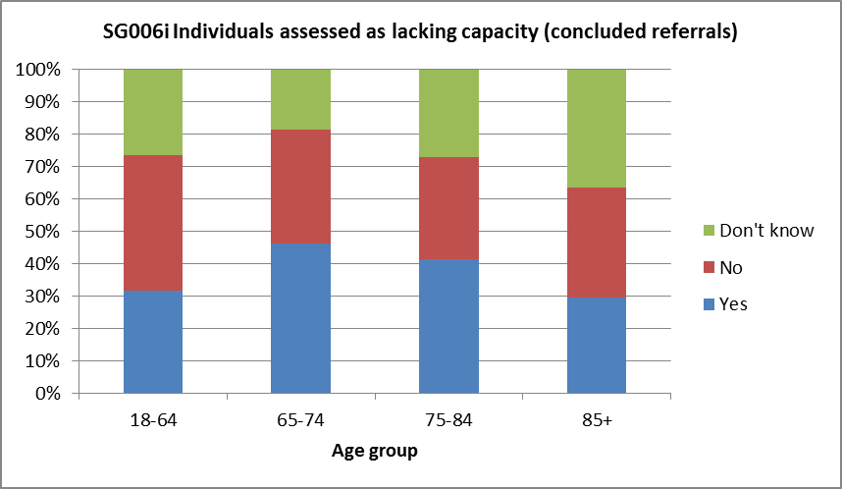

Definitions
Yes means that the person was assessed and was lacking capacity

No includes those that were assessed and found to be not lacking capacity, or they were not assessed because those who know them are all are clear that they do not lack capacity

Don’t know means that they were not assessed and we do not know if they lack capacity

The chart below shows that the proportion of people who were assessed as lacking capacity to make one or more decisions in relation to safeguarding and had the support or representation of advocate, family or friend. This shows that overall, many of the people did have this support (66%) although there were small variations between the age groups.

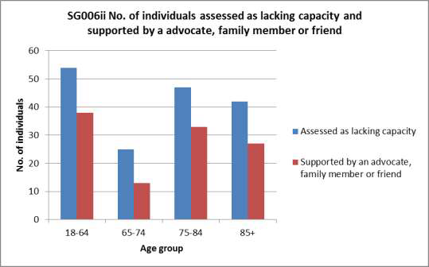

Measuring the outcomes from safeguarding; 2014/15

During 2014, 44 local authorities took part in a pilot study to establish if local authorities can practically use the survey to measure if adults at risk and those that support them think the safeguarding process is effective and to see if the survey is cost-effective. Each participating local authority was asked to survey 20 adults during a face to face interview over a period of 8 weeks and the results will be analysed and reported later in 2014. North Yorkshire is not taking part in this pilot but we will still use the findings to help plan our work.
Currently there are no national safeguarding outcome measures that focus on people who have been through an adult safeguarding case. This lack of data means it is not possible to make comparisons between councils as there is no national benchmark for whether adults at risk felt safer after a safeguarding investigation. It is therefore hard to identify best practice in a systematic way in adult safeguarding - or to share it across local authorities. The lack of outcome data also has implications for resource allocations. Commissioners have little way of comparing how well their council is performing in relation to others and whether more money or other resources is needed for effective safeguarding.

Quality and Performance Framework

This year we will use our Quality and Performance Framework to measure how well the Board is

doing and will act on what it tells us for these three questions.

- How safe are local people?
- Are local agencies working well to safeguard people?

- Do people feel better and safer as a result of our work?

Safeguarding partners keeping people safe from abuse and neglect.

  - North Yorkshire County Council – Health and Adult Services

Last year Health and Adult Services:

    - Worked closely with our partners on the Safeguarding Adults Board to respond to the health changes and safeguarding requirements in the Care Act.

    - Continued to respond to the requirements of the Winterbourne View Concordat; in particular to ensure that people in out of county placements are reviewed and supported to move to community based support where appropriate.

    - Continued to raise awareness of safeguarding concerns amongst vulnerable adults, their family and friends through promotion of the Safeguarding Adults Awareness Campaign.

    - Responded to the Serious Case Review in respect of ‘Robert’ by making sure that there are closer connections between out of hours operations and day time services and an increased understanding around safeguarding.

    - Promoted the use of the booklets called ‘what happens after you have reported abuse’ to ensure that people understand what safeguarding means. We continued to use the views of people about their experience of safeguarding and how they want to be involved to influence safeguarding policy, practice and training. We supported the roll out of safeguarding training for people with learning disabilities.

    - Increased the understanding of good safeguarding practice and promotion with safeguarding managers by using and reviewing the Decision Support Tool and Safeguarding Risk Assessment process.

    - Set up a new dedicated safeguarding adults’ business support team.
    - Undertook a Domestic Abuse training needs analysis for Health and Adult Service’s staff and commissioned learning solutions to meet the identified needs.

This year Health and Adult Services will:

    - Make sure that we are following the national guidance for the Care Act. This means that we will introduce new procedures and ways of working; we will make sure that staff have the right training and our partners understand the changes.

    - Develop a programme to adopt ‘Making Safeguarding Personal’ and make sure that people with care and support needs have a real say in their safeguarding investigation.

    - Continue to raise awareness of safeguarding concerns amongst partner agencies, working closely with Healthwatch and the Police. Introduce improved information sharing arrangements with police and health safeguarding leads.

    - Increase understanding of good safeguarding practice and promotion with safeguarding managers in Sensory Services.

    - Introduce a new practice based ICT system to support safeguarding practice and to support the Safeguarding Adults Board’s Quality and Performance Framework.

    - Continue to make sure that safeguarding investigations and are carried out effectively and professionally and that staff are supported to develop their practice. A rolling programme of practice workshops will take place.

    - Continue to work with our provider services to help understanding of when to raise a safeguarding concern and ensure that safeguarding responses are proportionate to the risks identified.

North Yorkshire County Council – Trading Standards and Planning Services

Last year the Trading Standards service continued to work towards two key performance indicators:
    - Achieving a further reduction in doorstep crime incidents of 10% by March 2015 compared to the baseline established in 2011/12.

    - Achieving a further increase of 20% in reporting of doorstep crime by March 2015, compared to the baseline established in 2011/12.

Good progress was made towards achieving both targets although there is an understanding that with increased reporting comes potentially a greater number of crimes. To address this, we are working out how to identify those complaints involving those vulnerable consumers who are affected the most so that we can respond to those first.
All Investigations and safeguarding staff have received safeguarding training and officers continue to identify vulnerable adults as part of their daily work. Officers make safeguarding referrals and attend safeguarding meetings as required.

The officers also attend the Police-led Multi Agency Partnership meetings in each of the districts of North Yorkshire where partner agencies work together to help and support vulnerable people.

There were some very important cases. Operation Opal
In February 2014, Trading Standards successfully prosecuted the Croke family from Pickering after the father and two sons defrauded a man suffering with Parkinson’s out of £100,000 as a result of overcharged and unnecessary property repairs and then a further £250,000 as a result of a fraudulent holiday cottage investment. In Crown Court they all received prison sentences which were increased on appeal.
Welfare visits – National Scams hub

Trading Standards is working with the National Scams Hub to assess the vulnerabilities of residents who are targets for frauds and scams. The hub has identified 747 people in North Yorkshire who could be victims. Trading Standards officers visit these people to ensure their welfare and to empower them to stop responding to these requests for money which are invariably fraudulent.
Trading Standards recognises that the welfare visits involve a lot of work and is looking to see if it can employ a Welfare Officer to help with the visits and stay in contact with victims from our criminal investigations. This would mean that the criminal investigators would have more time for investigations.
No Cold Calling Zones

We have now set up 527 No Cold Calling Zones in and around North Yorkshire to help protect vulnerable residents from the dangers of doorstep crime. Surveys of these zones are done every three years to make sure they remain effective and necessary. Almost all of the people surveyed said that their zone had reduced cold calling (91%) and they now feel more confident in sending cold callers away (93%). 72% said that their fear of crime had reduced since the zone was set up and 78% said that they were better prepared and more willing to protect neighbours from cold callers.
Health and Well-being

Trading Standards will be working with Health and Adult Services to prevent anti-social behaviour caused by alcohol and tobacco by preventing the sale of alcohol and tobacco to minors, ensuring only genuine, duty paid product is sold in the North Yorkshire shops and providing education and advice to traders as to their legal and social obligations.
We are also looking at the sale of psycho-active substances (legal highs) in key areas of North

Yorkshire, assessing what can be done to protect communities from the abuse of these drugs.

Trading Standards staff have delivered many talks to partner agencies and community groups, to raise awareness and increase reporting of doorstep crime.

This year Trading Standards will continue to work towards two key performance indicators:

    - A further reduction in doorstep crime incidents of 10% by March 2015
    - A further increase of 20% in reporting of doorstep crime by March 2015

Clinical Commissioning Groups – in North Yorkshire

Last year continued to be a busy time for the Clinical Commissioning Groups (CCGs) in the area covered by the North Yorkshire Safeguarding Adults Board as they worked through their authorisation process to ensure that all services that are commissioned are safe and protect the vulnerable of the population. The four CCGs that cover the North Yorkshire area also worked together with the Airedale, Whafedale and Craven CCG
The four CCGs within North Yorkshire continued to work within the joint working framework to support the implementation of the adult safeguarding agenda across the area. The Safeguarding Team (CCGs) is led by a Director of Partnerships and a Designated Professional for Safeguarding Adults.
The team was further strengthened with a number of Safeguarding Officers to support the work of the Designated Professional for Safeguarding Adults. It is still expected that the Director and the Designated Professional will attend the Board to maintain the support in the areas for commissioning and clinical advice.
The team remains committed to partnership working with the County Council along with other agencies in the area and is looking at ways to further enhance this work to ensure that North Yorkshire Safeguarding Adults Board is able to fulfil its objectives.
The Safeguarding Team for the CCGs continues to co-ordinate the Health Partnership Group.

Airedale, Wharfedale and Craven CCG (AWC CCG)

Airedale Wharfedale and Craven Clinical Commissioning Group formed in April 2013 and works with NHS England to arrange NHS funded services on behalf of the people who live in the Craven District of North Yorkshire.
Preventing and protecting people from abuse is one of the highest priorities for the CCG.

Airedale Wharfedale and Craven have come together with Bradford City CCG and Bradford District CCG to form a shared safeguarding team covering adults and children. As well as

representing the CCGs on safeguarding boards and providing advice within the organisations, the safeguarding team also provide advice and support to the wide range of health providers across the district.

Last year Airedale, Wharfedale and Craven CCG:

    - Welcomed a Named GP for Safeguarding Adults to the CCG safeguarding team. As a practicing GP, the post-holder brings new expertise to the team and will use her dedicated safeguarding time to lead and support the development of safeguarding adults within GP practices. This involves supporting safeguarding leads from each GP practice and helping to deliver safeguarding adults training to GPs across Craven.

    - Continued to support the work of the Safeguarding Adults Board, through regular attendance at board meetings and active membership of its sub-groups.

    - Provided regular safeguarding reports to committees and the governing body within the CCG, in order to keep them up to date about safeguarding issues and developments.

    - Continued the CCG work to make sure that we share clear safeguarding expectations with all our providers, ensuring that that all contracts include appropriate safeguarding standards that providers are expected to meet.

    - Delivered face-to-face training to help CCG staff, who may not have direct contact with service users and patients, think about how they might recognise abuse and contribute to safeguarding within their particular job.

    - Gave individual advice and support to staff who were worried about possible abuse and who may need help to make an alert into the multiagency safeguarding procedures. We regularly talk to staff who need to discuss complex safeguarding situations or mental capacity related issues and represent the CCG at multiagency safeguarding meetings where there are concerns about abuse within local health funded services.

    - Continued to support other safeguarding related work, such as Domestic Abuse, the Violence Against Women and Girls Strategy, Domestic Homicide Reviews and the Prevent initiative, which aims to stop people who are at risk of being radicalised from becoming terrorists.

This year Airedale, Wharfedale and Craven CCG:

      - Is committed to working at all levels, to safeguard adults from abuse.
      - Will continue work with our health providers and multi-agency partners, in order to safeguard adults across North Yorkshire.

North Yorkshire Police

North Yorkshire Police is committed to protecting vulnerable people and taking action against those individuals who commit crimes against them. To do this we will:
    - Investigate possible crimes and conduct joint investigations with partners
    - Gather best evidence to maximise the prospects for prosecuting offenders
    - Achieve, with partners, the best protection and support for the person suffering abuse or neglect – including victim support

Last year North Yorkshire Police has:

    - Implemented a new Safeguarding Hub and Central Referral Unit (CRU) in York with local partners to enable police officers, analysts and specialist staff to work to protect those most vulnerable within our communities.

    - Supported victims by opening Bridge House, a new Sexual Assault Referral Centre in York providing medical, forensic services and support for anyone who has been sexually assaulted where they can receive assistance anonymously without police involvement if they so wish.

    - Improved care to vulnerable people by introducing a new secure health-based 'Place of Safety' in hospital, so that people detained under the Mental Health Act no longer have to be locked up in police cells.

    - Given additional resources to the Protecting Vulnerable Persons Units. Staff continue to receive training to assist them in offering the best service possible. Uniform colleagues also benefitted from training events and inputs highlighted, as these are on most occasions the first responders to safeguarding concerns.

    - Developed a close working relationship between local Safer Neighbourhood Teams, specialist Protecting Vulnerable Persons officers and partnership agencies. This resulted in identifying and addressing cases of vulnerability through a range of methods including the district level Multi-Agency Problem Solving (MAPS) groups. In this way we were able to focus on our key priority of understanding harm from a victim’s point of view.

    - Continued to raise awareness of domestic abuse by delivering training and awareness sessions, particularly around violence in families.

This year North Yorkshire Police will continue to support the priorities of the Police and Crime Commissioner.
    - We will work towards improving services for victims. The Police and Crime Commissioner intends to commission new services for victims, especially of the most serious cases.

More victims will receive services. In addition, the way victims are supported by the police will be enhanced and new ways of assessing help will be introduced for all victims of crime.
    - We will deliver more effective services and support through the Protecting Vulnerable People unit of North Yorkshire Police and work effectively with key partners to develop better services and support for vulnerable people – including data sharing and practical problem-solving.

Outcome: Vulnerable people will be a priority and their needs will be met leading to higher satisfaction rates and greater confidence levels
    - We will work with partners, in particular health colleagues, to help deliver key services to protect vulnerable people and increase prosecutions for sexual assaults.

Outcome: Ensure that there is Section 136 ‘Place of Safety’ provision covering all areas of North Yorkshire
Outcome: Ensure long-term funding for a Sexual Assault Referral Centre (SARC) providing medical, forensic services and support for anyone who has been sexually assaulted
Everyone’s business: Improving the police response to domestic abuse

Domestic abuse has been in the media spotlight after the publication of Her Majesty’s
Inspectorate of Constabulary’s report in March 2014 into how Police Forces deal with these
distressing crimes. While the national media have painted a bleak picture of the police’s attitude to domestic abuse, North Yorkshire Police’s report reflects the excellent work and progress we have made over the years.
Before the inspection, we had already identified areas for improvement and put measures in place to address them. This work is set to continue to improve our response to domestic abuse even further and there are many examples of good work in the report.
Singled out as examples of good practice are:

    - The Protecting Vulnerable Person’s Units (PVPUs)
    - Investment in the PVPUs, and training for staff against a background of severe financial cuts

    - Working with our partners
    - The Making Safe scheme – a scheme to re-house the perpetrators of abuse
    - Specially Trained PCSOs who work with medium and standard risk victims to provide

safety planning

North Yorkshire Police and its staff remain committed to delivering a quality service and supporting victims of domestic abuse.

The Domestic Violence Disclosure Scheme

The Domestic Violence Disclosure Scheme (DVDS), also referred to as “Clare’s Law”, started in York and North Yorkshire in March 2014 as part of the national rollout. The aim of the scheme is to give members of the public a formal way to make enquiries about an individual who they are in a relationship with, or who is in a relationship with someone they know, and there is a concern that the person may be violent towards their partner. This is a significant step forward in relation to safeguarding individuals and their children.
We made sure that our safeguarding partners knew how to use the scheme and could promote it with the people they work with.

National Probation Service - North Yorkshire

This year the probation service has changed because of the government strategy called “Transforming Rehabilitation: A Strategy for Reform.”
A new National Probation Service (NPS) was formed on 1 June 2014, which is responsible for managing offenders who pose a high risk of harm to the public, managing Approved Premises, victim liaison work, and other public interest assessments, such as reports for court and for parole hearings, and the undertaking of breach proceedings.
Other probation work, including managing medium and low risk cases is currently managed by a Community Rehabilitation Company (CRC), until new contracts are awarded later this year.
The National Probation Service North Yorkshire is in the North East Division, stretching from Lincolnshire to Northumberland, and the CRC covers North Yorkshire, Humberside and Lincolnshire which means greater opportunities to work together and share best practice.
During this change, we have stayed committed to providing high quality services and key priorities of public protection, reducing reoffending, and safeguarding.
As part of the Multi-Agency Public Protection Arrangements (MAPPA), we have worked closely with Adult Services and Health, to manage the risk and support the resettlement of offenders with complex needs. We continue to encourage other agencies to come to MAPP meetings, and to this end we take part in MAPPA/MARAC awareness raising training, and have offered specific events to single agencies, including Adult Social Care.
The HMI Probation inspection report in 2014 found that ‘overall work with offenders was

delivered to a high standard,’ and ‘safeguarding was given a high priority at all levels.’ This year the Probation Service will:
- Continue our work with health, to improve access to services for offenders with personality disorder. This is now working well in our field teams, where a dedicated psychologist works with offender managers to support them to manage those vulnerable service users with personality disorder, who are at high risk of harming others.

- Develop our Approved Premises into a Psychologically Informed and Planned Environment (PIPE). There will be a psychologist and a psychology assistant based in the Approved Premises who will work with the staff team and residents to develop a structured programme of rehabilitative activities, and enhance the skills of staff to manage challenging behaviour and supporting vulnerable residents.

- Work to ensure that changes we have described do not impact on service delivery. We will work to embed a joined up approach to public protection and rehabilitation and to promote best practice across the new probation structures.

North Yorkshire District Councils

Last year the seven District Councils in North Yorkshire:

    - Adopted safeguarding training plans to increase awareness and ensure that relevant staff are adequately trained, including Mental Capacity Act training delivered via the NY Housing Training Group.

    - Contributed to the Suicide Prevention Task Group.
    - Contributed to the delivery of the Prevent strategy.
    - Contributed to the delivery of Serious Case Review Action Plans.
    - Provided a District Council and Community Safety perspective on Local Safeguarding Adults Groups.

This year District Councils will:

    - Continue to deliver appropriate training and keep their staff informed of changes and developments in relation to safeguarding.

    - Review their policies and procedures for Safeguarding of Children and Vulnerable Adults.
    - Develop information and guidance for Parish /Town Councils.

    - Respond to recommendations from Serious Case Reviews.
    - Respond to recommendations from further Section11 Audits.
    - Review safeguarding arrangements in relation to licencing.
    - Contribute to improvements in E Safety.
    - Contribute to the delivery of a Suicide Prevention Action Plan.

Safeguarding leads for the seven District Councils meet as a group to consider safeguarding
issues and to support the work of the Adult and Children’s Safeguarding Boards. In 2014/15 this group will:
    - Continue to provide a networking opportunity for District Council safeguarding leads focusing on the role and responsibilities of District Councils with regard to Safeguarding of Children and Vulnerable Adults.

    - Continue to provide a District Council and Community Safety perspective on Local Safeguarding Adults Groups.

    - Monitor delivery of those elements of the North Yorkshire Safeguarding Adults Board Strategic Plan of specific relevance to District Councils.

North Yorkshire Fire and Rescue Service

The safeguarding team delivers a range of referral schemes for young and vulnerable members of the community, ensuring they are aware of information about the risk of fire and make recommendations if needed to ensure safety.

Last year North Yorkshire Fire and Rescue Service:

    - Rolled out a training programme to frontline staff and those who come into contact with vulnerable people
    - Continued to support vulnerable people across the county
    - Ensured our policies and procedures were consistent and accessible to all
    - Ensured we were in line with changing legislation in relation to safeguarding
    - Continued to keep our staff informed of changes and developments in relation to safeguarding

This year North Yorkshire Fire and Rescue Service will:

    - Continue to provide safeguarding training to frontline staff and those who come into contact with vulnerable people
    - Provide training on Prevent (anti-terrorism agenda) to operational staff to assist with community safeguarding

    - Continue to support vulnerable people across the county
    - Continue to ensure our policies and procedures are consistent and accessible to all
    - Continue to ensure we are in line with changing legislation in relation to safeguarding
    - Continue to keep our staff informed of changes and developments in relation to safeguarding
    - Continue to expand our network of referring agencies in relation to safeguarding

Independent Care Group

The Independent Care Group (ICG) is a member of the Safeguarding Adults Board. It acts as a two way channel of information. It raises issues from the independent care sector and communicates safeguarding priorities to its members.

Last year the Independent Care Group:

    - Regularly promoted the free training in Safeguarding Adults, the Mental Capacity Act and DoLS

    - Promoted Safeguarding Adults Level 1: Alerter Champion (Train the Trainer) course for managers

    - Promoted the Kwango e-learning in Safeguarding Adults, Mental Capacity Act and DoLS and how to access it

    - Highlighted issues around abuse at the Winterbourne View private Hospital to its members
    - Promoted information and resources on preventing pressure sores and when they have to be reported under safeguarding. Also promoted Tissue Viability training

    - Disseminated news from the Disclosure and Barring Service (DBS) including letting providers know how to join the DBS Update Service

    - Helped individual members to understand when to send in a Safeguarding Alert when they are dealing with new, difficult and confidential issues

    - Promoted the North Yorkshire Safeguarding Adults Board Annual Report 2012-13 and where to download it

    - Promoted the updated Inter-agency Safeguarding Adults Alert Form
    - Promoted the MCA application forms and where to obtain them

This year the Independent Care Group will:

    - Obtain information from members to help the NYCC Care and Independence Scrutiny

Committee better understand financial abuse and where and how it occurs

    - Promote the updated Safeguarding self-assessment tool for providers

North Yorkshire and York Forum (NYYF)

Last year North Yorkshire and York Forum

    - Continued to promote awareness of safeguarding issues within the voluntary, community and social enterprise sector.

    - Provided training sessions on use of its Disclosure Service, which includes discussion of safeguarding issues. Eight training courses were delivered to 71 organisations, seven of which were new clients. A total of 94 people received training during 2013/14. 38 of these were new authorised signatories, and the other 56 existing signatories received refresher training.

    - Provided up to date information regarding legislative changes, particularly the update service which was launched in June 2013.

This year the Forum will continue to offer a secure and efficient Disclosure service in 2013/14 and will continue to engage with partners on the Safeguarding Adults Board as the service develops.

