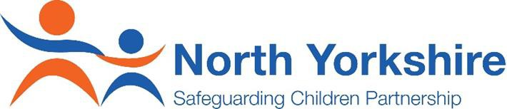
Drug Early Warning and Alert System
(May 2020)

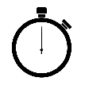
One Minute Guide

What is the Drug Early Warning and Alert (DEWA) System?
The process through which local, regional and national illicit drug intelligence is reported,
investigated and cascaded across the North
Yorkshire ‘system’ (e.g. statutory agencies, services).
It has been designed to reduce the risk of potential harm or death related to drug misuse.
It is intended for a professional audience – not the public.
What should be reported?
- Known and/or potential risks from the following highlight typical examples of what should be reported:
- Purity/contamination of illicit drug supplies in circulation;
- New novel psychoactive substances (also known as ‘NPS’);
- Diverted prescribed medications;
- Drugs recently seized by North Yorkshire Police;
- Health protection alerts related to substance misuse (such as drugs contaminated with infectious agents);
- Adverse effects after consumption by a person or group of people – such as ambulance call out, A&E attendance
How is information reported?
- Organisations should share any information they are concerned about with the North Yorkshire Public Health team, as follows:
- Email: nypublichealth@northyorks.gov.uk
- Phone: 01609 536962/ 07811 667681
- Where possible, this information should be shared by completing this Intelligence Form. However, we also accept information via the contact information as listed above.
The North Yorkshire Public Health team will confirm receipt of the information within 2 working days.
What happens once information has been submitted?
All information is reviewed utilising a set of screening questions to ascertain the level of risk; and
information is corroborated with relevant agencies and services to develop intelligence and ascertain validity.
If risk of harm is felt to be significant then a Drug Alert will be issued using agreed pro-forma.
If information cannot be substantiated or the risk is identified as low, then information may be issued to relevant organisations for reference and vigilance purposes only.
Who receives Drug Alerts?
The distribution of alerts will depend on the severity and scale of the Alert – ranging from local to national contacts. A key list of organisations is held by the
Public Health Team. Schools and other young people’s services will receive relevant communication through Children and Families Services (NYCC).
All Alerts are issued with a withdrawal date to ensure the alert has maximum impact.
Drug Alerts also contain links to other resources e.g. Talk to Frank.
It’s important to remember that the Drug Early Warning and Alert Protocol does not replace the responsibility of professionals to report concerns to the Police
(Intelligenceunit@northyorkshire.pnn.police.uk), or refer to Children or Adult Safeguarding or services
(referral forms for both can be found in the hyperlinks above).

Any further questions, please feel free to contact: nypublichealth@northyorks.gov.uk

