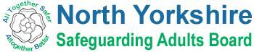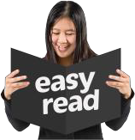

It is important that everyone has the information they need to be safe and feel safe.

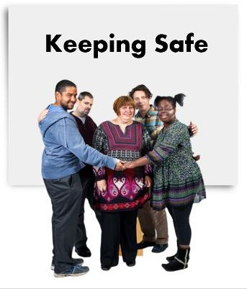
We worked with self-advocates from the North Yorkshire Learning Disability Partnership Board and Inclusion North to make easy read books about Keeping Safe.

- 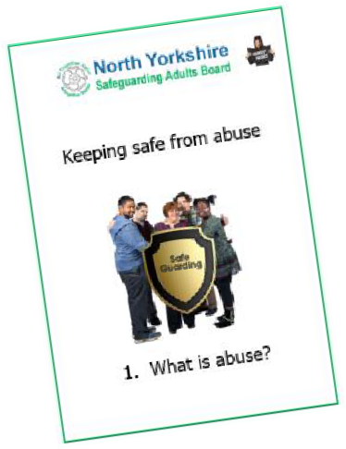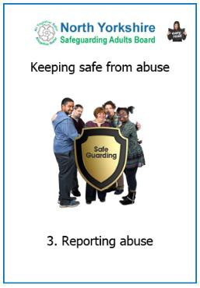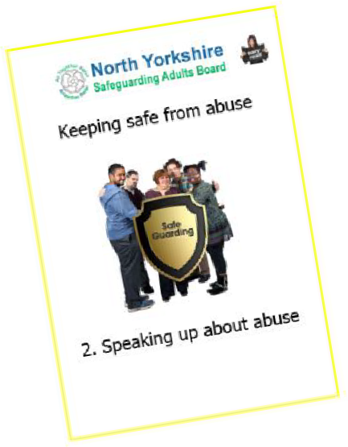Book 1 is about different types of abuse that can happen.

- Book 2 is about telling someone about abuse that is happening

- Book 3 is about making a report to the North Yorkshire Safeguarding Adults Board

All the books are free on our website: http://safeguardingadults.co.uk/keeping- safe/easy-read-guides/

