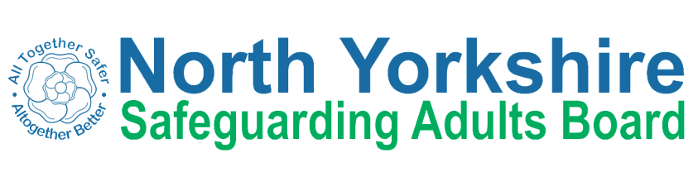
Safeguarding Adults Review Referral Form

North Yorkshire SAB considers every SAR referral based on whether it meets the criteria for a Safeguarding Adults Review.

The Board needs as much information as possible to enable members to make a proportionate decision as to how to respond to a SAR referral, ensuring, if the case is accepted for a review, that maximum learning can be achieved. Please therefore complete as much information on this form as possible.

If you have any questions, please do not hesitate to contact the SAB Business Unit via nysab@northyorks.gov.uk
A Safeguarding Adult Review will only be considered if Section 1 (below) is met and Section 2 or 3 are met. Please select all that apply.
1. | There is reasonable cause for concern about how the North Yorkshire Safeguarding Adults Board, its members or organisations worked together to safeguard this adult.
2. | The adult died and the North Yorkshire Safeguarding Adults Board knows/suspects this was as a result of abuse or neglect.
3. | The adult is still alive but the North Yorkshire Safeguarding Adults Board knows or suspects the adult has experienced serious abuse/neglect, sustained potentially life threatening injury, serious sexual abuse or serious/permanent impairment of health or development.

Details of adult at risk:
Name
Date of birth
Date of death (if applicable)
Ethnicity
GP (if known)
Family/next of kin/advocate/representative
Health and/or other care and support needs

Brief Details of the Incident
Main type of abuse/neglect identified: |  |  |  | Choose an item.
Other types of abuse/neglect identified (please tick as appropriate):
Discriminatory | Domestic Violence | Financial | Modern Slavery |  | Neglect
Organisational | Physical | Self-Neglect | Psychological |  | Sexual

Other Agencies Involved;
Name
Agency
Role
Address
Telephone number
E-mail

Details of individual/organisation referring the case for consideration for a SAR
Name
Position/designation
Organisation
Address
Contact telephone
Contact email

Safeguarding Lead
Position/designation
Contact telephone
Contact email

Date of request

ANY OTHER REVIEWS PENDING OR COMPLETED
(e.g. Serious Incidents, MAPPA, Domestic Homicide, Single Agency/Management Reviews, Children’s Serious Case Reviews, Police internal review processes, referred to Coroner).

Please return the completed document to nysab@northyorks.gov.uk

If a family member wishes to submit a referral for consideration, then they should submit their request in writing to the Independent Chair at;

Independent Chair
North Yorkshire Safeguarding Adults Board
c/o Health and Adult Services
North Yorkshire County Council
County Hall
Northallerton
DL7 8AD

