Appendix A
Useful links and resources
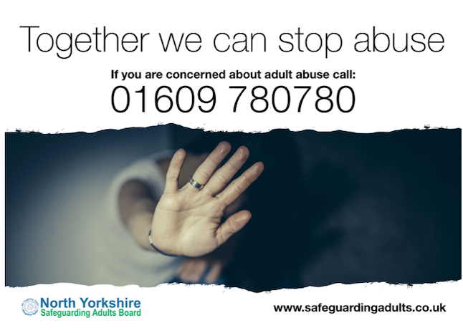
To report safeguarding concerns, you should contact North Yorkshire County Council on (01609) 780 780

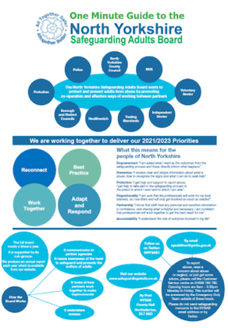
Safeguarding concerns should be report to North Yorkshire County Council. Do not report safeguarding concerns to the North Yorkshire Safeguarding Adults Board (NYSAB).

The NYSAB one-minute guide tells you all about the Board, what we do and who we are. You can find it here: https://safeguardingadults.co.uk/about-us

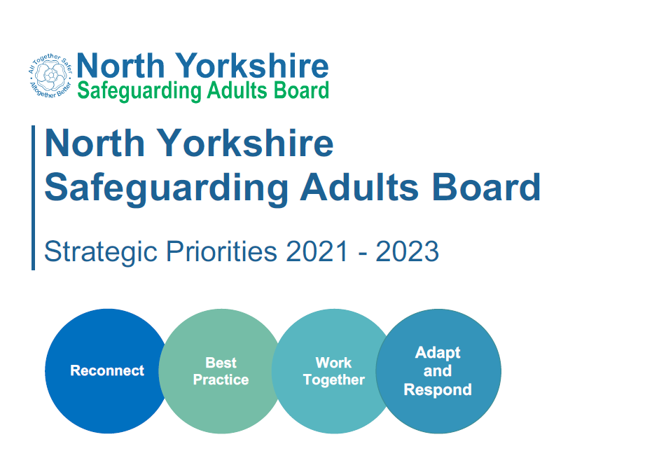

The NYSAB priorities tell you what the Board will be working on between 2021-2023. Our priorities can be found here on our website: https://safeguardingadults.co.uk/strategic-priorities

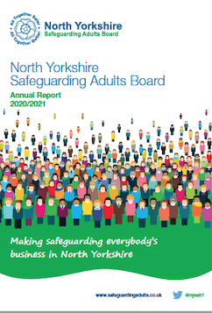

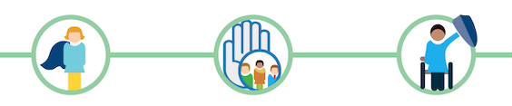
Our annual report tells you everything we have done over the past year. You can find our most recent annual report, along with an easy read summary, one page summary and audio easy read summary here: https://safeguardingadults.co.uk/annual-reports

Safeguarding Resources

Accessible safeguarding information
We have co-produced easy read keeping safe guides with the North Yorkshire Learning Disability Board and KeyRing Self Advocates. These books tell you about:

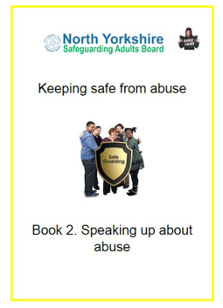
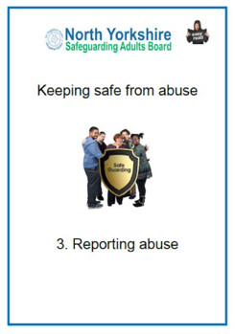
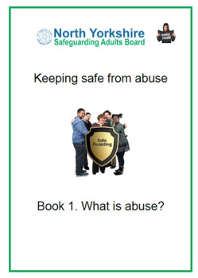
- What is abuse

- Speaking up about abuse

- Reporting abuse

The guides, along with audio versions, are available here on our website:

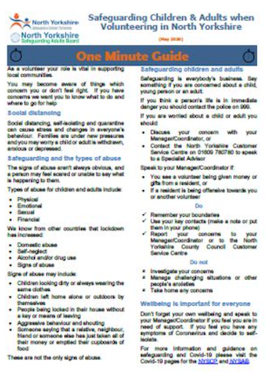
One-minute guides (OMGS)
Our OMGs are designed to provide bite sized information on key issues and areas of focus. The cover a number of areas from County Lines to Modern Slavery. All OMGs can be found on the NYSAB website:

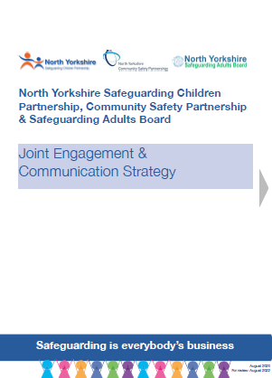
https://safeguardingadults.co.uk/one-minute-guides-omg

Policies and procedures

From our statutory Safeguarding Adult Review (SAR) policy to our joint Engagement and Communications strategy - all of our policies and procedures can be found here on the NYSAB website: https://safeguardingadults.co.uk/policies-and-procedures

