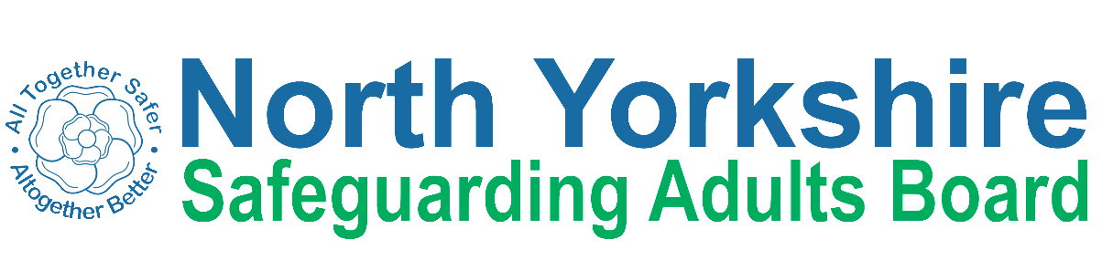
North Yorkshire Safeguarding Adults Board
Engagement Feedback: Easy Read summary
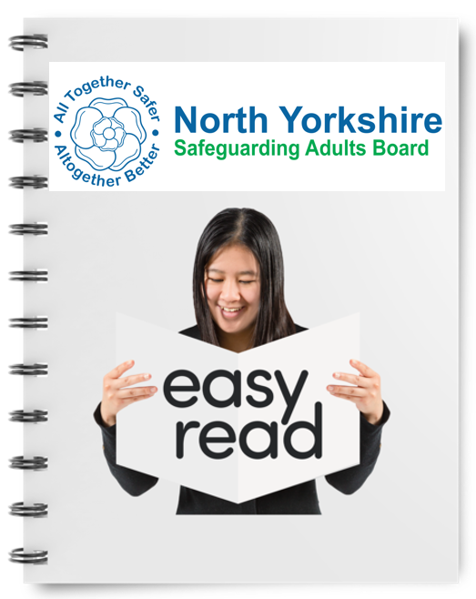 | This summary is from North Yorkshire Safeguarding Adults Board.
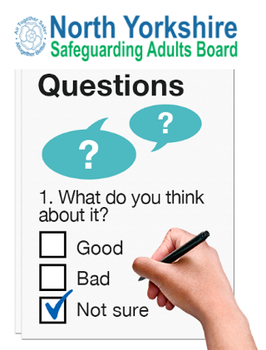 | It shares the feedback from people who took part in our survey and engagement sessions last year.  This summary sets out the questions we asked people and the things they told us.
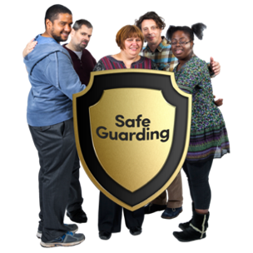 | These sessions were about safeguarding information, important safeguarding messages and ways people can talk to us about their safeguarding experiences.
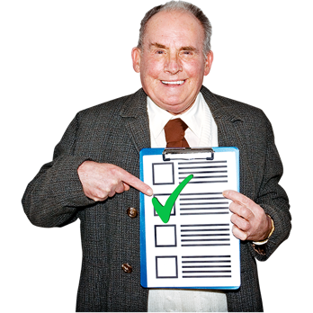 | At the end of this summary we have shared what we are going to about the things people told us and asked for.

What we asked

This section sets out all of the questions we asked people as part of our engagement.

- What do you know about the North Yorkshire Safeguarding Adults Board?

What you told us

 | Lots of people told us that they had heard about the North Yorkshire Safeguarding Adults Board but they do not know what the Board does.
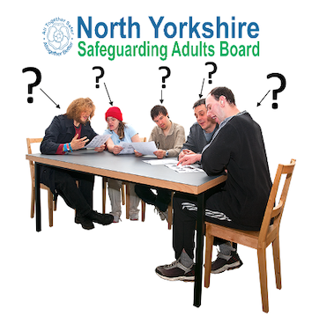 | People said they wanted to know which organisations are part of the safeguarding adults board.
What we asked

- Thinking about keeping yourself and others safe, what information and resources would you like from the North Yorkshire Safeguarding Adults Board?

What you told us

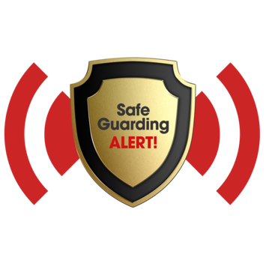 | People told us they would like to know who they report a safeguarding concern to and how they do this.
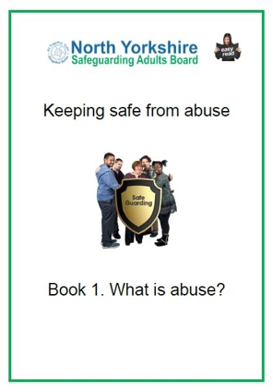 | People asked for clear information about what abuse is
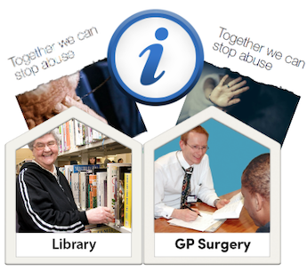 | People asked for keeping safe information to be available in public places like libraries and GP surgeries.
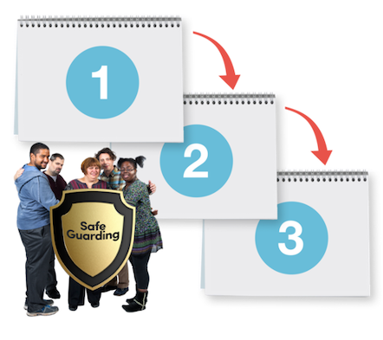 | People asked for a simple information or a chart showing them how the safeguarding process works.
What we asked

- How would you like the North Yorkshire Safeguarding Adults Board to produce these resources and information?
What you told us

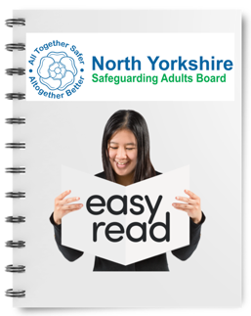  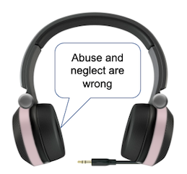  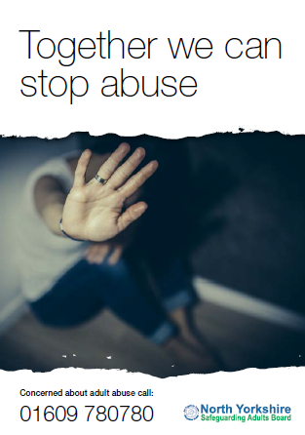  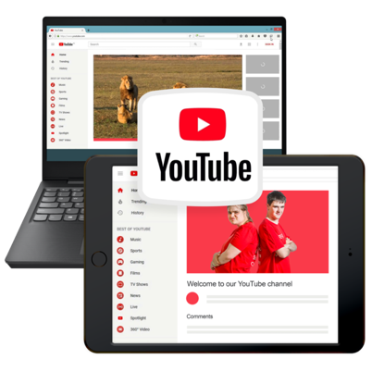 | People asked for information in:  Easy read guides  Audio versions and podcasts  Short videos  Posters and leaflets
What we asked

- How do you want to hear from the North Yorkshire Safeguarding Adults Board?
What you told us

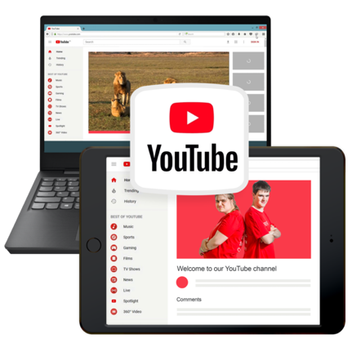 | People thought it would be a good idea for the NYSAB and the NYSAB Chair to do video updates to people and put these on YouTube.
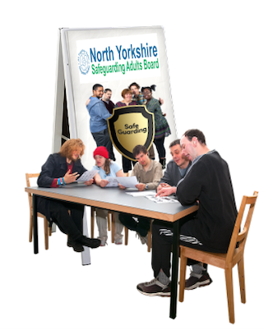 | People asked that NYSAB attend their local meetings to update them on important safeguarding information.  Groups can also update the NYSAB on what they are doing too.
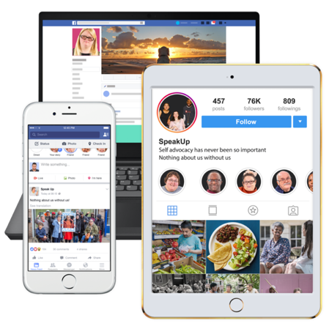 | People also asked that the NYSAB keep them up to date using social media and newsletters.
What we asked
- What do you want to tell the NYSAB?
What you told us

Some people said they were worried about the safeguarding process.
They said it would be helpful to have more information about the process that is simple and for easy to follow.

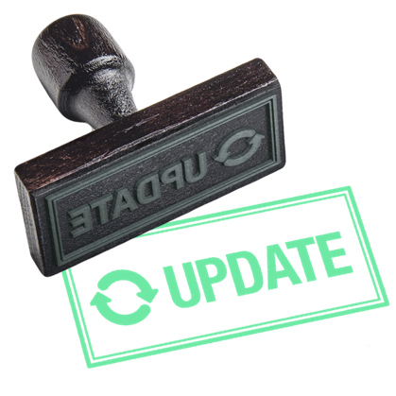 | Lots of people told us that change can be very confusing and sometimes it can be upsetting too.  They asked to be kept updated when big changes happen.
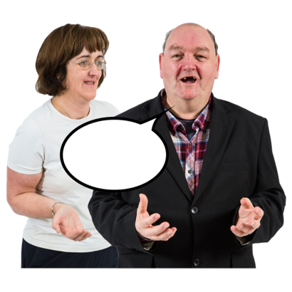 | People said they had access to an advocate who helped them and supported them through the safeguarding process.  They said this would be good to promote so everyone knows they can have an advocate if they need one.
What we asked

- How do you want to tell us this?

What you told us

People said they would like to tell us things by:

Talking to someone face to face

By filling in a survey or feedback forms

Sending emails

By having virtual calls on Zoom or GoTo

What we asked

- How would you like us to show that we have listened?

What you told us

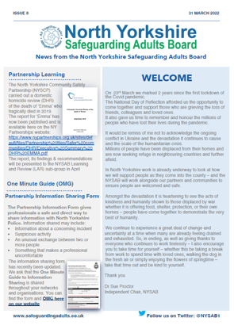 | People asked that we update them in a newsletter.
 | They asked that we meet with people with lived experience to talk about their feedback.
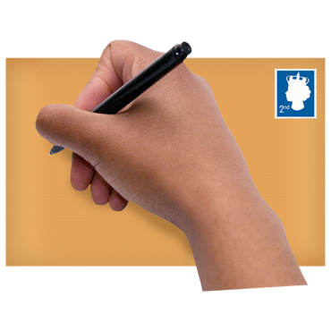 | Self-advocates said we could write a letter or do a video message to tell them what we are going to do about what people have told us.
What we asked

- Is there anything else you would like to tell us?

What you told us

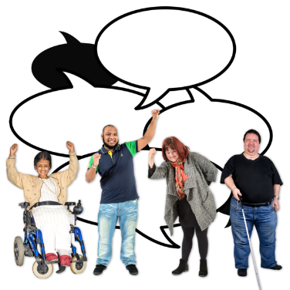 | If people have been through a safeguarding and want to talk to you, you should share their stories to help other people
 | We think the words people use can be confusing. Tell us things in a way we can understand.
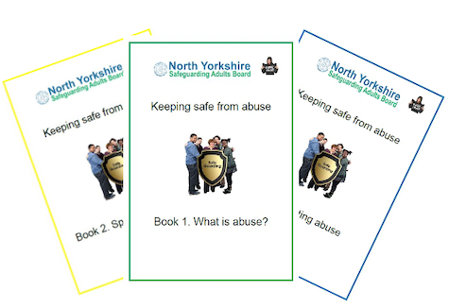 | Some of the organisations we work with said that they think the keeping safe guides are brilliant.  They said we should make more things like this with people with lived experience.
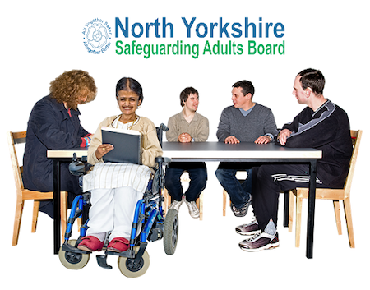 | Self-advocates told us that the NYSAB should get out and meet people and talk to them about what the Board does.  One self-advocate said the Board could have a safeguarding roadshow to raise awareness.
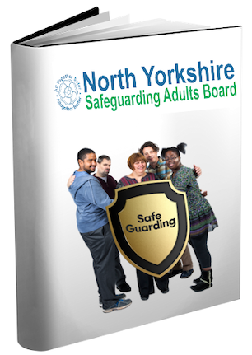 | Some more self-advocates thought we should do a storybook about safeguarding.  It would give people information and maybe help them feel better and less scared about safeguarding.
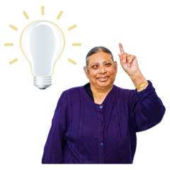 | We received feedback and ideas from lots of people.  It was really helpful and to hear what people would like and how we can improve the information we share and the way we engage with people.
We looked at everybody’s answers and we have turned these ideas into a list with 7 things we want to do.

These things are called recommendations and are actions we can take to make improvements and make things better for people.

These recommendations are in the next section of this summary.

What we are going to do about it

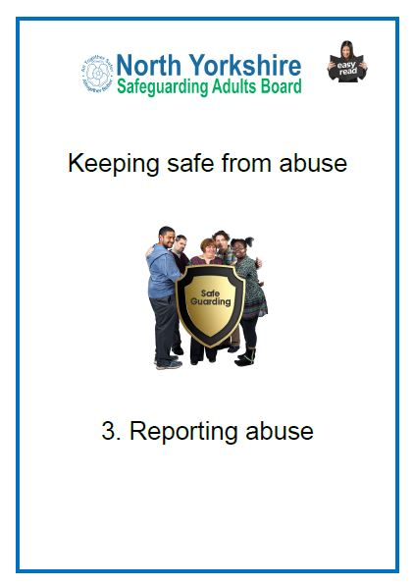  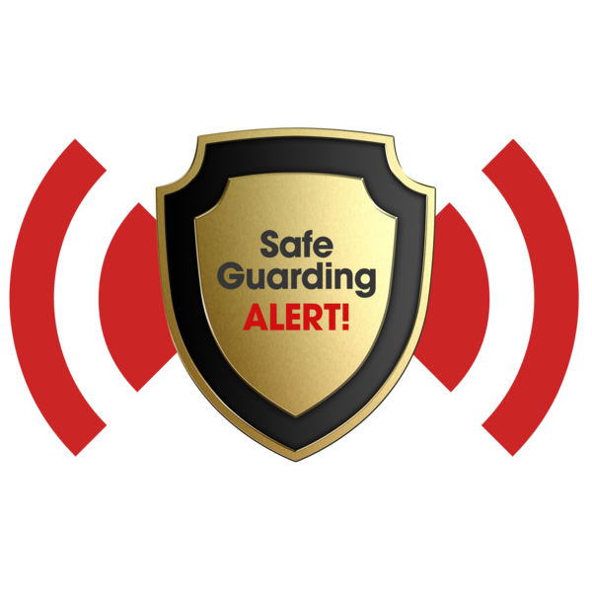 | - We will make sure people know how and where to report a safeguarding concern.
- We will host a campaign to tell people about the safeguarding information we have.

We will also make sure people can access this information.

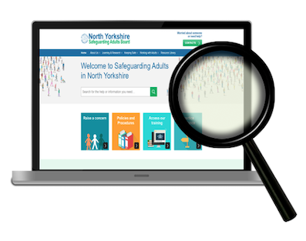 | - We will review all of our information to make sure it is accessible and what people need to understand safeguarding.
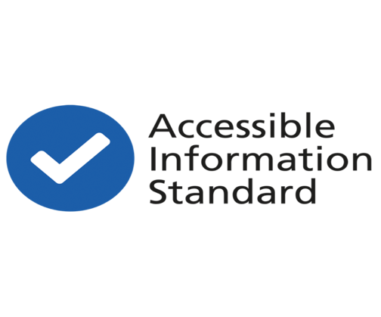  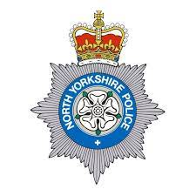  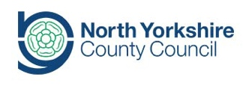  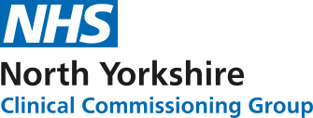 | - We will ask the that organisations we work with that they make their information accessible.  We will also ask that they communicate and engage with people about safeguarding.
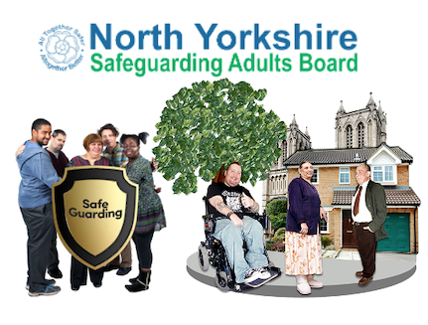 | - We will work with local communities and groups to raise awareness about safeguarding.
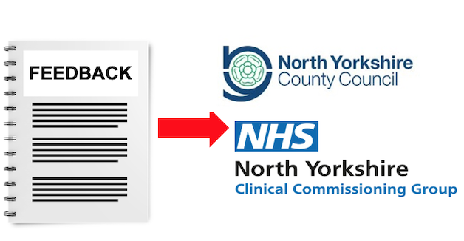 | - We will share the answers from this survey with organisations so that they can make changes.
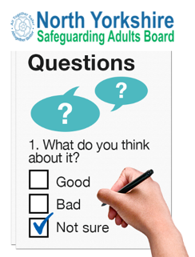 | - We will make sure that the Board and the organisations we work with provide opportunities for people to feedback and engage with their services.

Next steps

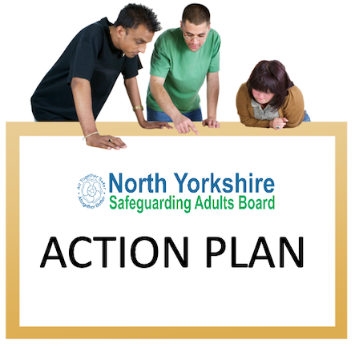 | Now that we have a list of things to do, we need to make an action plan.
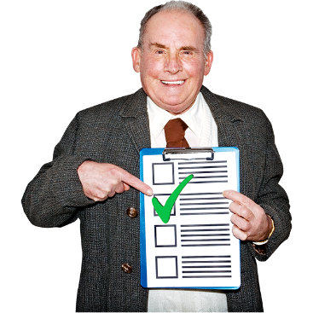 | An action plan will list the things we need to do and the people we need to involve.  This will be a way for us to show what we are doing and how we are doing it and who we will be doing it with.
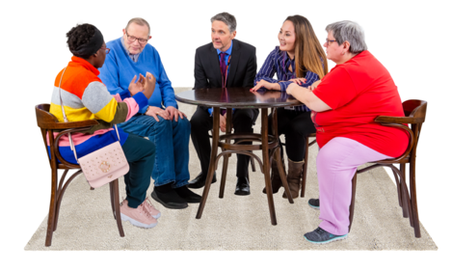 | We will talk to different groups about what we plan to do and how they can be involved and help us with these actions.  We will also share updates so everyone knows how well we are doing.

Get in touch with the North Yorkshire Safeguarding Adults Board

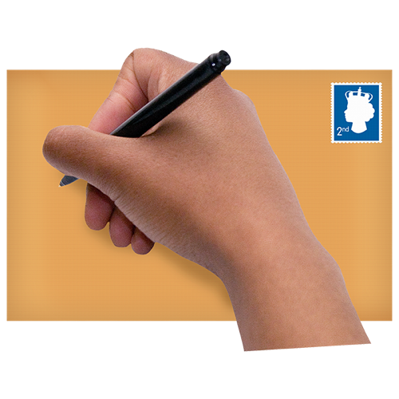 | You can write to us at:  North Yorkshire Safeguarding Adults Board  Health and Adult Services  County Hall  Racecourse Lane  Northallerton  DL7 8AD
You can email us at:

NYSAB@northyorks.gov.uk

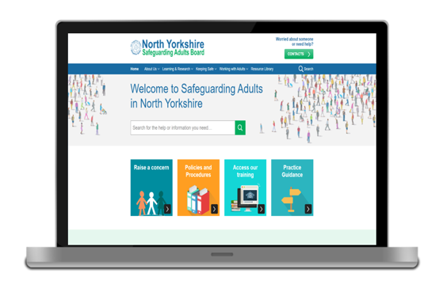 | You can visit our website:  https://safeguardingadults.co.uk-engagement-and-consultation

