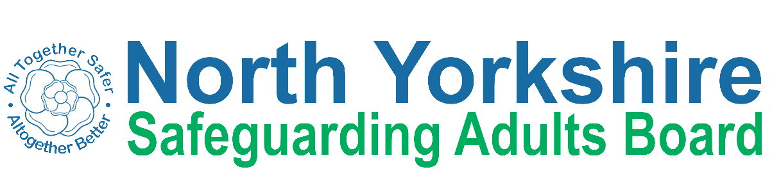
North Yorkshire
Safeguarding Adults Board

Engagement and Consultation 2021
Making
Safeguarding
Business
Everybody’s

Project overview
Between June – September 2021 the NYSAB went out to speak to as many people as possible. The purpose of this engagement work was to understand what information and resources the people of North Yorkshire wanted and to also identify meaningful and effective ways of engaging with the NYSAB and its partners.

We hoped that by engaging with and hearing from lots of people across North Yorkshire that we could do a number of things:

- Update the information we share with people, so they know how to keep themselves and others safe;

- Continue to look at ways we can work together to co-produce accessible information for all;

- Strengthen our engagement across North Yorkshire;

- Make sure our engagement is meaningful; and

- Listen to what people want and act on it.

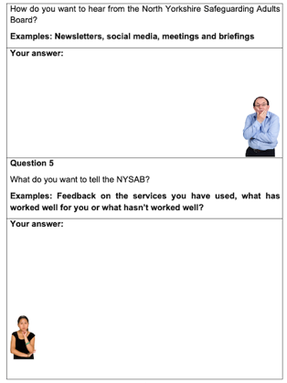

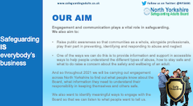
Due to the restrictions in place because of the Covid-19 pandemic, we were unable to carry out face-to-face engagement as planned and so we worked with the KeyRing self-advocates to co-produce an accessible survey.

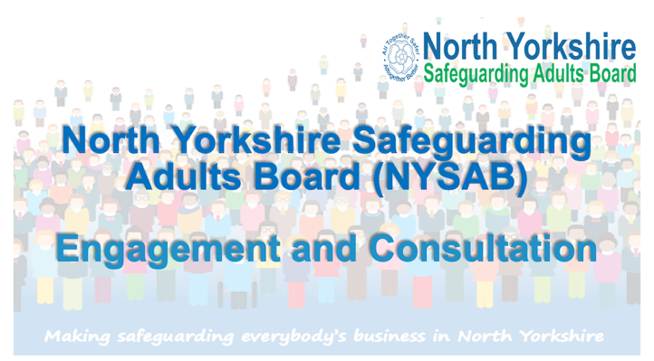

We also produced an accessible presentation for people to use and conduct their own engagement events. We also produced an online SNAP survey

We would like to thank everybody who has taken part in our engagement and consultation.

The feedback we received from this engagement and consultation will help the NYSAB understand what the best ways are to communicate with, engage with and listen to people about safeguarding across North Yorkshire.

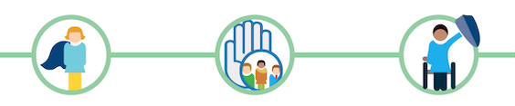

What we asked

We asked the following 4 questions to understand what people know about the NYSAB and safeguarding in general, and if they require further information, what this would be and how they would like to receive this

- What do you know about the North Yorkshire Safeguarding Adults Board?

- Thinking about keeping yourself and others safe – what information would you like from the North Yorkshire Safeguarding Adults Board?

- How would you like the North Yorkshire Safeguarding Adults Board to produce these resources and information?

- How do you want to hear from the North Yorkshire Safeguarding Adults Board?

We asked the following 4 questions to understand what people know about the NYSAB and safeguarding in general, and if they require further information, what this would be and how they would like to receive this.

- What do you want to tell the North Yorkshire Safeguarding Adults Board?

- How do you want to tell us this?

- How would you like us to show that we have listened?

- Is there anything else you would like to tell the North Yorkshire Safeguarding Adults Board?
Summary – What you told us

- Of the 392 people we engaged with - 25% (98 people) did not know what the NYSAB does.

- Of those who said they were aware of the Board and its purpose, 18% (70 people) believed that safeguarding concerns should be reported to the NYSAB and not the local authority.

- Almost everyone we spoke to wanted information about what the Board does and understand what its priorities are.

- In terms of safeguarding, people asked for information about what abuse is, how to spot the signs and how to report abuse. When we discussed the resources already available people said that they didn’t know that they were there.

- The most popular formats for information and guidance were one-minute guides, podcasts, short videos including YouTube clips, webinars, case studies.

- Almost all participants (97%) asked for information to be accessible for both members of the public and professionals.
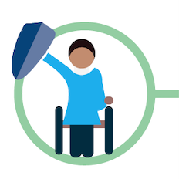
- At the 15 engagement events participants asked for information, guides and updates to be shared in ‘plain English’ with ‘no jargon’.

- People said that they liked the one-minute guides but would find it helpful if there was less jargon in these. If technical words had to be used in the guides, these should be explained.

- Both professionals and the wider public fed back that they found agencies still use inaccessible language, acronyms and jargon that ‘they may be able to understand – but we can’t’

- At the engagement sessions with professionals’ people fed back that some policies and guidance are very long and suggested having a one-minute-guide to go alongside so that the key details and any required actions for providers could be quick to read.

- Many professionals (89%) fed back that the wording and terminology used by organisations can be confusing and alienate people. This can lead to people feeling inadequate.

- At a meeting with family members and carers they asked that information is provided to them around what support is available for them if their loved one is being cared for.
- Appendix B sets out the detailed feedback which we received from people for each question we asked during the engagement.
We have analysed the answers and feedback people gave us and based on the feedback people gave, we have made seven recommendations which can be found on page 6 of this report.
Some of the he answers people have shared about how to report safeguarding concerns are not quite right and some of the things that people asked for we already produce.
We know that we need to make sure people know how to report concerns and about the resources we have these – and the feedback has helped inform our recommendations. In the meantime, we have put together a list of helpful links in Appendix A

What we will do about it

Recommendation 1
NYSAB and its partners to raise awareness to ensure the people of North Yorkshire know how and where to report a safeguarding concern.

Recommendation 2
NYSAB to develop a communications and engagement campaign for it and its partners to promote the Board’s existing safeguarding resources at both a strategic and local level.

Recommendation 3
NYSAB to review and update its existing suite of safeguarding information and resources to ensure it is in line with the feedback from the engagement and consultation as well as the Joint Engagement and Communication strategy – particularly in relation to accessibility.

Recommendation 4
NYSAB to seek assurance from its partner organisations that they are following and implementing the Joint Engagement and Communication strategy

Recommendation 5
Work with the third sector to raise awareness and increase knowledge around safeguarding in community settings.

Recommendation 6
NYSAB to share the findings from this review with organisations, in particular the NYCC safeguarding team, and seek assurance that, where appropriate, relevant and timely action has been taken.

Recommendation 7
NYSAB and its partners to ensure and evidence that they are providing meaningful and qualitative opportunities for people to feedback and provide their input.

Next steps

Now that we have made our recommendations, we will work with people across North Yorkshire to co-produce an action plan which will outline how we will deliver and implement changes.

There will be some things that we can do in the short-term, such as continuing with spreading the word and raising awareness - and other things that will take time as they require a lot of work and input – such as reviewing, updating and co-producing resources – but we feel these things are important.

We will be going back to people to make them aware of the changes we want to make based on their feedback and will keep people up to date with progress via our online channels but also engaging with people by attending groups and meetings to share what we are doing.

We will also provide our first full update in the NYSAB annual report for 2021 – 2022 which will be published later in the year along with a ‘You said – we did’ summary

You can keep up to date with progress on our dedicated webpage at https://safeguardingadults.co.uk/engagement-and-consultation

Appendix A
Useful links and resources
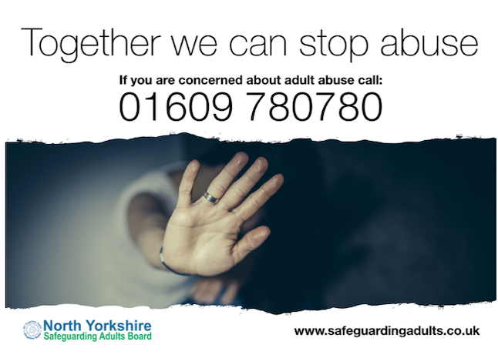
To report safeguarding concerns, you should contact North Yorkshire County Council on (01609) 780 780

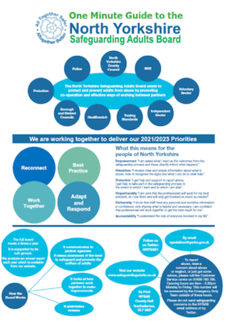
Safeguarding concerns should be report to North Yorkshire County Council. Do not report safeguarding concerns to the North Yorkshire Safeguarding Adults Board (NYSAB).

The NYSAB one-minute guide tells you all about the Board, what we do and who we are. You can find it here: https://safeguardingadults.co.uk/about-us

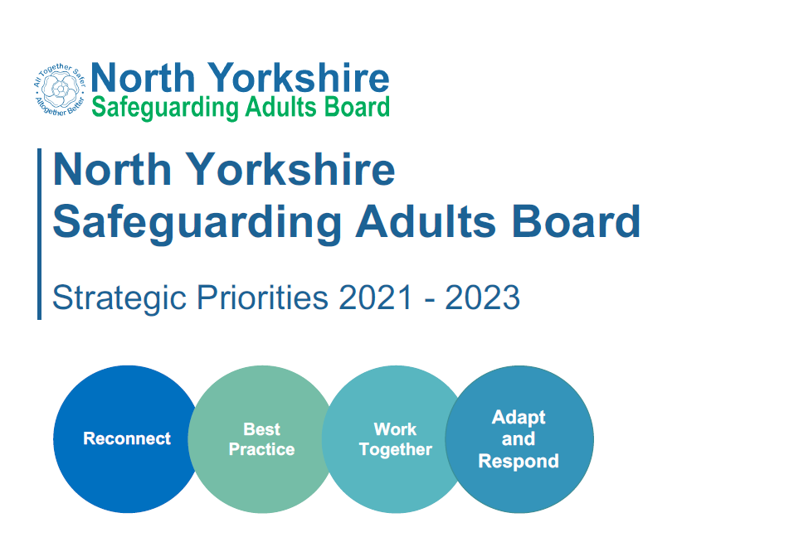

The NYSAB priorities tell you what the Board will be working on between 2021-2023. Our priorities can be found here on our website: https://safeguardingadults.co.uk/strategic-priorities

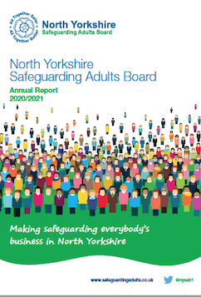

Our annual report tells you everything we have done over the past year. You can find our most recent annual report, along with an easy read summary, one page summary and audio easy read summary here: https://safeguardingadults.co.uk/annual-reports

Safeguarding Resources

Accessible safeguarding information
We have co-produced easy read keeping safe guides with the North Yorkshire Learning Disability Board and KeyRing Self Advocates. These books tell you about:

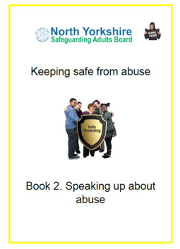
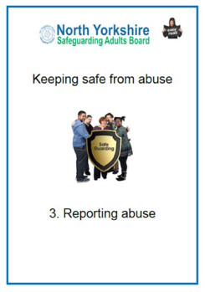
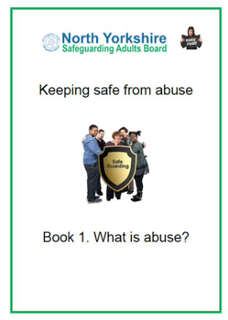
- What is abuse

- Speaking up about abuse

- Reporting abuse

The guides, along with audio versions, are available here on our website:

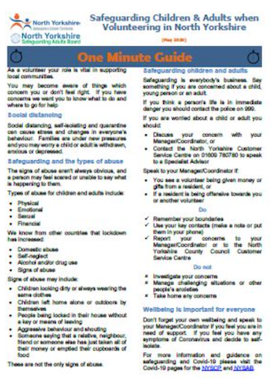
One-minute guides (OMGS)
Our OMGs are designed to provide bite sized information on key issues and areas of focus. The cover a number of areas from County Lines to Modern Slavery. All OMGs can be found on the NYSAB website:

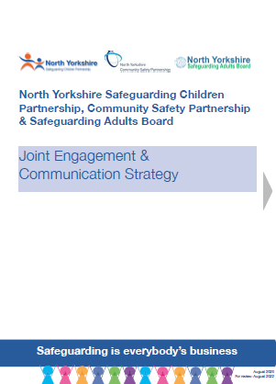
https://safeguardingadults.co.uk/one-minute-guides-omg

Policies and procedures

From our statutory Safeguarding Adult Review (SAR) policy to our joint Engagement and Communications strategy - all of our policies and procedures can be found here on the NYSAB website: https://safeguardingadults.co.uk/policies-and-procedures

Appendix B
Full findings
Following the recent engagement and consultation work carried out by the North Yorkshire Safeguarding Adults Board, we have put together the responses and findings in this document.

Where we received detailed and thorough answers, we have grouped these responses together and given some examples of the answers and feedback people have shared which will help inform our recommendations.

What do you know about the North Yorkshire Safeguarding Adults Board?
1

- Of the 392 people we engaged with 25% (98 people) do not know what the NYSAB do.

- Of those who said they were aware of the Board and its purpose, 18% (70 people) believed that safeguarding concerns should be reported to the NYSAB and not the local authority.

- Many people we engaged with 54% (211 people) had a clear understanding of what the Board does

2
Thinking about keeping yourself and others safe, what information and resources would you like from the North Yorkshire Safeguarding Adults Board?
Summary
Almost everyone we spoke to wanted information about what the Board does and understand what its priorities are.
In terms of safeguarding, people asked for information about what abuse is, how to spot the signs and how to report abuse. When we discussed the resources already available people said that they didn’t know that they were there. This included professionals who work within partner organisations – they felt that information was not shared widely enough within their teams.

General information
- We would like information about the Board. What you do? Who is on your Board? How do you help people?

- Information on priorities for the Board and how well it has done – you should produce an annual report.

- Safeguarding to be incorporated into all college and university courses during the induction week.

- Information regarding recent safeguarding adult reviews (SARs) and the key learning points for professionals. It is important for information to also be shared with members of the public to ensure everyone can recognise and report abuse.

- A one-page resource based on how to maintain the relationship with an adult at risk that does not want to be referred to safeguarding i.e., communities that may be out of touch with local councils, Black Asian Minority Ethnic (BAME), traveller communities etc.
- We would benefit on in depth knowledge around autism, how to approach and communicate with autistic / Asperger's adults at risk.
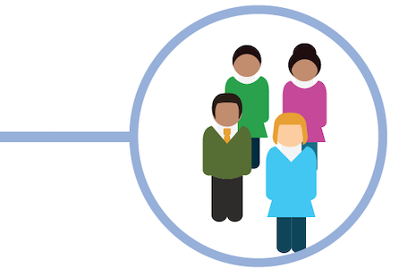

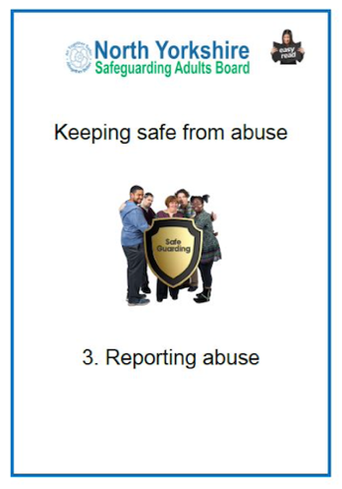
Information and resources about safeguarding and keeping safe
- Clear information about what abuse is and how to report abuse.
- Easy read booklets about different types of abuse in public places like libraries, GP surgeries.
- Quick guides to all safeguarding policies and new guidance.
- Information/resources on safeguarding training and learning opportunities.

Safeguarding process information

- What information and support is there for families / carers if you are part of a safeguarding?
- Feedback to the person submitting the safeguarding concern and better communication to the referrer.
- Straight forward information about how the system and pathways work.
- Easy read information about what the safeguarding process is in North Yorkshire.
- Providers to have an understanding of the organisational safeguarding process and what to expect and what they need to bring to the meetings.
- Information on different routes of support for different groups of people i.e., minorities, those with disabilities.
- Information about what action needs to be taken / who to contact if I have any concerns.

Raising awareness

- How to get the messages out about safeguarding.
- More awareness about people recognising safeguarding adults who are 'hidden' i.e., recognising vulnerability in workplaces).
- Information regarding safeguarding campaigns
- We have found that sometimes the safeguarding process can be too much of a blame culture, rather than a continuous learning tool / process – positive reinforcement and awareness raising would help with this.

5
What do you want to tell the North Yorkshire Safeguarding Adults Board?
Summary
Those involved in the safeguarding process asked for support – not just from advocates – but also something accessible to explain to them what the process will entail.
People also fed back that having someone who has been through the process as an advocate would be really helpful.
Professionals asked for prompt feedback when they submit concerns. If feedback cannot be given, that they are told why this can’t be provided.
Many people told us that their experience was positive. However, for those who did not have a positive experience issues included communication, not being updated, inconsistency in the process and people feeling belittled.

Support and understanding the safeguarding process
- As family members / carers we found the safeguarding process daunting, isolating and very scary. The investigation was thorough and professional but as lay people we needed support and an advocate to help us make sense of the whole thing.

- 24% (94 people) asked that prompt feedback was given when they submitted a safeguarding concern

- It would be useful to have a clear understanding of safeguarding thresholds. What people should expect when their circumstances meet the criteria for support.

- Would be good to have an update following safeguarding review as to the plan for the individual concerned.

- Safeguarding questionnaire often not completed, feedback on the process would be helpful to look at any issues with procedures.

- Advocacy feedback - sometimes referral to advocacy is quite last minute. It can be difficult to ensure an advocate has been allocated and met with the client prior to a meeting taking place.

- Have the reassurance that clients or professionals supporting them are always asked to complete the questionnaire when the safeguarding process is over.

- Reassurance for my clients that there are procedures in place, and that they are followed so this doesn't happen again.

Feedback on services and the safeguarding process
- Of those professionals and members of the public who had been through the safeguarding process 72% (81 people), fed back that they had very positive experiences and felt supported throughout.

- Recently submitted a safeguarding concern, no communication from safeguarding team as to whether this was being processed

- Not convinced that safeguard is personal in practice. How much weight is given to the adults’ views and wishes in reality? Particularly where the adult lacks capacity around safeguarding procedures?
- When big changes are happening, I would like someone to tell me about it. Change can be confusing

- Very difficult to access and report issues, and zero follow up given to referrers, so we never know if action has been taken.

- The safeguarding process and meetings are not always consistent, it can depend on who is the chair of the organisational meetings.

- A provider has fed back this week that the organisation safeguarding meetings and the process has made them feel belittled, like a schoolchild being reprimanded.

Training and raising awareness
- More training around making safeguarding personal and self-neglect would be useful as we are aware a lot of our staff within drug and alcohol services often struggle to identify self-neglect cases i.e., balancing lifestyle choice vs self-neglect.

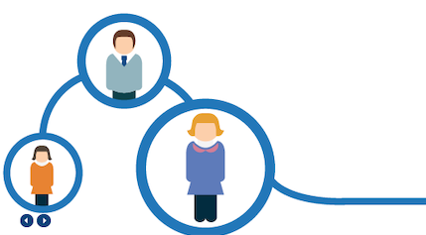
- Increasing confidence through knowledge of the safeguarding process.

7
How would you like to show that we have listened?

- Newsletter updates.

- Meet with people with lived experience and don't bring it down to statistics and graphs, we are all individuals with our own stories and journeys which can be learned from.

- Action plan.

- Update on any progress.

- Take what we have said seriously.

- Come back to meetings and tell us.

- Write us a letter or do a video message.

- Briefing after these surveys with updates on what has been said and how you will act on this.

- Publish what you have changed on your website.

- Make necessary changes.

- A report to show feedback.

- E-mail alerts with a link to the page on the website to read the feedback.

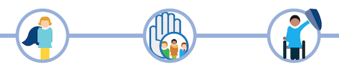
- Take on board what we have said & follow through.

8
Is there anything else you would
like to tell us?

Feedback

- If people who have been through a safeguarding are willing to speak to yourselves, they could be a huge resource which could be tapped into.

- During reviews, including continuing healthcare, have a section where questions are asked about safeguarding.

- We found the presentation about the NYSAB really useful and informative on what the Board is and does, could this be provided to the wider provider market?

- Wider communications to the providers especially some smaller services and domiciliary care on what is available on the website especially the easy reads as these would be very useful.

- We feel that some wording and terminology used can be confusing and can alienate people, including professionals. We think having more of the plain English and accessible information would be very beneficial.

NYSAB Resources

- The information and communication from the NYSAB is excellent, particularly the awareness raising and accessible information - and as a professional working in social care, I get a fair amount of information about the Board and its activities/priorities.

- It can feel very daunting - contemplating or actually making a safeguarding referral. You can feel it's possibly opening up a whole 'can of worms'. Some communications around reassurance might be useful?

- Have information letters about safeguarding and the Board to go out with the invoices for charges, or social funding payments.

- If safeguarding is everybody’s business you need to make sure everybody, not just professionals at the top, understand their role and responsibility. This means having information that is not full or jargon and “professional speak” but

something that is in plain English that everyone can understand – many professionals prefer straightforward accessible information
- Do a storybook about safeguarding. Make a video about the process explaining the steps. When you are developing a process, you should check with people whether they understand it when it is in draft & then tweak it accordingly.

