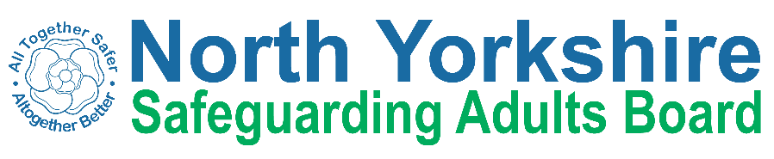

North Yorkshire Safeguarding Adults Board Summary of meeting minutes
 | Item
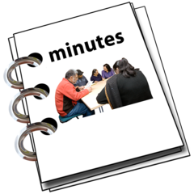 | This is a summary of the minutes for the North Yorkshire Safeguarding Adults (NYSAB) Board meeting on Wednesday 16th March
 | This meeting took place as a video conference
This is because of coronavirus

The Government asked everyone to work from home and not have face to face meetings
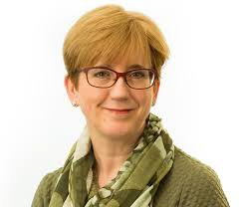 | 1. Welcome and Introductions  Sue Proctor, the Chair of the Board, welcomed everyone to the meeting.
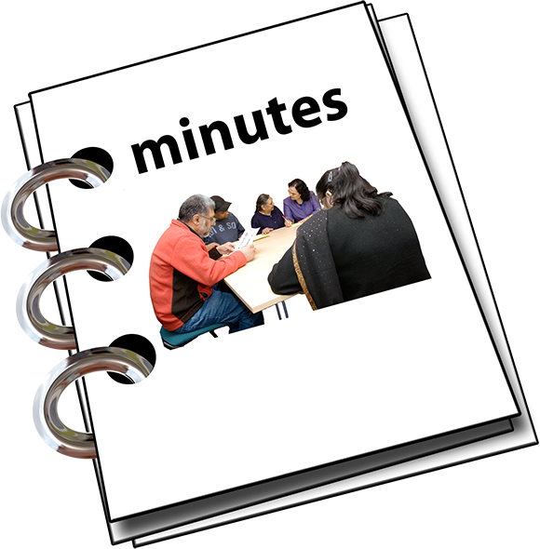 | Previous meeting minutes  Everyone was happy with the minutes from the previous NYSAB meeting in December.
Action log
The action log is a list of all of the things that members of the NYSAB have promised to do
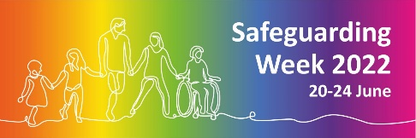  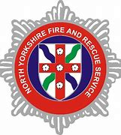  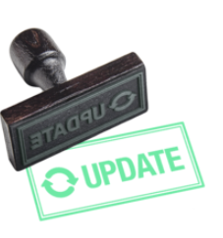 | Members updated on the actions they have carried out.  Some of the updates included:  Topics from North Yorkshire Fire & Rescue Service for Safeguarding Week 2022  An update about a homelessness presentation the NYSAB gave in March.
Updates from Board members
Sue asked Board members to share important safeguarding issues.

Caroline O’Neill from Community First Yorkshire spoke about people who work and volunteer in care and support needing to have the Covid vaccination.

If they do not have this vaccination they can not work in places like hospitals and care homes.
Board members also spoke about the crisis in Ukraine and what North Yorkshire is doing to support refugees who come to North Yorkshire.

The Board agreed that it is important to safeguard people who come to North Yorkshire from Ukraine.

 | Sue told Board members that the SAB meetings would continue to take place via Microsoft Teams for now.
Delivery Plan
The delivery plan was noted.

The Board agreed it was positive to see all of the work and actions that have been completed.
Risk Register
The risk register was noted.
A risk register lists all of the things that could cause problems for the NYSAB when they work through their delivery plan
Each risk is given a colour
Red is for an action that has a lot of risk and needs a lot of work
Amber is for an action that doesn’t have a lot of risk but still needs work
Green is for an action that has no risk.
Green risks can sometimes be taken off the register.

Care Market update

Abi Barron, Head of Service Development at North Yorkshire County Council, came along to the Board to give an update on the Care Market.

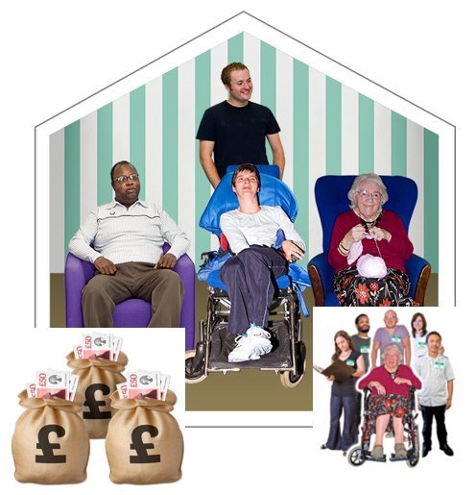 | Abi told the Board that some of the care providers needed financial help and support to help their businesses.  Abi also spoke about staffing issues that were affecting care and support settings and that it was
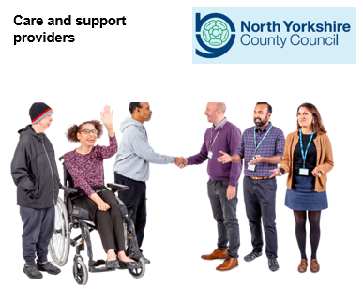 | Abi reassured the Board that lots of work was going on to support Care Providers.  They are working together to look at different ways of doing things to help care providers to make sure people receive the care and support they need.
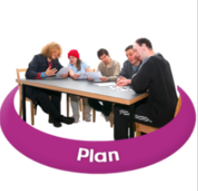 | Quality Pathway Update  Janine Tranmer, Head of Quality and Business Continuity at North Yorkshire County Council, gave an update to the Board on the Quality Pathway.  The quality pathway is a process to make sure that care providers are giving high quality care.  To help them do this resources and tools have been developed to help providers to make sure they are providing excellent quality of care and support in their services.  There will be tools that will help to identify when care providers need support and what level of support they need
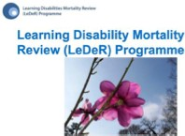 | LeDeR Report  Jennifer MacNeil from North Yorkshire CCG presented the LeDeR report.  There is a lot of work going on around LeDeR reviews in North Yorkshire and lots of learning to be shared.  Jennifer told the Board that the reviews now include the deaths of Autistic Adults.
Any other business

There were no further updates from the Board.

Sue thanked all members for their continued hard work.

Independent Chair | North Yorkshire Police
Sue Proctor | Lindsey Butterfield
North Yorkshire County Council (NYCC) | North Yorkshire Fire Service
Louise Wallace | Dave Winspear
Chris Jones-King
NYSAB Team | Health Trusts and Clinical Commissioning Groups (CCGs)
Sheila Hall | Helen Hart (BDC CCG)
Joseph Smith | Sue Peckitt (NY CCG)
Aurelie Redpath | Emma Stevens (NY CCG)
Sarah Abram | Jennifer MacNeil (NY CCG)
North Yorkshire Safeguarding  Children Partnership (NYSCP) | Borough and District Councils
James Parkes | Tony Clark (Richmondshire)
Services | Independent Care Group (ICG)
Louise Johnson (Probation) | John Pattinson
Caroline O’Neill (Community First Yorkshire)
Ashley Green (Healthwatch NY) | Presenters
Apologies | Abigail Barron (NYCC)
Karen Agar, Ruth Andrews, Rachel Bowes, Emma Dixon, Olwen Fisher, Emma Nunez, Elizabeth Moody, Christine Pearson, Richard Webb and Fran Wright | Janine Tranmer (NYCC)

