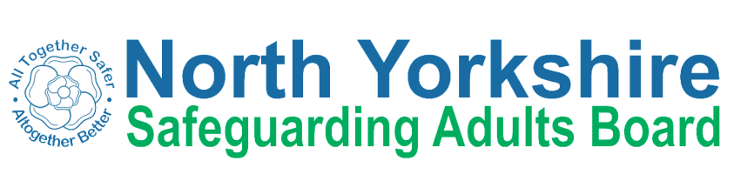

**Leaflets for Families Safeguarding Adults Reviews: Information for Families**

If you need this information in another format, please contact; NYSAB Safeguarding Adults Board Support Unit at [nysab@northyorks.gov.uk](mailto:nysab@northyorks.gov.uk) or telephone 01609 780780

**What is NYSAB Safeguarding Adults Board?**

North Yorkshire Safeguarding Adults Board brings together all the main organisations who work with adults at risk and their families in North Yorkshire to keep them safe.

**What is a Safeguarding Adults Review?**

A Safeguarding Adults Review looks at how local organisations worked together to look after the adult at risk at the centre of the review. It may also look at how they are working with other adults with care and support needs in the immediate family or care settings. The review considers what was done, what lessons can be learned for the future and what changes may need to be made. It is not a Criminal Investigation or Public Enquiry and its aim is not to place blame, but to learn.

**Why Are You Carrying Out A Safeguarding Adults Review?**

NYSAB Safeguarding Adults Board will carry out a SAR whenever an adult at risk has been seriously harmed or has died in circumstances where abuse or neglect is suspected or confirmed.

**Who Will Carry Out the Review?**

A panel of professionals from Community and Adult Care Services, the Health Service, the police and sometimes other organisations are led by an independent person (the ‘Author’). They will meet to review reports from each organisation or agency which has worked with or provided services to the adult at risk or their family. The Independent Author will prepare a report. This report will say what lessons have been learnt and make recommendations for North Yorkshire Safeguarding Adults Board.

**What Will Happen after the Report is Finished?**

NYSAB Safeguarding Adults Board will write an action plan to make sure improvements are made to the way organisations work together to keep adults at risk safe. NYSAB Safeguarding Adults Board will make sure the actions are carried out and have a positive effect.

**What Will I/We Have To Do?**

You do not have to do anything. However, you will have the opportunity to give your views if you would like to. We will make sure that there is someone who can help you to do this (see contact details below).

**Who Will See the Report?**

Normally the Report will be kept confidential to those people who represent their organisations at NYSAB Safeguarding Adults Board or have contributed to the review and the staff within those organisations who worked with the adult at risk and their family. The Executive Summary sets out the key findings and recommendations of the review. It does not give any personal details or information which would identify the adult at risk, family or anyone else involved. It is available to anyone who wants to read it and will be on our web site. Your personal contact will meet with you and tell you what is in the Executive Summary before it goes on the website.

**How Long Will the Review Take?**

It usually takes six months from the start of the review to publication of the Executive Summary.

In this leaflet we have answered some of the most frequently asked questions families have about Safeguarding Adults Reviews. Of course, each case is different, and you may have other questions you would like to ask. If so, you can call your personal contact.

Your personal contact is (insert name)