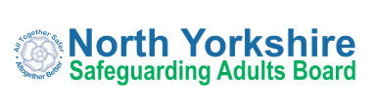

Annual Report 2021-22
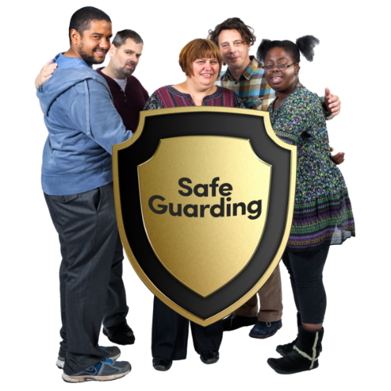

Easy Read Summary

Introduction

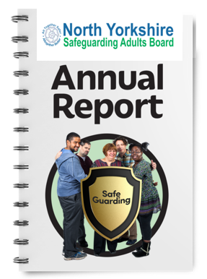 | This is the easy read summary of the annual report of the North Yorkshire Safeguarding Adults Board (NYSAB).
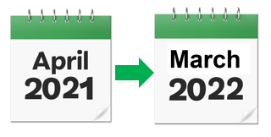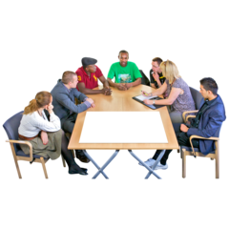 | This annual report tells you about the work that the NYSAB has done between 1st April 2021 – 31st March 2022.
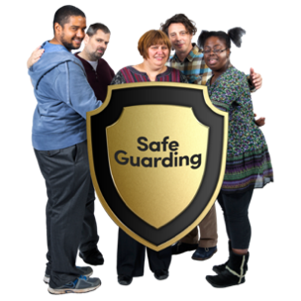 | The NYSAB works with other organisations in North Yorkshire to make sure that adults with care and support needs are kept safe.
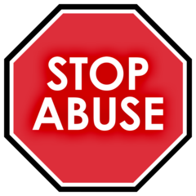 | Safeguarding means protecting people from abuse and neglect.
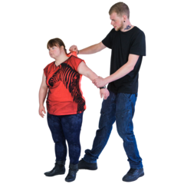 | Abuse is when someone does or says things that frighten you or cause you harm.  Neglect is when your care and support needs are not being met.
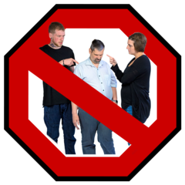 | Abuse and neglect are wrong.
About the North Yorkshire Safeguarding Adults Board (NYSAB)

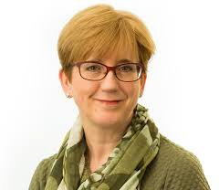 | Dr Sue Proctor is the Independent Chair of the NYSAB.
 | The NYSAB is made up of lots of different organisations including: the Police
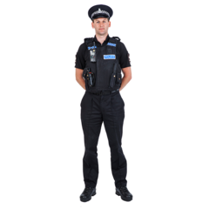 | North Yorkshire Police
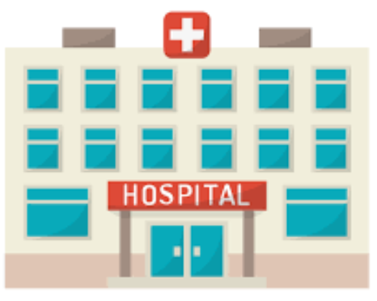 | Health providers like hospitals and GP surgeries
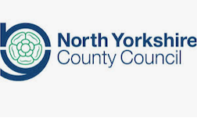 | North Yorkshire County Council
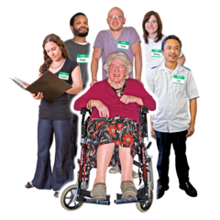 | Care and support providers
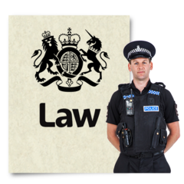 | The Board also has legal responsibilities – these are things they must do by law.
One of these things is to write a report every year about what it has done.

This is called an Annual Report.
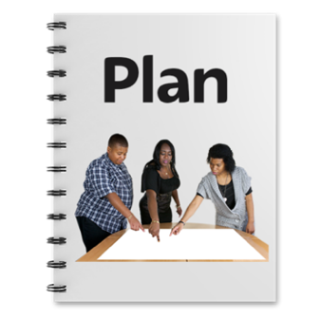 | The Board must also have a plan for what it will do for the next year to keep people safe.
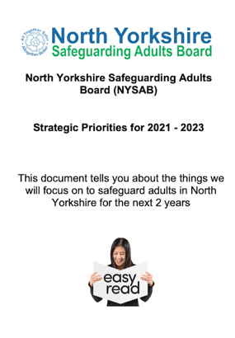 | You can find an easy read version and audio version of our plan for 2022 – 2023 on our website at: https://www.safeguardingadults.co.uk/strategic-priorities
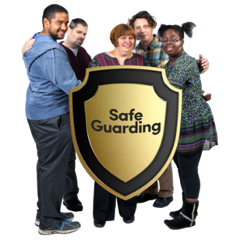 | All organisations have a duty to work together to keep people safe from abuse and neglect.
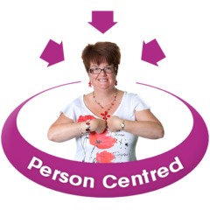 | We also want to make sure that adults who are abused or neglected are asked how they want to be kept safe in the future.  This is called ‘Making Safeguarding Personal’.  We want all of our partners to work this way too and tell us how they do this.

What the Board has done in 2021 – 22

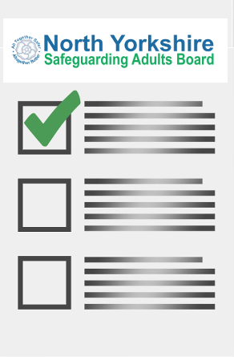 | Here are some of the pieces of work that the NYSAB and its partners have done this year
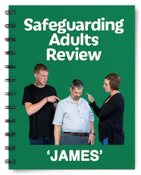 | We have carried out a safeguarding adult review about someone called ‘James’.
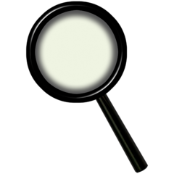 | A safeguarding adult review looks at what organisations could have done differently to stop someone from being harmed or stop them from dying.
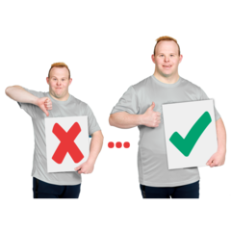  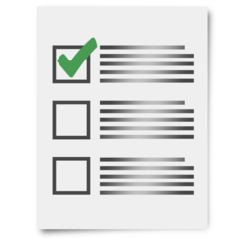  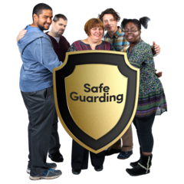 | The report will make recommendations to the NYSAB and different organisations.  These recommendations tell us things we need to do and learn from to make sure other people are kept safe from harm.  We will share the recommendations in our next annual report. We will also provide updates about how we have actioned the recommendations.

Safeguarding Week 2021
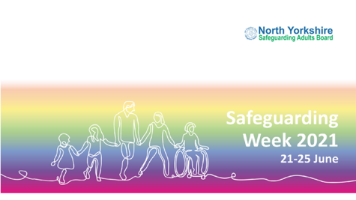 | Safeguarding Week took place in June 2021.
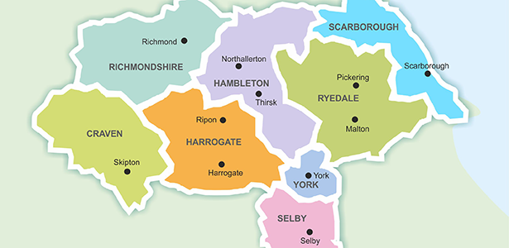  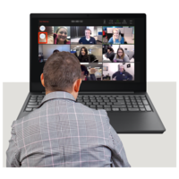 | Because of COVID-19 restrictions we couldn’t go out to meet people to talk about safeguarding.  Instead, we invited speakers to come and talk about different safeguarding topics so that people could watch these workshops online.
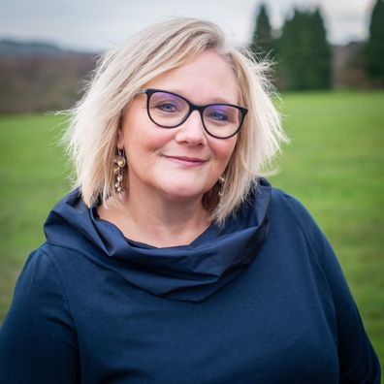 | The NYSAB hosted two workshops.  Workshop 1  Pat Sowa spoke to people about suicide prevention and the things people can do in their organisations and communities to prevent suicide.  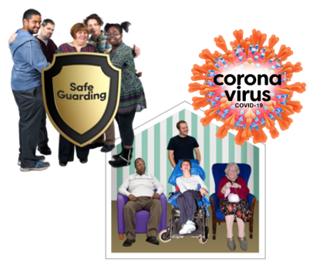  Workshop 2  A panel of people spoke about keeping safe in care settings.  The panel spoke about the different things that they had to done to keep themselves and others who receive care and support safe during COVID-19
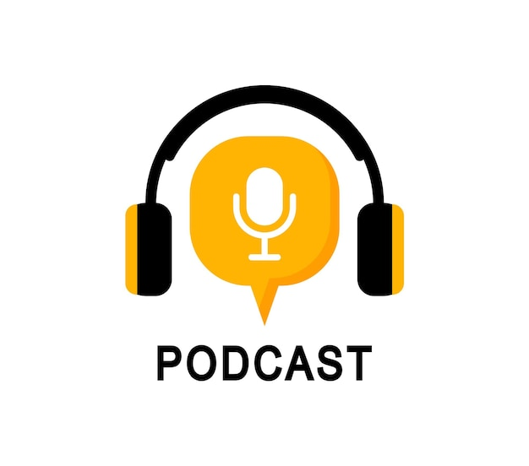  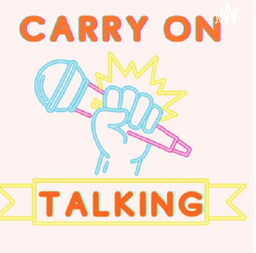 | We also recorded a podcast.  Sam Suttar, Keeping Safe Champion from the North Yorkshire Learning Disability Partnership Board and Laura Watson from the NYSAB spoke about safeguarding.  People told us that they enjoyed listening to the podcast and that it helped them understand safeguarding.
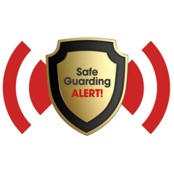 | People from the local authority, health, police and many others gave advice on what you should do if you or someone you know has been abused or neglected.
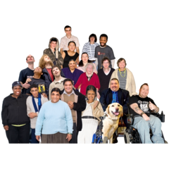 | Lots of people used the information we shared.  They said that they were very useful and there was a lot of helpful information to understand what to do to keep themselves and others safe.

What else did the North Yorkshire Safeguarding Adults Board do last year?
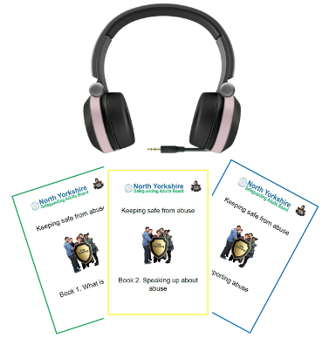 | We made audio versions of the easy read keeping safe guides that we co-produced with self-advocates.  People told us that they like the guides being in different formats so they can understand information about keeping safe.
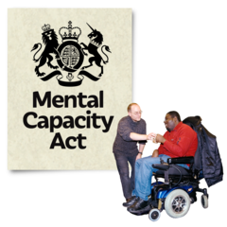  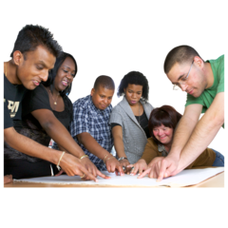 | We are working with lots of different organisations to co-produce accessible guides about the Mental Capacity Act.
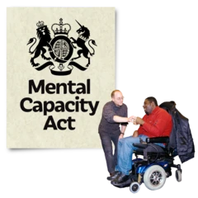 | The Mental Capacity Act is a law.  It puts some rules in place for people who are 16 years old or older and may not be able to make some decisions.  Examples of things they can’t decide may include:  - About where they live  - What support they may need  - How to manage their money
Dorset Advocacy have made a really helpful easy read guide about Liberty Protection Safeguards (LPS).

It also has information about the Mental Capacity Act.

You can find it here: https://www.dorsetadvocacy.co.uk/wp-content/uploads/2021/08/liberty-protection-Easy-Read.pdf

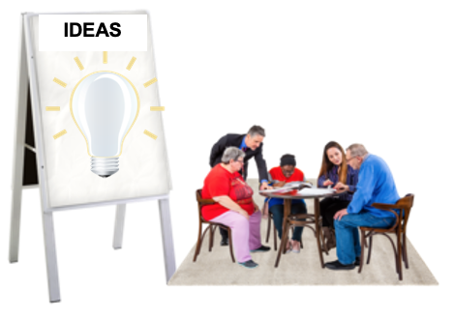  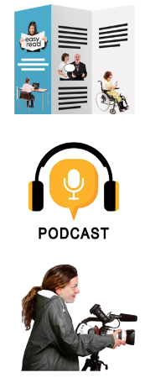 | Different groups from across North Yorkshire have met to talk about what the Mental Capacity Act and means to them.  The groups came up with ideas about what sort of information they would like.  Some ideas included:  - Accessible leaflets  - A podcast  - A short film
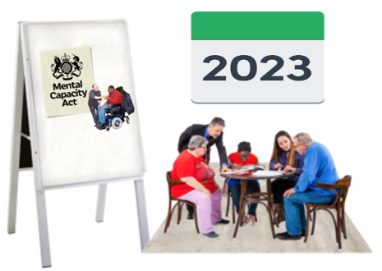 | The groups are going to meet again so that they can move on to the next stage of planning and make some resources.
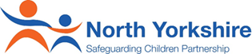  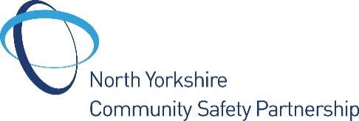 | We have worked really closely with the North Yorkshire Safeguarding Children Partnership and Community Safety Partnership.
 | Working together means we can share ideas and information with each other to help keep adults, children, young people and communities safer in their areas.

What we are going to do in 2022 - 23
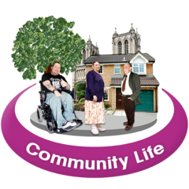 | We will continue to work closely with communities in North Yorkshire to keep people safe.
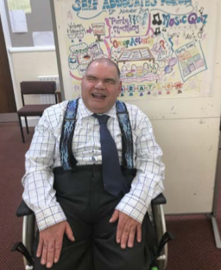 | We will be working with the Keeping Safe Champion, Sam Suttar, to raise awareness about safeguarding and the NYSAB with people and organisations across North Yorkshire
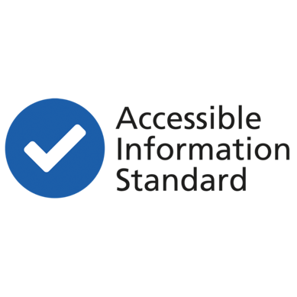  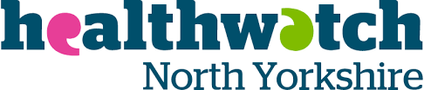 | We will work with Healthwatch to support the recommendations from their Accessible Information Standard report are carried out.
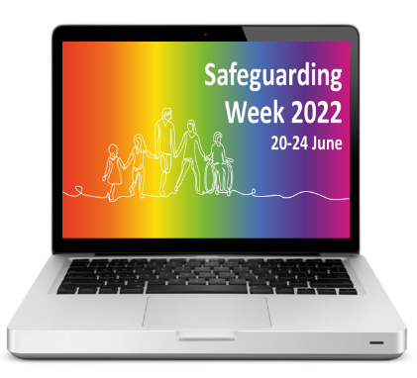 | We will host the Safeguarding Week 2022 campaign for professionals and members of the public.
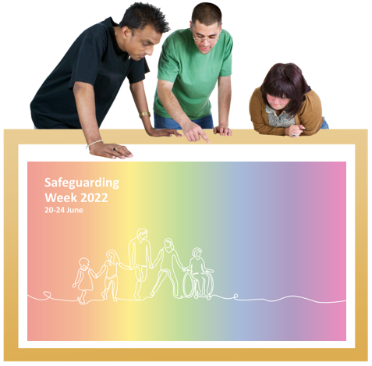 | We are going to work with people from across North Yorkshire to plan Safeguarding Week
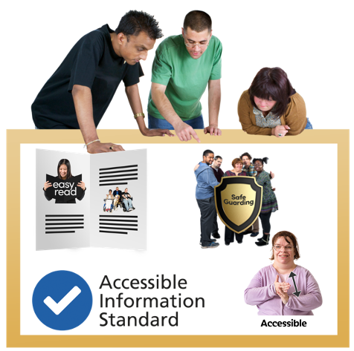 | We will continue to work with groups and communities to find new and accessible ways to share information with people to keep themselves and others safe from abuse and neglect.
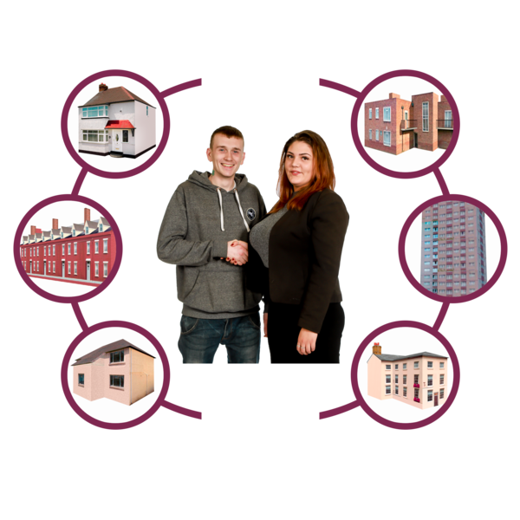 | We will be working with organisations and communities to look at how we can support people who are homeless.  This includes engaging with people who are homeless to ask them about their experiences and what support they need.  We will then use their feedback to help improve services and make sure that people who are homeless are safeguarded.
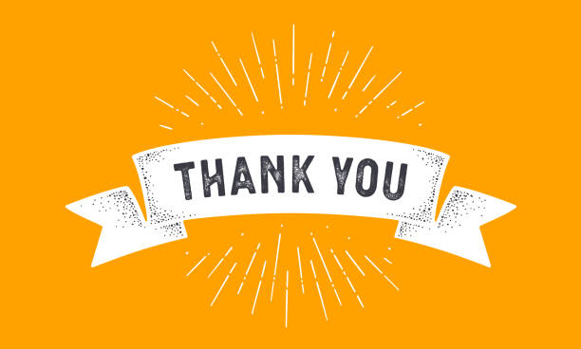 | We would like to say another BIG THANK YOU to everyone who has been involved with our work over the last year.
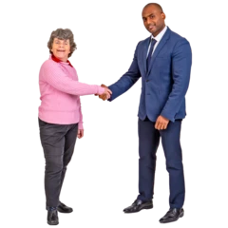 | We really look forward to working with you next year to continue to keep adults in North Yorkshire safe.

How to contact us about this report
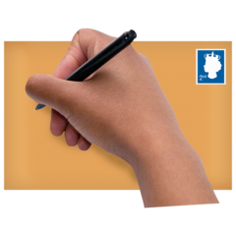 | You can write to us at: North Yorkshire Safeguarding Adults Board, North Block, Health and Adult Services, County Hall, Northallerton DL7 8DD  You can email us at: nysab@northyorks.gov.uk  You can visit our website at: www.safeguardingadults.co.uk
 | This easy read summary was made using Photosymbols

Copyright © 2022 North Yorkshire Safeguarding Adults Board

