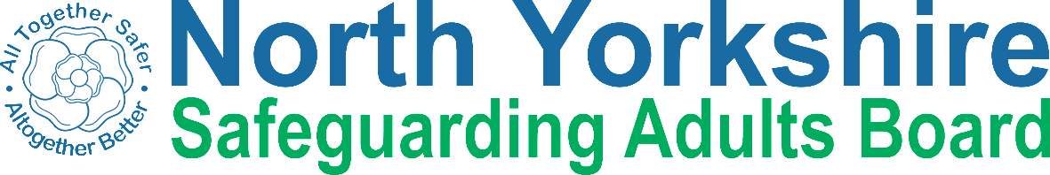

Keeping safe from abuse

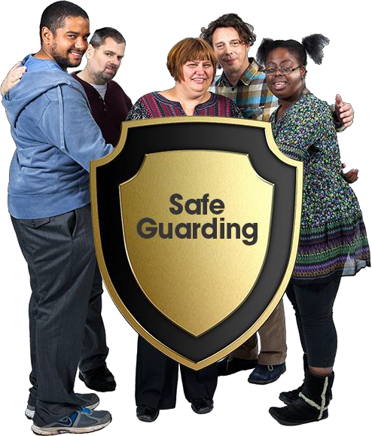

Book 2. Speaking up about abuse

What is this book about?

 | Everybody has a right to be safe from abuse. This book has been written to help you understand abuse and to stay safe.
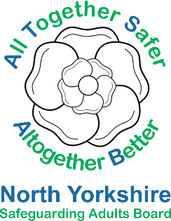 | It was made by the North Yorkshire Safeguarding Adults Board.
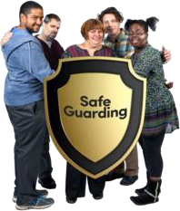 | Safeguarding is about everyone working together to make sure people are safe.
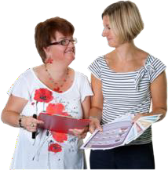 | This book has information about how to speak up about abuse and report it.  You can read it alone or with someone to support you.

Speaking up about abuse is hard

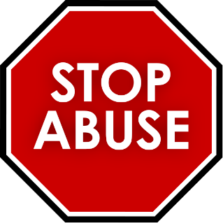 | Abuse and neglect are never OK. If you or someone you know is being abused, tell someone you trust.
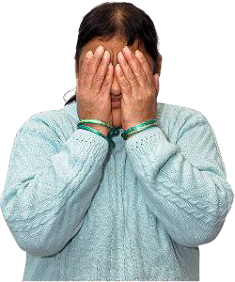 | Speaking up about abuse is not easy. You might feel:  - Scared or stressed  - Ashamed or embarrassed  - That no one will believe you  - Worried about getting into trouble or getting other people into trouble
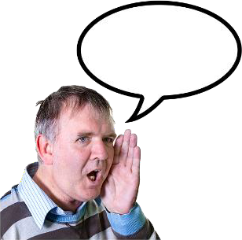 | Abuse is never your fault. It is always OK to speak up about abuse.
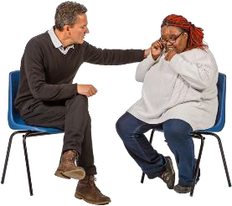 | If you feel scared or worried and are not sure if it is abuse, still tell someone.

What to do if you know the person who is abusing

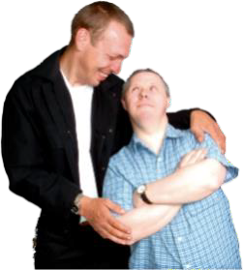 | Speaking up about abuse can be harder if you know the person doing the abuse.
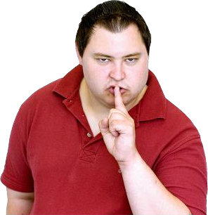 | They might:  - Tell you to keep it a secret  - Tell you they will hurt you, your family or your pets  - Tell you no one will believe you  - Tell you that you are confused  - Tell you that it’s your fault
 | It is still important to speak up and get help. Tell someone that you trust.

Talk to someone you trust

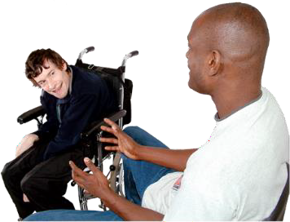 | Think about someone you trust and feel happy talking to.
This could be:
- Someone in your family
- A friend
- A carer or support worker
- A social worker
- An advocate
- The police
- A nurse or doctor
- Someone from a charity like Mencap, Age UK or Mind
- Someone from the Care Quality Commission
- Someone you work with
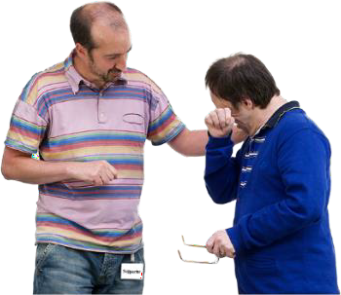 | Tell them you have something important you want to talk about.

Finding a time and place to talk

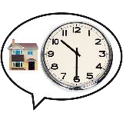 | Think about when you might talk to someone.
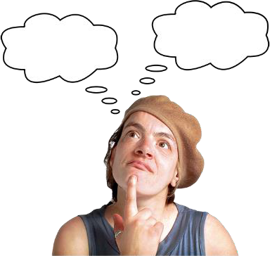 | Think about where you could talk to someone.
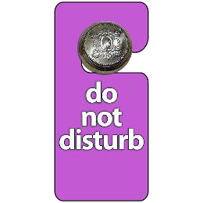 | If possible  - Choose somewhere private where other people won’t overhear you  - Choose a time and place where other people won’t interrupt you  - Choose somewhere you feel safe and comfortable
 | It might feel like there is never a good time - but it is still important that you speak up and tell someone.

It is good to talk

 | Sometimes it can be good to just talk to someone.
 | It can help you think about what is happening and you can hear what another person thinks.
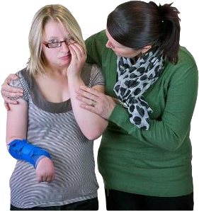 | They might be able to help you sort out whatever is wrong.
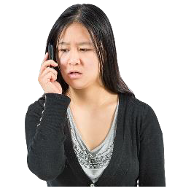 | If you experience abuse it is important that you or someone you trust tells North Yorkshire Council.

If you don’t have a person you can trust

 | If you are in danger, please call 999 to get help straight away.
 | You can contact North Yorkshire County and they can ask an advocacy organisation to support you https://www.northyorks.gov.uk/make-your- voice-heard
 | Anyone can report abuse if they are worried.
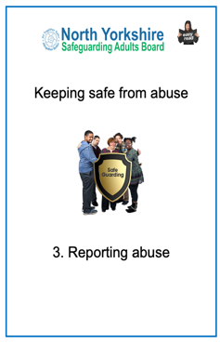  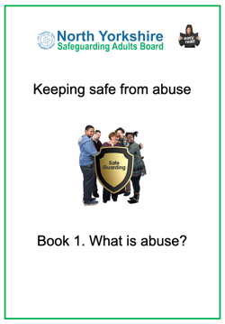 | There is more information in Keeping Safe from Abuse Book 1 ‘What is abuse?’ and Book 3 ‘Reporting abuse’.

Contact details

North Yorkshire Council

Telephone: 0300 131 2 131
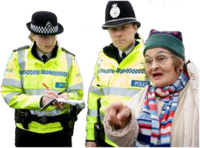 | North Yorkshire Police  For emergencies call 999. To talk to someone call 101.

Thank you!
Thank you to everyone who helped us make this book including:

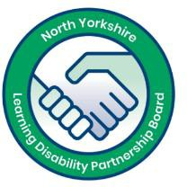 | KeyRing self-advocates from the North Yorkshire Learning Disability Partnership Board
 | Inclusion North www.inclusionnorth.org
North Yorkshire Council
Health and Adult Services
Copyright © 2019 North Yorkshire Safeguarding Adults Board

