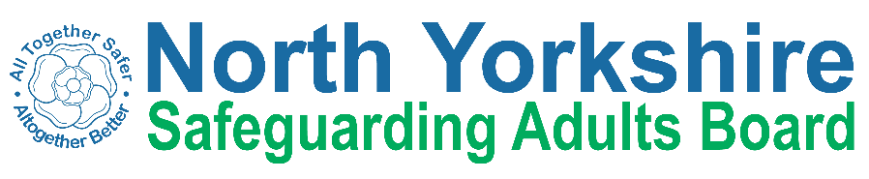
North Yorkshire Safeguarding Adults Board Summary of meeting minutes
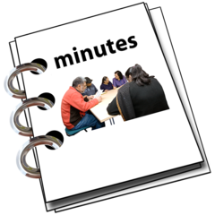 | This is a summary of the minutes for the North Yorkshire Safeguarding Adults (NYSAB) Board meeting on Wednesday 22 March 2023.
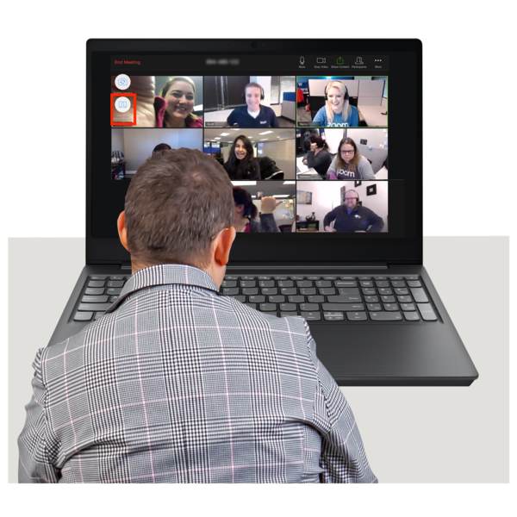 | This meeting was held online.
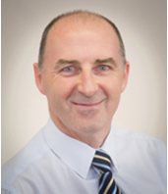 | Welcome and Introductions  Tony Clark, who chaired the NYSAB, welcomed everyone to the meeting.
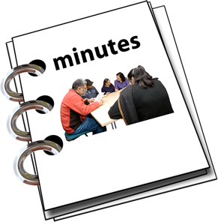 | Previous meeting minutes  Everyone was happy with the minutes from the previous NYSAB meeting in December.
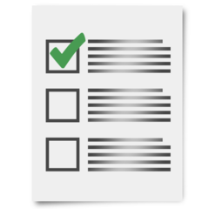 | Action log  The action log is a list of all the things that members of the NYSAB have promised to do.  Members updated on the actions they have carried out.
Delivery Plan
The delivery plan was noted.
The Board agreed it was positive to see all the work and actions that have been completed.

Risk Register
The risk register was noted.
A risk register lists all the things that could cause problems for the NYSAB when they work through their delivery plan.
Each risk is given a colour.
Red is for an action that has a lot of risk and needs a lot of work.
Amber is for an action that doesn’t have a lot of risk but still needs work.
Green is for an action that has no risk.
Green risks can sometimes be taken off the register.

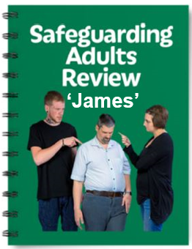  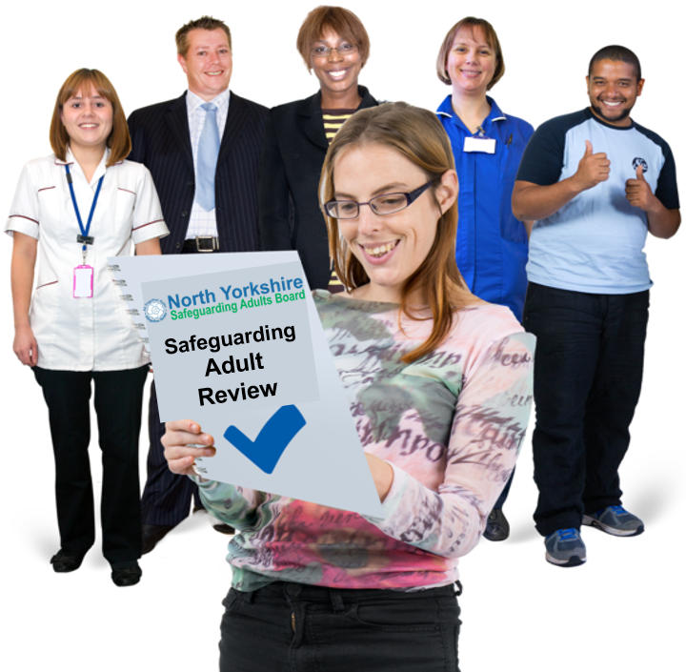  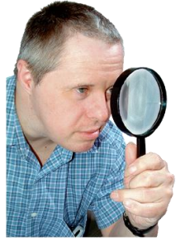 | Safeguarding Adult Review (SAR) regarding James  A safeguarding adult review about a young man called ‘James’ was carried out to look at the sad circumstances surrounding his death.  A safeguarding adult review looks at how well local organisations have worked together.  The review is done by an independent author.  The independent author will look closely at what was done and how they can do things better in the future.  The author will also think about what changes may need to be made to services and will make recommendations.
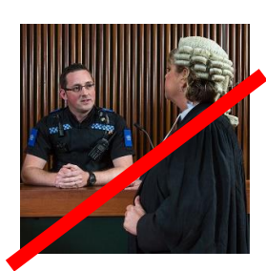 | A safeguarding adult review is not:  a criminal investigation or  public enquiry – a big review run by a government official
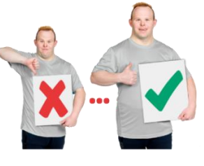 | The independent author wants to learn how to make things better. They do not want to blame people.
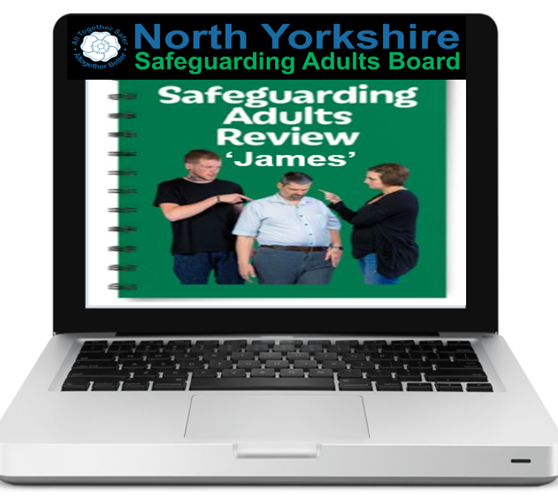 | The Board agreed that the SAR report about ‘James’ could be shared and made available on the North Yorkshire Safeguarding Adults Board website in May 2023.
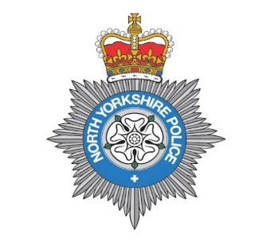 | Updates from partners  Heather Whoriskey from North Yorkshire Police told the Board that some extra safeguarding jobs had been created to work with children and adults.
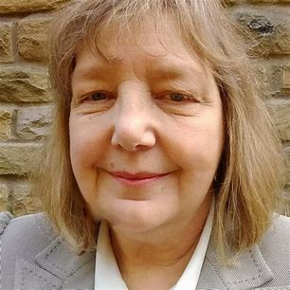  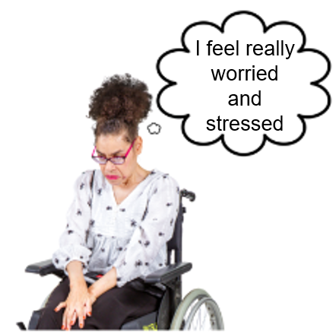  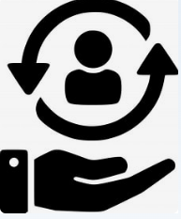 | Caroline O’Neill from Community First Yorkshire gave an update to the Board on behalf of the Voluntary and Community Sector.  Caroline told the Board that managers in the voluntary sector are worried that their staff may be suffering from anxiety.  There are support services that offer advice available for staff to use.  Staff are being encouraged to use these.
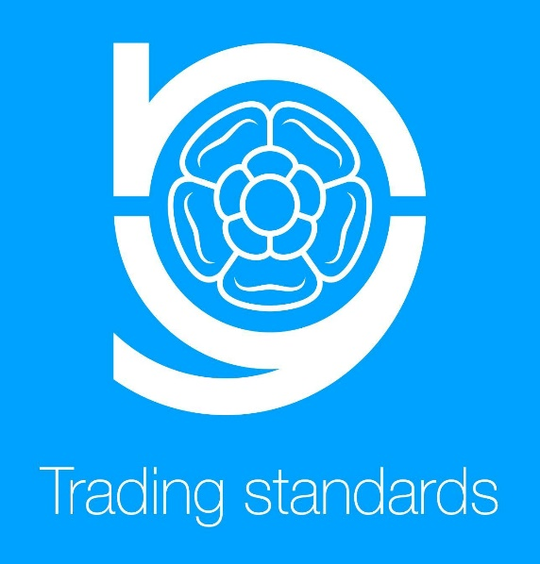 | Trading Standards update  Trading Standards is part of your local council.  They give advice about consumer law so that customers and businesses are treated fairly.  They investigate trading and customer complaints and visit shops and businesses to make sure they are following the law.  Jo Boutflower from North Yorkshire County Council gave a presentation about the work her team does.
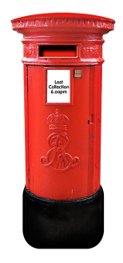  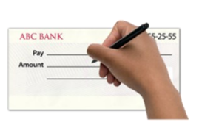 | The team works on things like:  Stopping Mail or Postal scams  Mail scams come in the post and try to get your money or personal information.  Mail scams sometimes tell you to pay money before you can get something from them
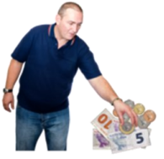 | Stopping internet scams  Internet scams are when criminals trick people on email and the internet.  The criminals take personal information so that they can steal the person’s money
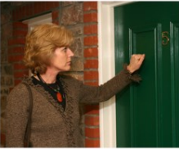 | Stopping ‘Doorstep Scams’  Doorstep scams are when a criminal comes to your door to try to get your money or personal information.
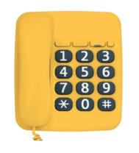 | Stopping scam telephone calls.  Telephone scams are when criminals call you to try to get your money or personal information.  This is sometimes called ‘Cold Calling’
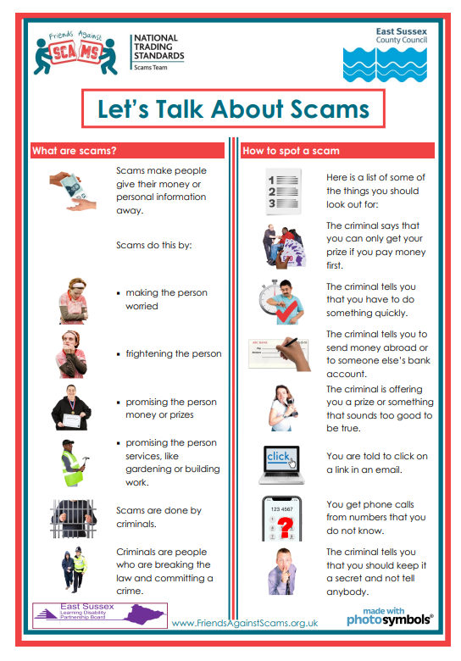 | North Yorkshire Council are working to make sure that people are aware of the different scams.  They are also sharing information so people know how to spot a scam and how to report a scam.
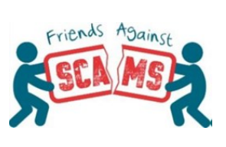 | Friends Against Scams have co-produced an easy read leaflet that talks about:  - Protecting yourself with scams  - How to spot scams  - Where to get scams  You can find the leaflet here:  https://www.friendsagainstscams.org.uk/shopimages/Accessible%20training%20and%20easy%20read/Embedded_Conversation_Info_Sheet.pdf
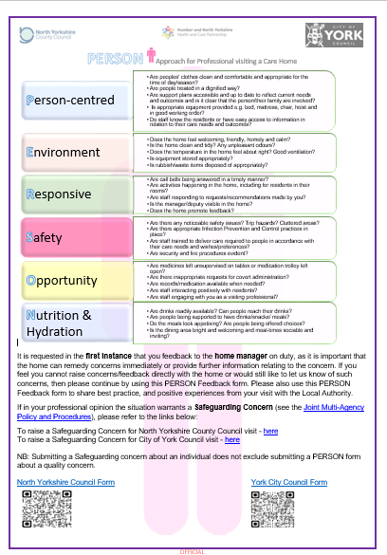  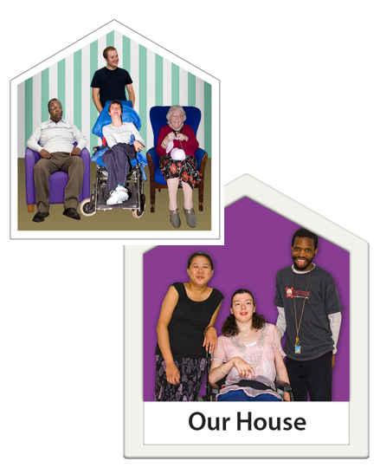 | New PERSON Form  A form had been designed for professionals to use when visiting people in care settings,  A care setting could be a residential home or sheltered housing.
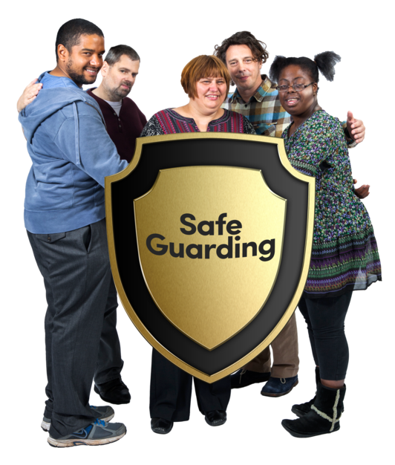  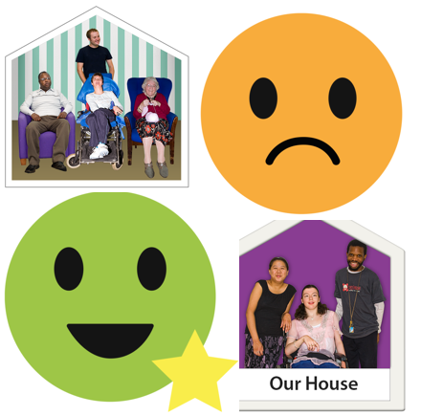 | The form has lots of suggestions to help people who work in care settings to understand what things they need to look for.  This includes things such as  - How clean a care setting is  - How safe a care setting is  - If people in care settings have good diets and  - If the care people get is good or bad
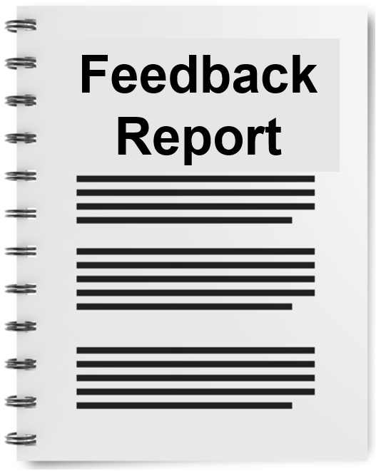  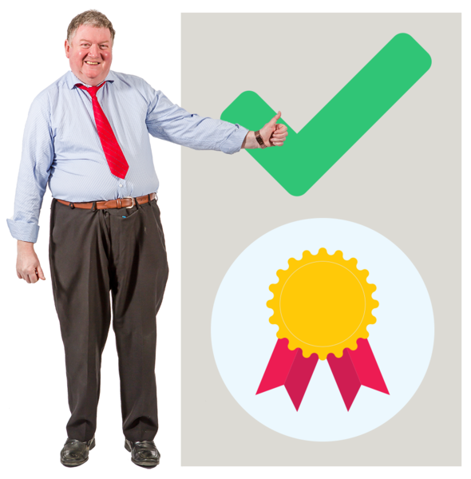  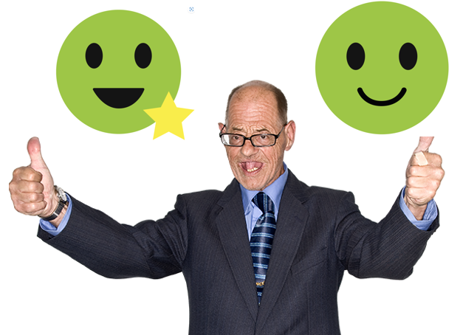 | The PERSON form will be used to share best practice and positive experiences with the local authority.  Information collected will be used to:  - feedback to the different teams in the council  - feedback to partner agencies  - monitor quality  - celebrate good practice  - keep a record to make sure care settings are good quality and safe
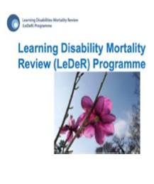 | Learning from Lives and Deaths – People with a Learning Disability and Autistic People (LeDeR)  LeDeR is a programme that reviews the deaths of people with a learning disability and autistic people.
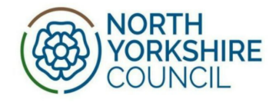  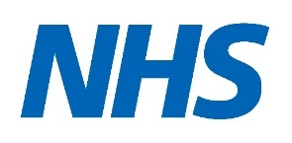 | It was reported that:  - LeDeR reviews are done by a company outside of the NHS.  The NHS have said that they would like to do the reviews in the future if possible.  - Lots of different organisations and professionals, would meet to review cases.  This would include:  - representatives of the council,  - NHS and other service providers
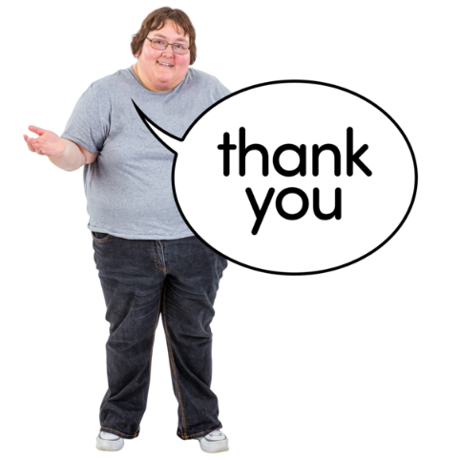 | Any other business  Tony thanked all NYSAB members for their continued hard work.

Chair | North Yorkshire Police
Tony Clark (Richmondshire District Council) | Heather Whoriskey
North Yorkshire County Council (NYCC) | North Yorkshire Fire Service
Jo Boutflower | Thomas Hirst
Emma Dixon
Louise Wallace | Health Trusts and NHS Integrated Care Boards
Richard Webb | Emma Nunez (Harrogate District NHS Foundation Trust)
Sheila Hall | Olwen Fisher (Humber and North Yorkshire Health and Care Partnership)
North Yorkshire Safeguarding  Children Partnership (NYSCP) | Amanda Robinson (NHS Bradford District and Craven Health and Care Partnership)
Hannah Ellingworth | Katrina Uttley (Bradford District and Craven NHS Foundation Trust)
 | Helen Day (Tees, Esk and Wear Valley NHS Foundation Trust)
NYSAB Team | Community First Yorkshire
Rachel Craig | Caroline O’Neill
Janice Foxton
Laura Watson | Presenters
 | Julie Toman (NYCC)
Apologies
Sue Proctor, Elizabeth Moody, Scott Bissett,
Sue Peckitt,
Helen Hart, Christine Pearson, John Pattinson

