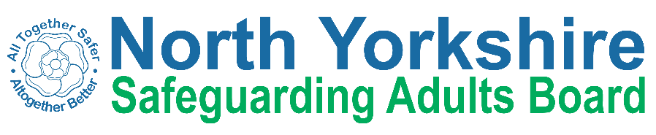
North Yorkshire Safeguarding Adults Board Summary of meeting minutes
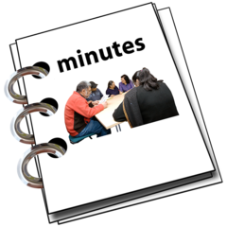 | This is a summary of the minutes for the North Yorkshire Safeguarding Adults (NYSAB) Board meeting on Wednesday 21 June 2023.
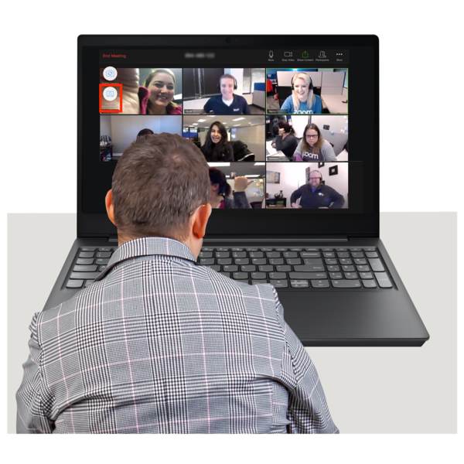 | This meeting was held online.
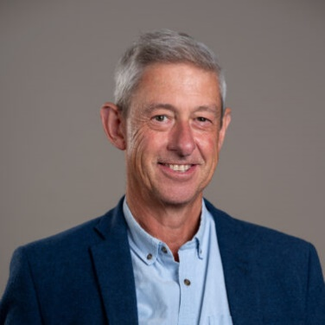 | Welcome and Introductions  Richard Jones, who chaired the NYSAB, welcomed everyone to the meeting.
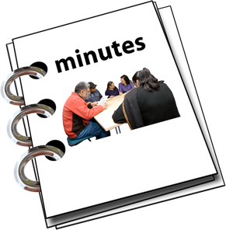 | Previous meeting minutes  Everyone was happy with the minutes from the previous NYSAB meeting in March.
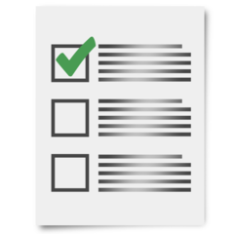 | Action log  The action log is a list of all the things that members of the NYSAB have promised to do.  Members updated on the actions they have carried out.
Delivery Plan
The delivery plan sets out work that has been or will be done in the coming year and contents of the plan were noted.
The Board agreed it was positive to see all the work and actions that have been completed.

Risk Register
The risk register had been read by members of the board.
A risk register lists all the things that could cause problems for the NYSAB when they work through their delivery plan.
Each risk is given a colour.
Red is for an action that has a lot of risk and needs a lot of work.
Amber is for an action that doesn’t have a lot of risk but still needs work.
Green is for an action that has no risk.
Green risks can sometimes be taken off the register.

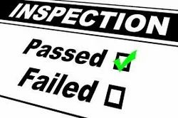  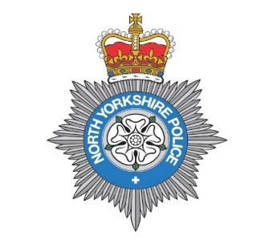 | Updates from partners  North Yorkshire Police said they were being inspected by His Majesty’s Inspectorate (this is an independent organisation that looks closely at the quality of services provided to citizens by police and fire services in the United Kingdom). Police staff were very busy.  Jobs for police officers and people to work in safeguarding will be advertised soon.
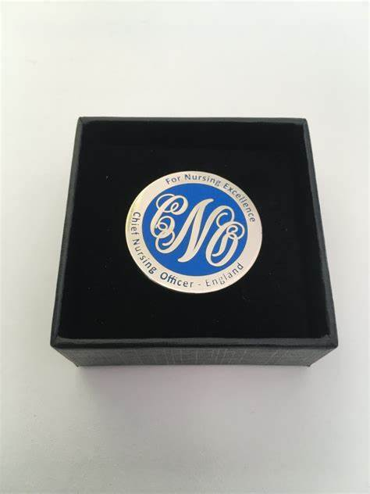  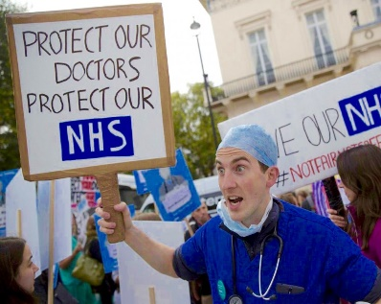  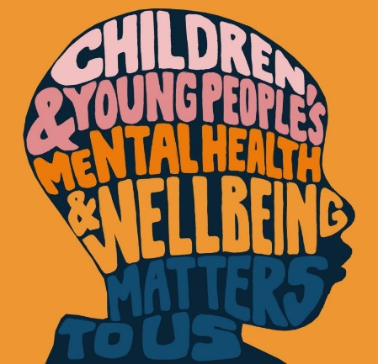 | Yorkshire and Humber NHS won Chief Nurse Gold Award in Adult Social Care. The award recognizes nurses in the UK who go above and beyond to make outstanding contributions in the field of care giving.  Junior doctors in Harrogate NHS will go on strike in July and August.  Children in North Yorkshire must wait a long time for help with mental health.  It is important that the NHS and the Council work together to help children and continue to help as they become adults.
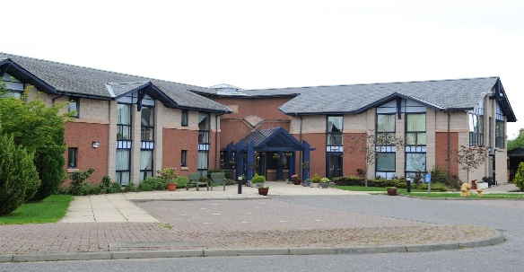  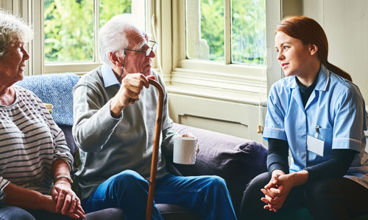 | Care Market Update  Consideration was being given to how the council would cover gaps in care in rural and coastal areas.  North Yorkshire Council (NYC) were working closely with care providers in the region that had recruited carers from other countries to ensure quality of care was maintained.
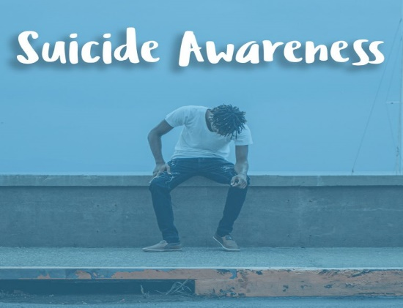  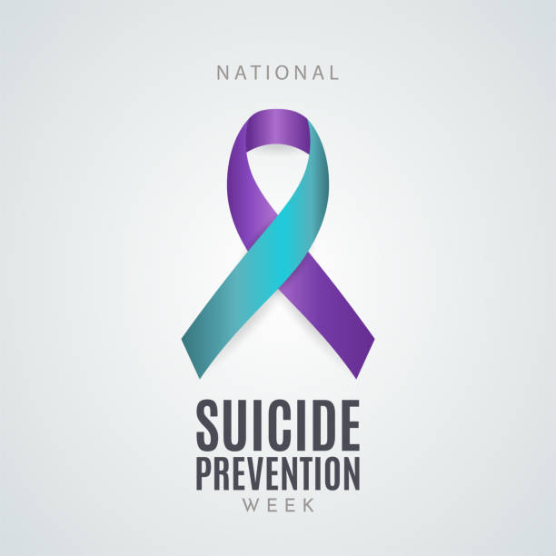 | Suicide Prevention  Number of suicides in North Yorkshire had decreased between 2018 and 2021 from 12 in 100,000 to 11 in 100,000.  Individuals aged 30-49 made up the largest number of those recorded.  North Yorkshire Suicide Prevention Group would be re-formed to help organisations work together to prevent suicides.
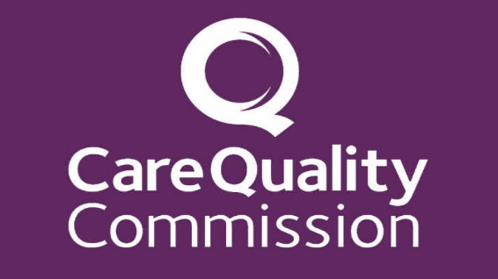  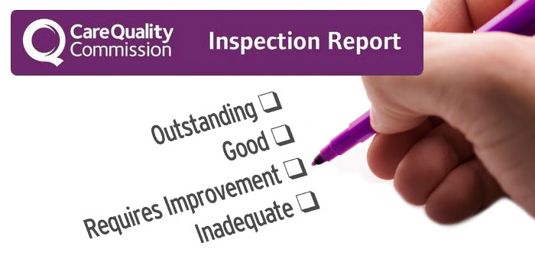  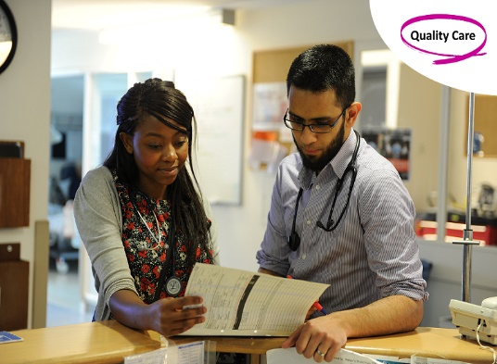 | Care Quality Commission (CQC) Assurance Framework  The Care Quality Commission (CQC) inspects and works with providers in NYC area to ensure that health and social care services provide people with safe, effective, compassionate, and high-quality care.  North Yorkshire Council Health and Adult Services will be inspected by CQC within the next year, but a date had not been set. Teams are working hard to prepare for inspection by holding “practice” assessments. Four areas would be assessed by CQC: working with people, providing support, ensuring safety and leadership.  Members of North Yorkshire Safeguarding Adults Board (NYSAB) were advised that inspectors may want to speak to them about the work of the Board during the inspection.
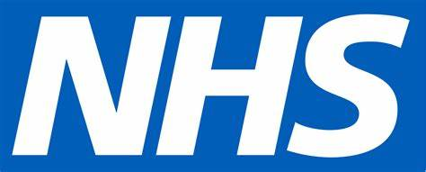  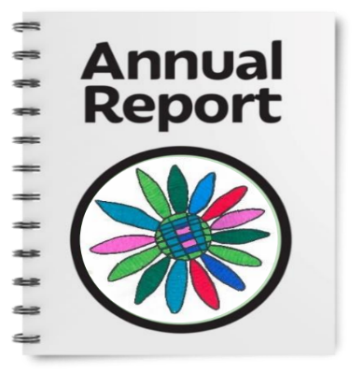 | Learning from lives and deaths (LeDeR)  LeDeR reviews help improve the quality of health and social care for people with a learning disability and the programme is run by the NHS.  The LeDeR annual report for this  region was in draft form and would be shared with the Board once complete.  Members of the Board agreed that an update regarding LeDeR would be received every six months.
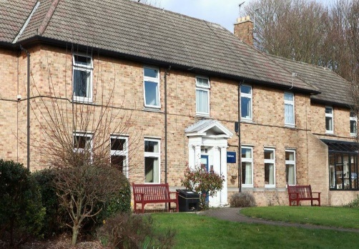  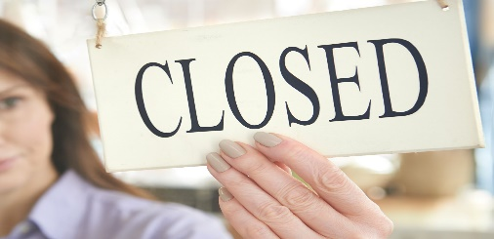  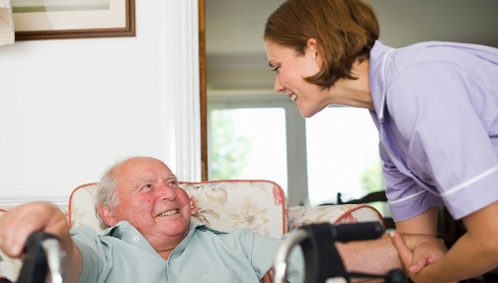 | Unplanned Care Home Closure Action Plan update  NYC works with care providers in the region to offer support with how they operate, and the processes and systems that they use. NYC may review a provider at intervals of three and six months to ensure improvement by providers when need for improvement was identified.  A form to act as a prompt for consideration and assessment of risks in a care setting (PERSON form) had been launched and feedback received showed that users had found this form useful.  NYC would continue to review the closure of care homes as they arose.
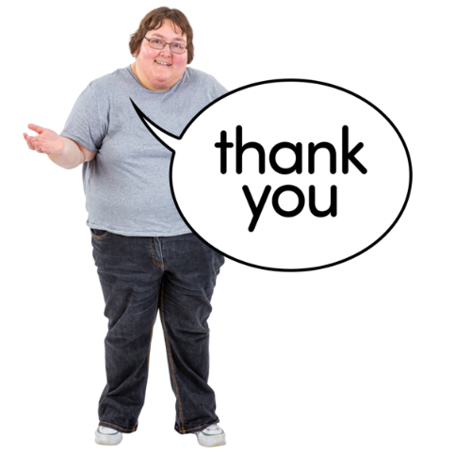 | Any other business  Richard thanked all NYSAB members for their continued hard work.

Chair | North Yorkshire Police
Richard Jones | Heather Whoriskey
North Yorkshire Council (NYC) | North Yorkshire Fire Service
Jo Boutflower | Thomas Hirst
Emma Dixon
Louise Wallace | Health Trusts and NHS Integrated Care Boards
Richard Webb | Emma Nunez (Harrogate District NHS Foundation Trust)
Sheila Hall | Olwen Fisher (Humber and North Yorkshire Health and Care Partnership)
North Yorkshire Safeguarding  Children Partnership (NYSCP) | Amanda Robinson (NHS Bradford District and Craven Health and Care Partnership)
Hannah Ellingworth | Katrina Uttley (Bradford District and Craven NHS Foundation Trust)
 | Helen Day (Tees, Esk and Wear Valley NHS Foundation Trust)
NYSAB Team | Community First Yorkshire
Rachel Craig | Caroline O’Neill
Janice Foxton
Laura Watson | Presenters
 | Julie Toman (NYC)
Apologies
Sue Proctor, Elizabeth Moody, Scott Bissett, Sue Peckitt,
Helen Hart, Christine Pearson, John Pattinson

