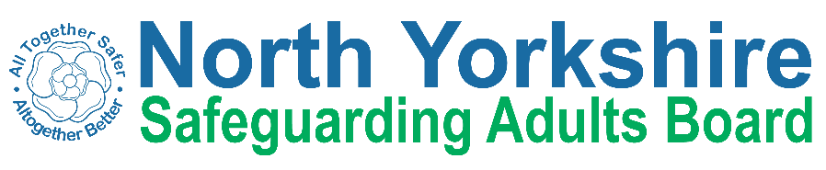
North Yorkshire Safeguarding Adults Board Summary of meeting minutes
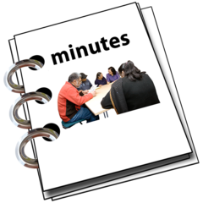 | This is a summary of the minutes for the North Yorkshire Safeguarding Adults (NYSAB) Board meeting on Wednesday 27 September 2023.
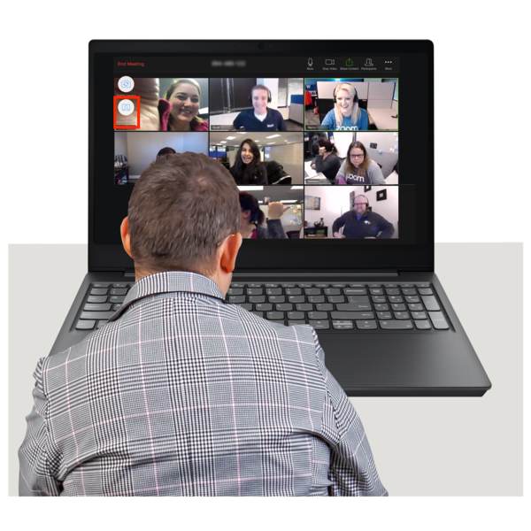 | This meeting was held online.
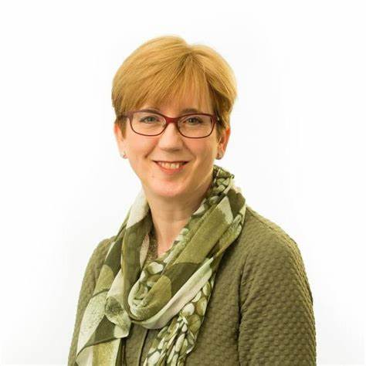 | Welcome and Introductions  Sue Proctor, who chaired the NYSAB, welcomed everyone to the meeting.
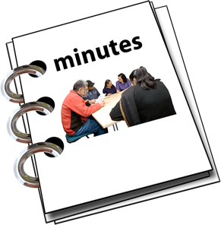 | Previous meeting minutes  Everyone was happy with the minutes from the previous NYSAB meeting in June.
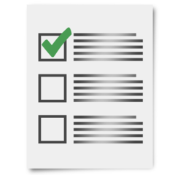 | Action log  The action log is a list of all the things that members of the NYSAB have promised to do.  Members updated on the actions they have carried out.
Delivery Plan
The delivery plan sets out work that has been or will be done in the coming year and contents of the plan were noted.
The Board agreed it was positive to see all the work and actions that have been completed.

Risk Register
The risk register had been read by members of the board.
A risk register lists all the things that could cause problems for the NYSAB when they work through their delivery plan.
Each risk is given a colour.
Red is for an action that has a lot of risk and needs a lot of work.
Amber is for an action that doesn’t have a lot of risk but still needs work.
Green is for an action that has no risk.
Green risks can sometimes be taken off the register.

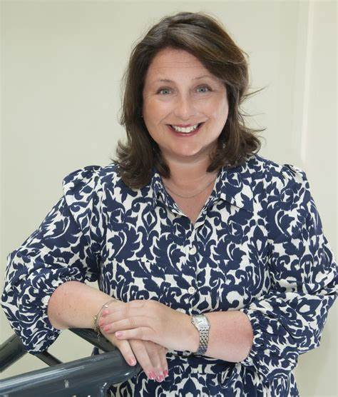  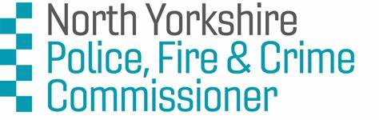 | Police Fire and Crime Commissioner for North Yorkshire  Zoe Metcalfe is the Police, Fire and Crime Commissioner (PFCC) for North Yorkshire and the City of York, and she attended the meeting to talk about her work.  Zoe’s job as PFCC is to ensure that people in the region are safe/feel safe wherever they are and whatever they are doing and to make sure that the Chief Constable and Chief Fire Officer (in North Yorkshire) are doing their jobs properly.  Zoe and her team of staff work with other teams in North Yorkshire to help people that are victims of violence, and to prevent and reduce violence in the area and to form a plan to ensure that the work continues and is effective.  Zoe told the Board that a centre will be built in autumn/winter 2023 and would open in 2024. A team of people will work there and would offer support for victims of violence.
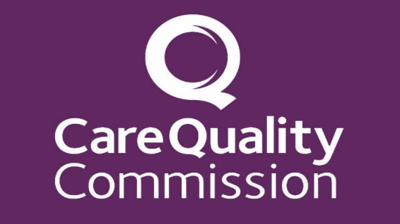  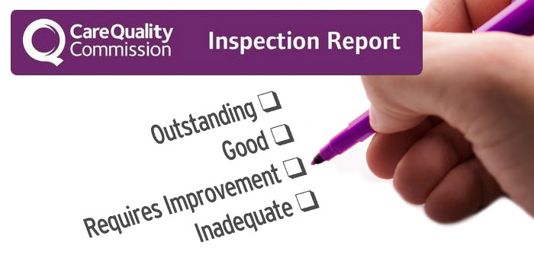  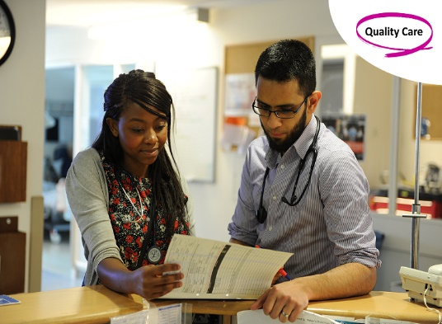 | Care Quality Commission (CQC) Assurance Framework  The Care Quality Commission (CQC) inspects and works with providers in NYC area to ensure that health and social care services provide people with safe, effective, compassionate, and high-quality care.  Two members of the CQC team, Philip Boyce and Jayne Reid joined the meeting to tell members about changes that had been made in the CQC.  The new system for inspections would be introduced in November 2023.  Inspections would start in April 2024 and would focus on care and making sure that care is improved.  Members of North Yorkshire Safeguarding Adults Board (NYSAB) were advised that inspectors may want to speak to them about the work of the Board during the inspection.  Health and Adult Services department of North Yorkshire Council are busy preparing for the inspection, but a date had not been set for the CQC visit.
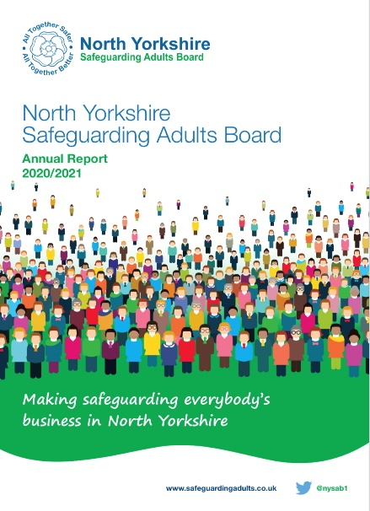 | Annual Report North Yorkshire Safeguarding Adults Board (NYSAB) for 2022/23  Members of the Board had read the draft report and approved the content.  Members of the team would arrange for the report to be formatted and once final it would be shared with other regional organisations and on the website.
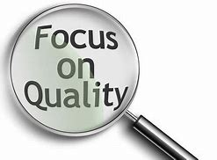 | Quality Pathway Update  Members of the Board head that an evaluation of the quality team had been completed.  Some changes had been made to the management structure, feedback had been given to staff and a work plan put in place to make sure that actions were completed.
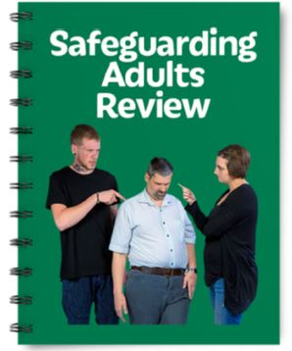 | Safeguarding Adults Review (SAR) for Anne  Safeguarding adults review is a process to look at how organisations can work together to help safeguard adults that are at risk of abuse or neglect.  It is important that lessons are learned from each case by the organisations involved to protect vulnerable adults in the future.  Members of SAB were pleased to hear that the recommendations from this report the were being carried out.
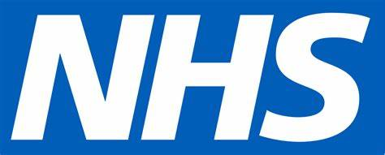  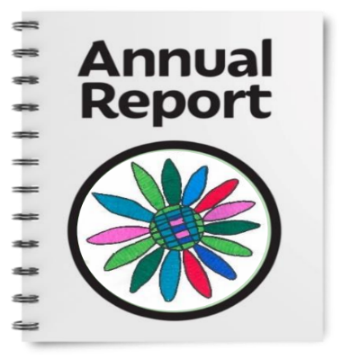 | Learning from lives and deaths (LeDeR)  LeDeR reviews help improve the quality of health and social care for people with a learning disability and the programme is run by the NHS.  The LeDeR annual report for this  region was final.  The report and an easy read version would be placed on the NYSAB website when available.
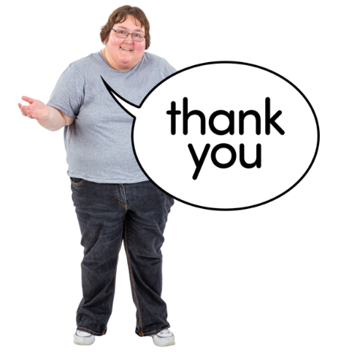 | Any other business  Sue thanked all NYSAB members for their continued hard work.

Chair | North Yorkshire Police
Sue Proctor | Scott Bissett
North Yorkshire Council (NYC) | North Yorkshire Fire Service
Emma Dixon | Vicky Coe
Louise Wallace
Richard Webb | Health Trusts and NHS Integrated Care Boards
Kim Robertshaw | Olwen Fisher (Humber and North Yorkshire Health and Care Partnership)
Jo Boutflower | Katrina Uttley (BDCFT)
Claire Lindsay | Helen Day (Tees, Esk and Wear Valley NHS Foundation Trust)
North Yorkshire Safeguarding
Children Partnership (NYSCP)
Hannah Ellingworth | CQC
 | Philip Boyce
 | Jayne Reid
NYSAB Team | Community First Yorkshire
Rachel Craig | Carole Roberts
Janice Foxton
Sarah Abram | OFPCC
 | Zoe Metcalfe
 | Sarah Arnott
Apologies
Emma Nunez, Rachel Bowes, Caroline O’Neill, Louise Johnson, Karen Siennicki, Phil Hubbard, Sheila Hall, Ashley Green, Thomas Hirst, Michelle Carrington

