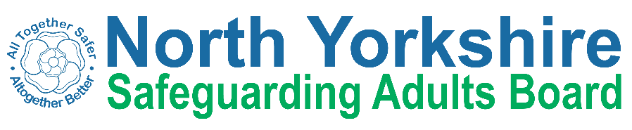
North Yorkshire Safeguarding Adults Board Summary of meeting minutes
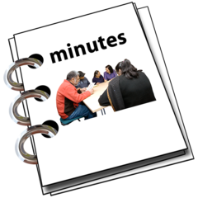 | This is a summary of the minutes for the North Yorkshire Safeguarding Adults (NYSAB) Board meeting on Wednesday 20 December 2023.
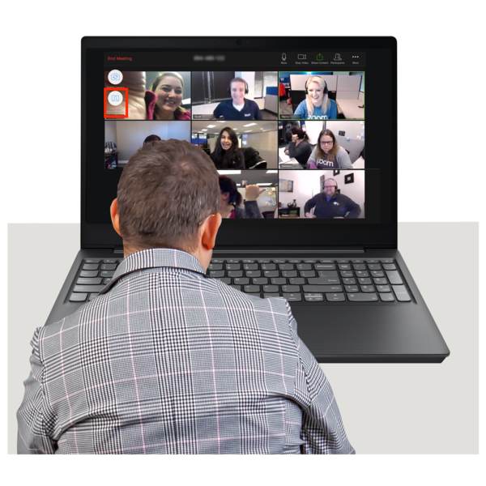 | This meeting was held online.
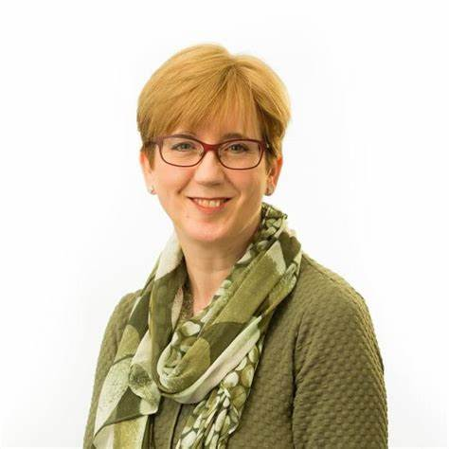 | Welcome and Introductions  Sue Proctor, who chaired the NYSAB, welcomed everyone to the meeting.
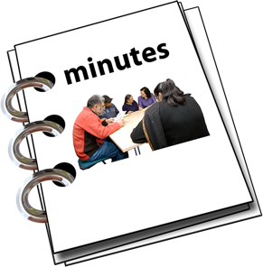 | Previous meeting minutes  Everyone was happy with the minutes from the previous NYSAB meeting in September.
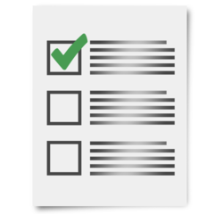 | Action log  The action log is a list of all the things that members of the NYSAB have promised to do.  Members updated on the actions they have carried out.
Delivery Plan
The delivery plan sets out work that has been or will be done in the coming year and contents of the plan were noted.
The Board agreed it was positive to see all the work and actions that have been completed.

Risk Register
The risk register had been read by members of the board.
A risk register lists all the things that could cause problems for the NYSAB when they work through their delivery plan.
Each risk is given a colour.
Red is for an action that has a lot of risk and needs a lot of work.
Amber is for an action that doesn’t have a lot of risk but still needs work.
Green is for an action that has no risk.
Green risks can sometimes be taken off the register.

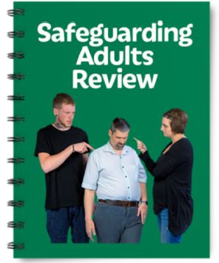  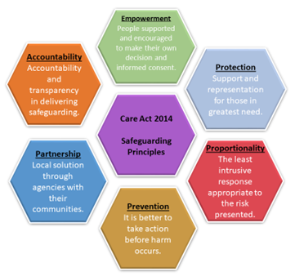 | “Elaine” Safeguarding Adult Review (SAR) Report  Mike Ward was the author of the report about “Elaine” and the circumstances around her death.  Members of the Board said that the report was well written and easy to understand.  The organisations that work together to safeguard adults in North Yorkshire would all learn from the findings of the report.  A plan would be created to carry out the recommendations made in the report.  The report would be published early in 2024.
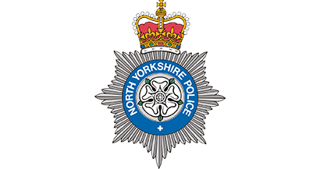 | North Yorkshire Police (NYP): Investment for safeguarding adults  Members of the Board heard that North Yorkshire Police had employed more staff to their adult safeguarding team.  The number of safeguarding adult referrals received by North Yorkshire Police is high -1,300 were received in the period July to September 2023.  North Yorkshire Police wants organisations involved in safeguarding adults to work together better to ensure that safeguarding adults run smoothly in North Yorkshire.  A Detective Sergeant would join the team on 1 March 2024.
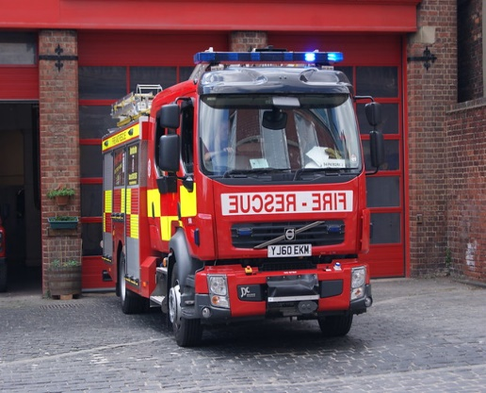  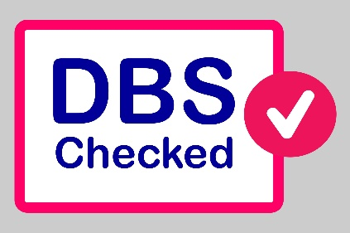 | Legislation and North Yorkshire Fire and Rescue Service(NYFRS) policy/plans with regard to Disclosure and Barring Service (DBS) checks  A basic Disclosure and Barring Service check is a background check that can be done when a person applies for a job. The check will show any criminal offences that have been committed by that person.  North Yorkshire Fire and Rescue Service said that since 2018 all operational staff that have contact with members of the public had been DBS checked and this would now be applied to all staff. Checks would be completed by March 2024.
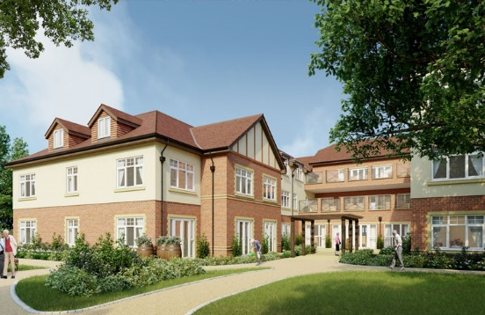 | Care Homes Update  Members of the Board heard that two care homes in the region had closed. One closed because the owner had died and the other for financial reasons. All residents were moved to suitable accommodation.  A trial is taking place that supports people leaving hospital so that they can go straight home rather than into a care home before they can go home.  North Yorkshire Council are working with care providers so that they can offer care to people with more complex needs, for example, people with dementia.
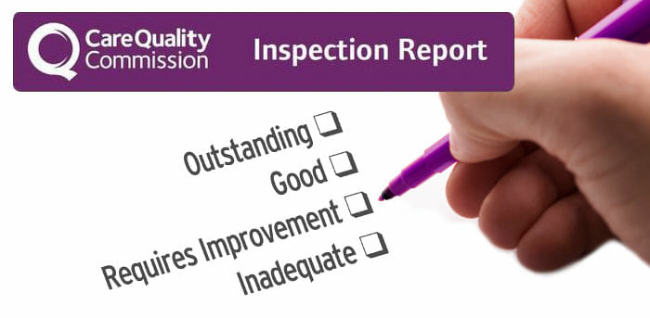  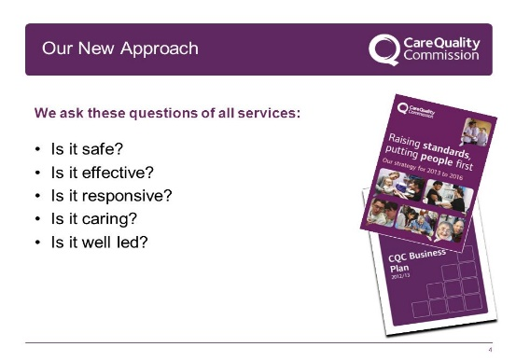 | Care Quality Commission (CQC) Assurance Framework – Feedback from mock inspection held 20/21 November 2023  The Board heard that a mock inspection had taken place to help the team prepare for the real inspection.  The mock inspection had gone well and would assist staff with preparation for the official inspection.  The council had not received a date for the inspection.
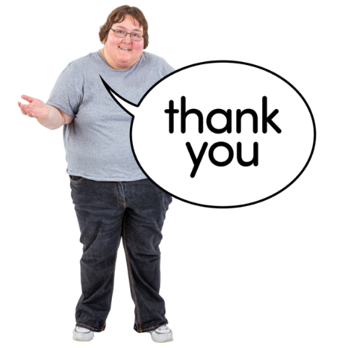 | Any other business  Sue thanked all NYSAB members for their continued hard work.

Chair | North Yorkshire Police
Sue Proctor | Graeme Wright
North Yorkshire Council (NYC) | North Yorkshire Fire Service
Louise Wallace | Thomas Hirst
Richard Webb
Kim Robertshaw | Health Trusts and NHS Integrated Care Boards
Nicola Webb | Olwen Fisher (Humber and North Yorkshire Health and Care Partnership)
North Yorkshire Safeguarding  Children Partnership (NYSCP) | Katrina Uttley (BDCFT)
Hannah Ellingworth | Helen Day (Tees, Esk and Wear Valley NHS Foundation Trust)
 | Emma Nunez
NYSAB Team | Amanda Robinson
Rachel Craig
Janice Foxton | North Yorkshire Healthwatch
 | Ashley Green
Independent Care Group
John Pattinson | Community First Yorkshire
 | Carole Roberts
National Probation Service
Joe Howard | SAR Author
 | Mike Ward
Apologies
Michelle Carrington, Phil Hubbard, Scott Bissett, Emma Dixon, Jo Boutflower, Louise Johnson

