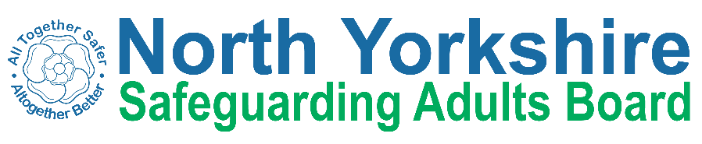
North Yorkshire Safeguarding Adults Board Summary of meeting minutes
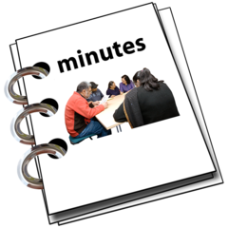 | This is a summary of the minutes for the North Yorkshire Safeguarding Adults (NYSAB) Board meeting on Wednesday 20 March 2024  .
 | This meeting was held online.
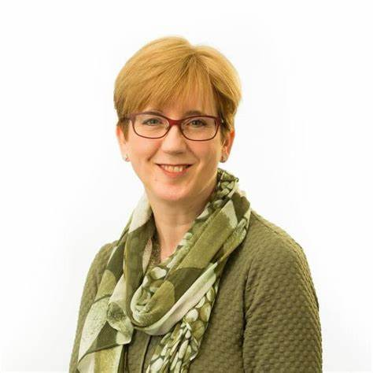 | Welcome and Introductions  Sue Proctor, who chaired the NYSAB, welcomed everyone to the meeting.
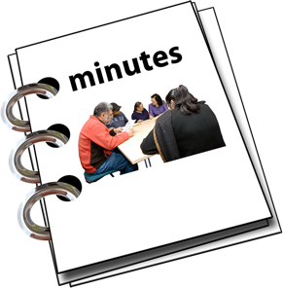 | Previous meeting minutes  Everyone was happy with the minutes from the previous NYSAB meeting in September.
 | Action log  The action log is a list of all the things that members of the NYSAB have promised to do.  Members updated on the actions they have carried out.
Delivery Plan
The delivery plan sets out work that has been or will be done in the coming year and contents of the plan were noted.
The Board agreed it was positive to see all the work and actions that have been completed.

Risk Register
The risk register had been read by members of the board.
A risk register lists all the things that could cause problems for the NYSAB when they work through their delivery plan.
Each risk is given a colour.
Red is for an action that has a lot of risk and needs a lot of work.
Amber is for an action that doesn’t have a lot of risk but still needs work.
Green is for an action that has no risk.
Green risks can sometimes be taken off the register.

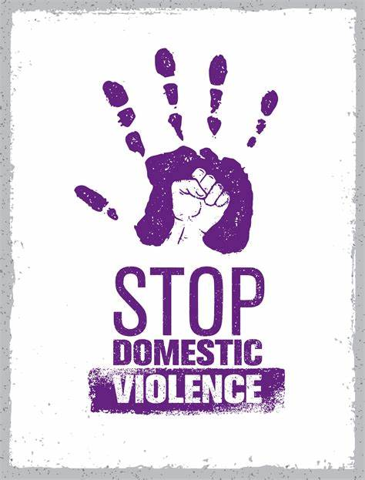    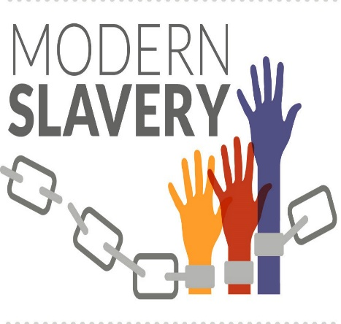 | Report from Executive Group  Members of the Executive Group had an update about North Yorkshire Council’s strategy on domestic abuse. The council worked with other organisations in the region, e.g., police and health organisations to make the strategy. When the strategy was complete it would be published on the website.  Nursing beds - Members were concerned about the drop in nursing beds available as there was the need for more beds. Part of the problem is recruitment of and keeping nursing staff to look after patients. The reduction in beds is an issue across the country, not just in North Yorkshire  Modern slavery is when people are forced by threats or violence to work for little or no pay, and cannot control what work they do or where they do it. Work was being done to help workers that come to Yorkshire from overseas to understand their rights when working here and where they can get help if they are not treated right by their bosses when working in the care sector.
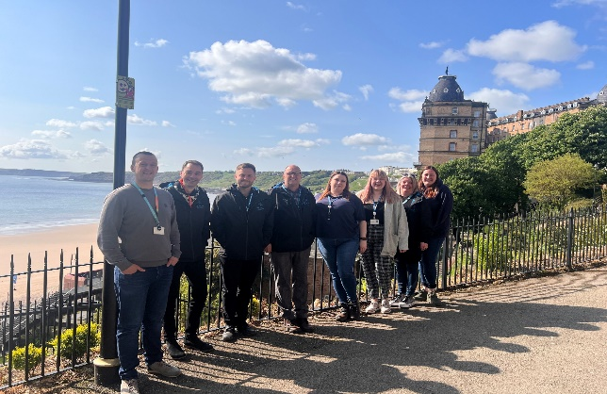  Reach Team   | REACH Project Update  Reach stands for Reducing Exclusion for Adults with Complex Housing needs.  The project started as a 3-years project in the Scarborough area to help people that are homeless or may be made homeless due to health needs including mental health, substance misuse, physical health needs or due to their criminal activity or anti-social behavior.  Since August 2021, 25 people had been accepted by REACH.  16 people were currently in properties.  The programme had been extended by 12 months and would now run for 4 years.
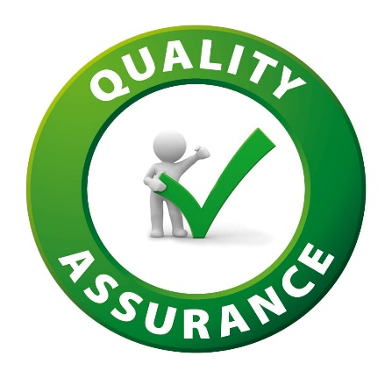  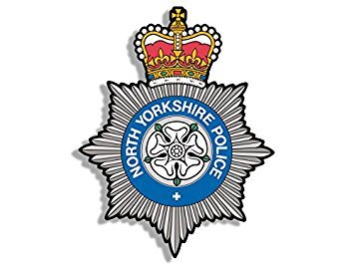 | Quality Update/Standards & Outcomes Framework  A restructure of the quality team had been completed.  Quality Assurance Assessments commenced in February 2023 and to date 71 assessments had been completed.  North Yorkshire Police and police forces throughout the country had started a scheme called “Operation Aidant” to help people recognise signs of modern slavery and to encourage them to report it.
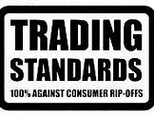  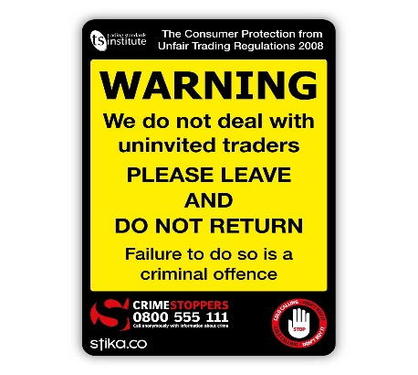 | Trading Standards Update  Personal visits had been made to residents that were victims of a scam, or at risk of being scammed to offer advice and support.  Letters had been sent to 280 residents to raise awareness of scams and offer advice with regard to avoiding scams.  Work had been undertaken with residents that may be vulnerable to scams, to help them ignore or get rid of cold callers.  A number of fraudsters had been convicted and some of the money was returned to victims.
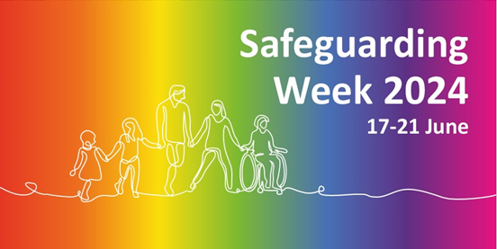 | Safeguarding Week 17-20 June 2024  Notification of the dates for Safeguarding Week had been circulated to partners.  The team were putting the programme of events together.  Further information would be circulated when available.
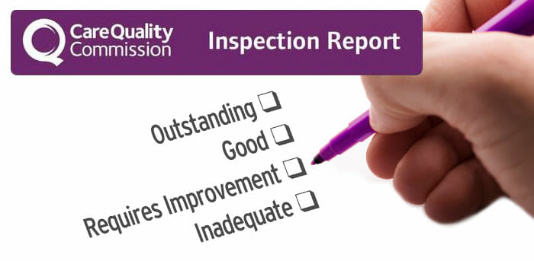  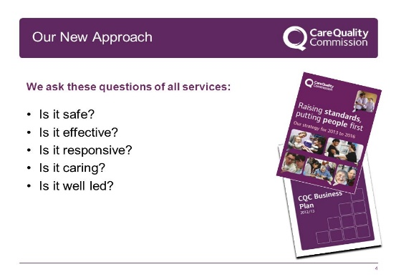 | Summary of the Care Quality Commission (CQC) Core Services inspection 2023 at Tees, Esk and Wear Valleys (TEWV) NHS Foundation Trust  Beverley Murphy the Chief Nurse for Tees, Esk and Wear Valleys NHS Foundation Trust joined the meeting to update on outcomes of the inspection undertaken by the Care Quality Commission (CQC).  Beverley Murphy explained to members of North Yorkshire Safeguarding Adults Board that her team understood what the CQC had found during the inspection and where improvements were required and that a plan was in place to ensure that the required improvements were made.
 | Any other business  Members of NYSAB thanked Sue Proctor for her work on behalf of the Board as this was her final meeting as Chair.  Sue had enjoyed her time as Chair and thanked the team their work over the years and wished them well in the future.

Chair | North Yorkshire Police
Sue Proctor | Graeme Wright
North Yorkshire Council (NYC) | North Yorkshire Fire Service
Louise Wallace | Thomas Hirst
Richard Webb
Kim Robertshaw | Health Trusts and NHS Integrated Care Boards
Nicola Webb | Olwen Fisher (Humber and North Yorkshire Health and Care Partnership)
North Yorkshire Safeguarding  Children Partnership (NYSCP) | Katrina Uttley (BDCFT)
Hannah Ellingworth | Helen Day (Tees, Esk and Wear Valley NHS Foundation Trust)
 | Emma Nunez
NYSAB Team | Amanda Robinson
Rachel Craig
Janice Foxton | North Yorkshire Healthwatch
 | Ashley Green
Independent Care Group
John Pattinson | Community First Yorkshire
 | Carole Roberts
National Probation Service
Joe Howard | SAR Author
 | Mike Ward
Apologies
Michelle Carrington, Phil Hubbard, Scott Bissett, Emma Dixon, Jo Boutflower, Louise Johnson

