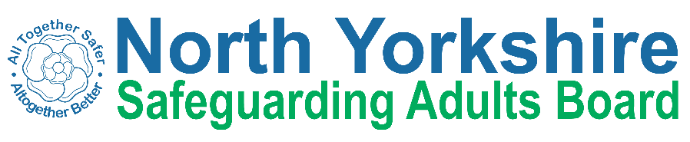
North Yorkshire Safeguarding Adults Board Summary of meeting minutes
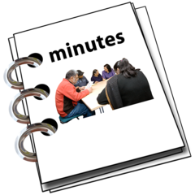 | This is a summary of the minutes for the North Yorkshire Safeguarding Adults (NYSAB) Board meeting on Wednesday 19 June 2024  .
 | This meeting was held online.
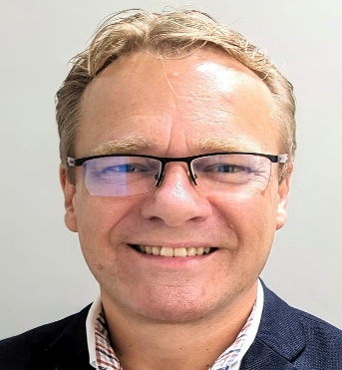 | Welcome and Introductions  Adrian Green, who chaired the NYSAB, welcomed everyone to the meeting.
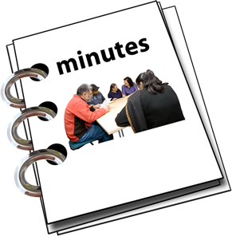 | Previous meeting minutes  Everyone was happy with the minutes from the previous NYSAB meeting in December.
 | Action log  The action log is a list of all the things that members of the NYSAB have promised to do.  Members updated on the actions they have carried out.
Delivery Plan
The delivery plan sets out work that has been or will be done in the coming year and contents of the plan were noted.
The Board agreed it was positive to see all the work and actions that have been completed.

Risk Register
The risk register had been read by members of the board.
A risk register lists all the things that could cause problems for the NYSAB when they work through their delivery plan.
Each risk is given a colour.
Red is for an action that has a lot of risk and needs a lot of work.
Amber is for an action that doesn’t have a lot of risk but still needs work.
Green is for an action that has no risk.
Green risks can sometimes be taken off the register.
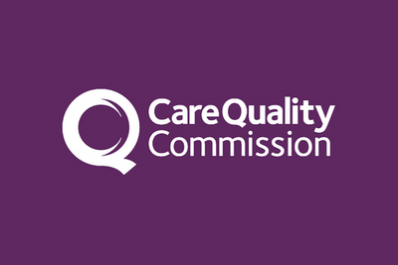 | Preparing for Care Quality Commission (CQC) inspection  North Yorkshire Council had not been given a date for inspection of Health and Adult Services Department by the Care Quality Commission.  Members of the team were preparing for inspection and would advise members of Safeguarding Adults Board as soon as confirmation of a date for inspection had been received.
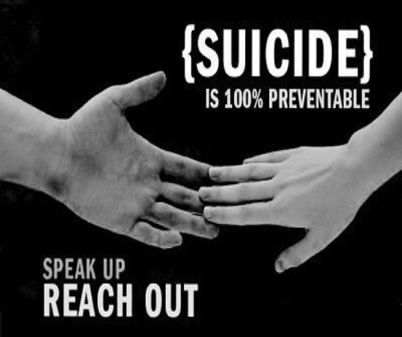 | Suicide Prevention Update  Staff in Health and Adult Services were working to help prevent suicides in North Yorkshire.  Although suicide rates had fallen between 2018 and 2022 approximately 13 between 2018-20 and 11 between 2020-22 more work was needed to reduce the number of suicides.  In North Yorkshire, more men than women attempted suicide and people aged between 40 and 59 were more likely to attempt suicide.
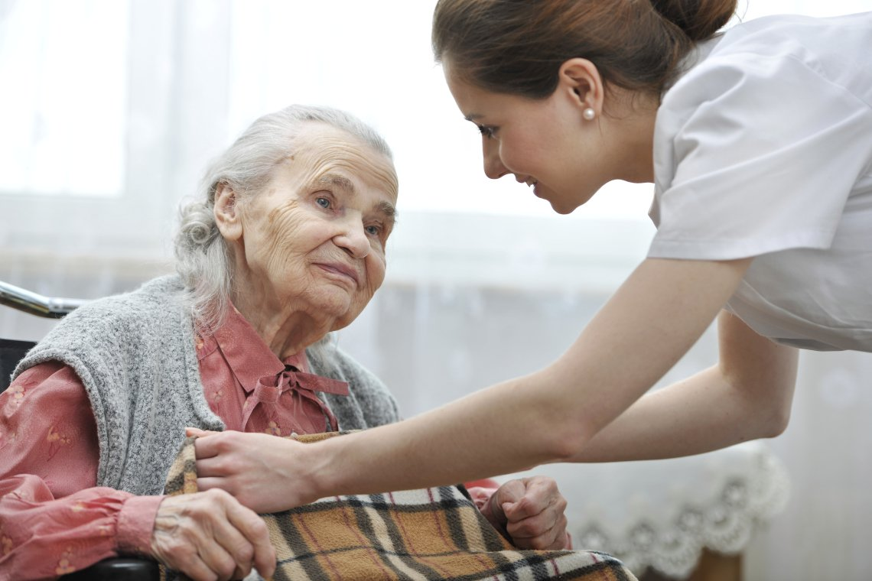 | Care Sector Workforce Update  There is great demand for care sector services in North Yorkshire.  There are 360 care providers in North Yorkshire and demand is growing for specialist care.  There is a high turnover rate for staff in the care sector. The average age for care sector staff is 43 years old and it is difficult to attract young workers. Only 9% of the workforce is aged under 25 years old.
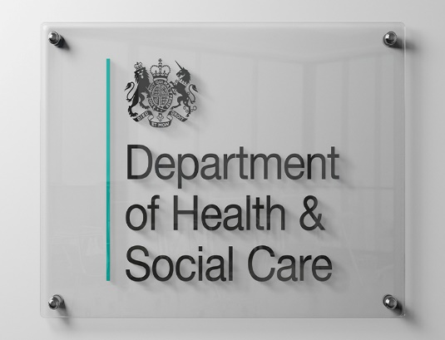  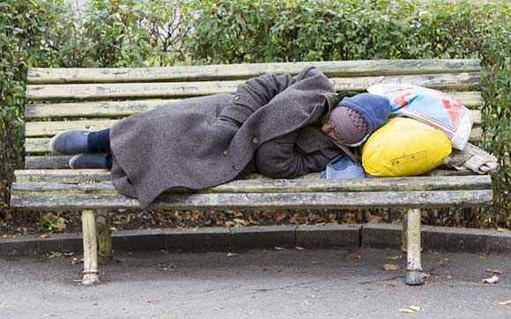 | Ministerial recommendations for Safeguarding Adults Boards on rough sleeping  North Yorkshire Safeguarding Adults Board received a letter from the Government Minister for Social Care.  The letter said that each Safeguarding Adults Board should appoint a representative for rough sleeping on the Board. This representative would ensure that North Yorkshire Council worked closely with rough sleeping teams and the safeguarding board.
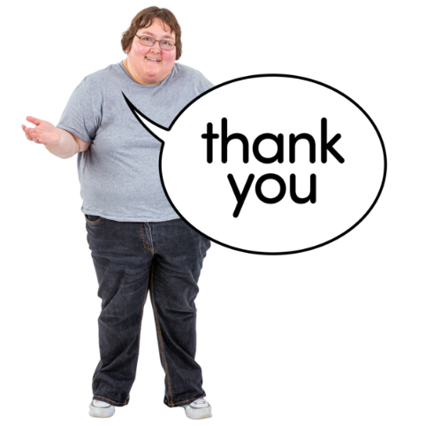 | Any other business  The structure of the social care department at North Yorkshire Council had been reviewed and would change to provide a better service could be provided in the region.  There would be a meeting of representatives of the Safeguarding Adults Board and other organisations across North Yorkshire in early October 2024 to discuss and agree the priorities of the Safeguarding Adults Board in North Yorkshire

Chair | North Yorkshire Police
Adrian Green | Ian Scott
North Yorkshire Council (NYC) | North Yorkshire Fire Service
Louise Wallace | Hannah Oakley
Richard Webb
Ema Dixon | Health Trusts and NHS Integrated Care Boards
Dan Atkinson  Rachel Bowes  Jo Holland | Olwen Fisher (Humber and North Yorkshire Health and Care Partnership)
North Yorkshire Safeguarding  Children Partnership (NYSCP) | Katrina Uttley (BDCFT)
No representative | Jemma Hill (Tees, Esk and Wear Valley NHS Foundation Trust)
 | Amanda Robinson (BDCFT)
NYSAB Team | Tara Filby (York and Scarborough NHSFT)
Sally Lichfield | Caroline Johnson (Humber and North Yorkshire)
Janice Foxton | North Yorkshire Healthwatch
 | Ashley Green
Independent Care Group
John Pattinson | Community First Yorkshire
 | Carole Roberts
National Probation Service
Joe Howard
Apologies
Vicky Coe, Emma Nunez, Karen Siennicki, Graeme Wright, Kim Robertshaw, Laura Watson, Phill Hubbard, Emma Stevens, Christine Pearson, Jo Boutflower, Hannah Ellingworth.

