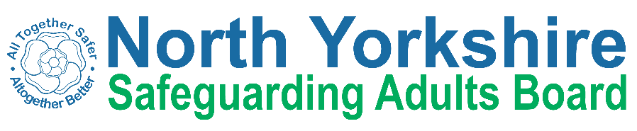
North Yorkshire Safeguarding Adults Board Summary of meeting minutes
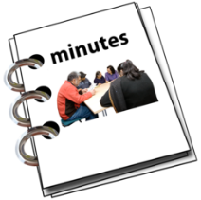 | This is a summary of the minutes for the North Yorkshire Safeguarding Adults (NYSAB) Board meeting on Wednesday 25 June 2025.
 | This meeting was held online.
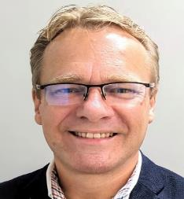 | Welcome and Introductions  Adrian Green, who chaired the NYSAB, welcomed everyone to the meeting.
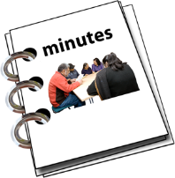 | Previous meeting minutes  Everyone was happy with the minutes from the previous NYSAB meeting March.
 | Action log  The action log is a list of all the things that members of the NYSAB have promised to do.  Members updated on the actions they have carried out.
Delivery Plan
The delivery plan sets out work that has been or will be done in the coming year and contents of the plan were noted.
The Board agreed it was positive to see all the work and actions that have been completed.

Risk Register
The risk register had been read by members of the board.
A risk register lists all the things that could cause problems for the NYSAB when they work through their delivery plan.
Each risk is given a colour.
Red is for an action that has a lot of risk and needs a lot of work.
Amber is for an action that doesn’t have a lot of risk but still needs work.
Green is for an action that has no risk.
Green risks can sometimes be taken off the register.
  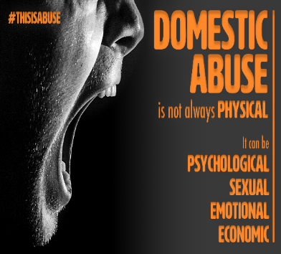 | Domestic Abuse Strategy Update  The Domestic Abuse Strategy for North Yorkshire Council was launched in April 2024 and would run until 2028.  The team reported that staff had been trained on polices and procedures for domestic abuse. Ways in which to refer those that needed help to the teams that could help had improved.  Our team was looking for ways to ensure that the “voice” of survivors of domestic abuse was heard, recorded, and shared.  The team would update North Yorkshire Safeguarding Adults Board regularly.
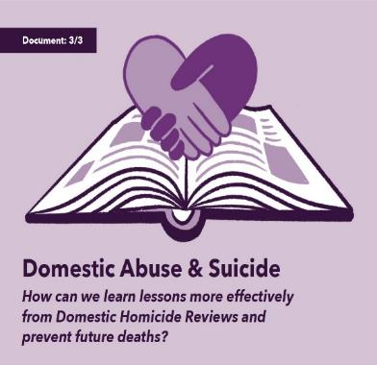  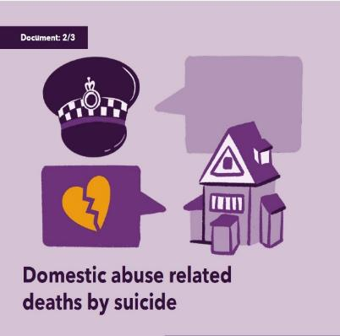 | Domestic Homicide Review (DHR)/Multi Agency Risk Assessment Conferences (MARAC) Update  Multi Agency Risk Assessment Conferences are known as the best way to identify and manage “high risk” cases of domestic abuse where the victim is at risk of serious harm or death. There is a national framework to help agencies to meet and share information, solve problems, and plan for the safety of those high-risk cases of domestic abuse.  North Yorkshire had experienced a high volume of cases during and since Covid, but this appeared to have peaked and there were now just under 2,000 cases each year.  138 adults and 94 children had been accommodated in safe accommodation in 2024/25.  A Domestic Homicide Review helps to ensure that lessons are learned and identifies what needs to change to reduce the risk of deaths due to domestic violence in future.  A new process for Domestic Homicide Reviews (DHR) would be introduced and this would affect how we manage those people that write the of reviews, the appointment of a chairperson for a review and how reviews are requested. The team were being trained to introduce this process in the region.  North Yorkshire Council would continue to work with partners to provide the best service possible for those experiencing domestic abuse.
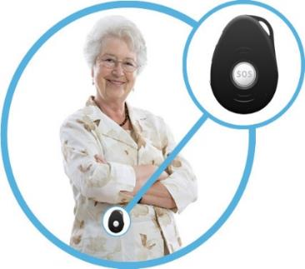  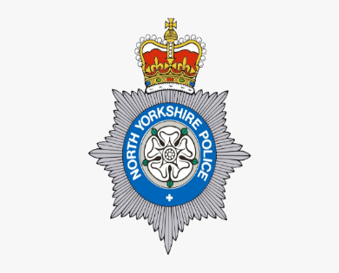 | GPS Tracker Project – North Yorkshire Police  North Yorkshire Police told the Board about a scheme to provide trackers for use by families where someone had dementia, who might go missing. The tracker would be attached to the person with dementia and would link to an “app” on a computer, tablet or mobile phone that would show the location of the person.  York Safeguarding Adults Board had offered to contribute to the scheme and North Yorkshire Police would like North Yorkshire Council and other partners to sign up to the scheme.  Work would continue to see if this could be introduced in North Yorkshire.
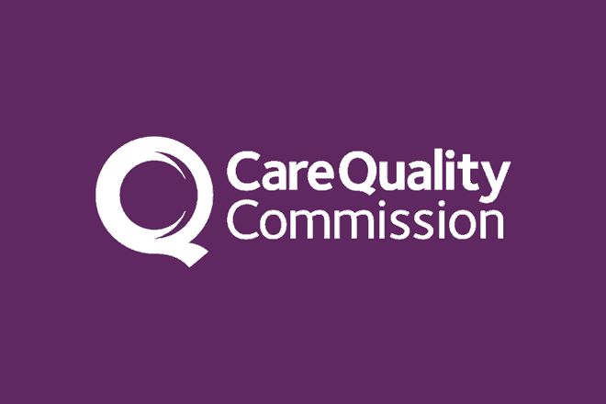 | Care Quality Commission Inspection Update  Health and Adult Services had received “headline” feedback from the Care Quality Commission following the inspection. The team could not tell what the result of the inspection might be from the feedback. The team awaited the final report.
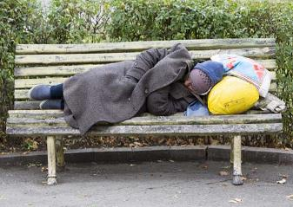 | Rough Sleeping Update  There were 29 people at risk of rough sleeping in North Yorkshire and work would be undertaken with partner organisations to see what could be done to help those at risk of rough sleeping.  A shower and washing machine had been installed in Church House, Northallerton, so those people rough sleeping could wash and clean their clothes.  A rough sleeper pod had opened in Selby.  A Strategy for Homelessness and Rough Sleeping had been drafted and would be introduced in due course.
 | Any other business  The Chairman of the board, Adrian Green thanked members for attending and the meeting closed.

Chair | North Yorkshire Police
Adrian Green | Graeme Wright/Carol Kirk
North Yorkshire Council (NYC) | North Yorkshire Fire Service
Louise Wallace | Toni Tranter
Richard Webb
Kim Robertshaw  Gavin Swankie | Health Trusts and NHS Integrated Care Boards
Emma Dixon | Julie Wilburn (Humber and North Yorkshire Health and Care Partnership) (ICB)  Emma Stevens (Humber and North Yorkshire Health and Care Partnership) (ICB)
North Yorkshire Safeguarding  Children Partnership (NYSCP) | Amanda Robinson (BDCFT)
Hannah Ellingworth | Nicki Smith (Tees, Esk and Wear Valley NHS Foundation Trust)
Community First Yorkshire  Carole Roberts | Emma Nunez (Harrogate District)  Helen Williams (STHFT)  Saiki Said (West Yorkshire ICB)
NYSAB Team | North Yorkshire Healthwatch
Sally Lichfield  Janice Foxton  Rachael Jennings | Ashley Green
Independent Care Group | National Probation Service
No representative | Joe Howard
Apologies
Ian Scott, Phil Hubbard, John Pattinson

